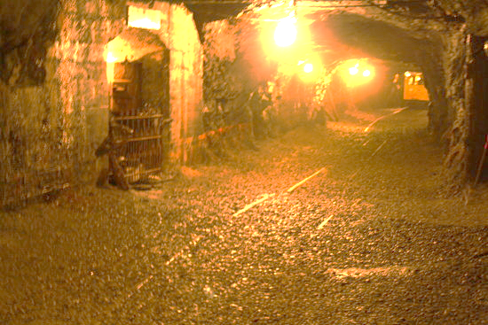
Saturday May 19
& Sunday May 20
Bills Old Bike Barn
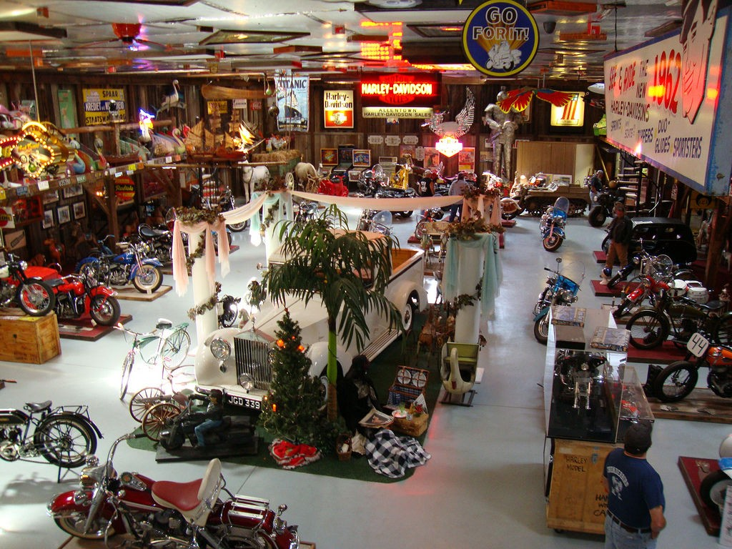
A 2-day jaunt designed to give you a healthy dose of vintage touring the way it was meant to be. This trip will take us through the forests and mountains of Pennsylvania’s core region and just might alter your priorities in life. Here, coal was once king, and because there has been little economic development in recent years, there is still very little traffic to contend with as we enjoy the natural splendor of the Pocono and Endless Mountains.
Plan to arrive in Kennett Square sometime Friday afternoon or night for orientation and loading if you’re from out of town. You can spend the night here if you like. Locals can arrive early Saturday morning. Choose your bike, and we’ll set out after an early breakfast, heading north on back roads through scenic, wooded, French Creek and through an ancient covered bridge before crossing the Eastern Continental Divide where it meets the Appalachian Trail. After lunch, a short ride takes us to into Lansford, where we’ll stop at Coal Mine #9 for a subterranean tour, descending nearly a mile into one of the country’s oldest coal mines to learn how real men earned a living back when coal was a way of life.
The next section of road is twisty and challenging, and features abrupt elevation changes that make this 25-mile segment feel like a long roller coaster, joining tiny villages and farms that dot the landscape. We pop out of the woods at Route 11 which we follow for just a few miles to our luxury cabins. Dinner is at a a biker friendly steak house: a well-deserved chow down before returning to our cabins for serious campfire discussions about the meaning of life and riding: are they not one? A tiny corner of Bill’s Old Bike Barn
On Sunday morning after a mountain-man-breakfast we’ll ride a 25-mile loop featuring two interesting covered bridges, before spending an hour or two at Bill's Old Bike Barn: an amazing experience every time; there is always something new. We will not want to leave but the open road beckons so we head south through Shamokin to meandering Route 125, a favorite with local bikers, crossing over several mountains before bottoming out in Amish farm country where we may share the road with families returning home from their Sabbath in horse drawn buggies. The final leg of our journey is relaxed and includes an ice cream stop on the way home where a cold beer and a hot meal await us. Tomorrow it’s back to work, but no one is in a hurry.

