THE PINNACLES: SATURDAY/SUNDAY, JUNE 2, 3
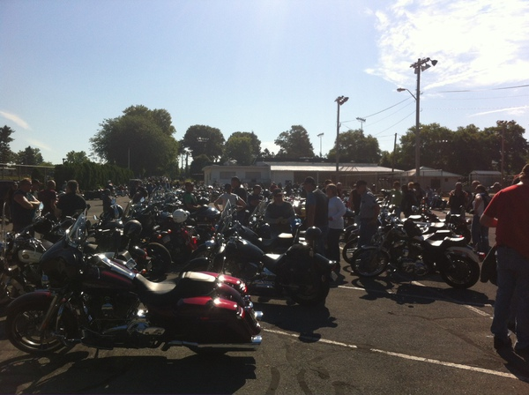
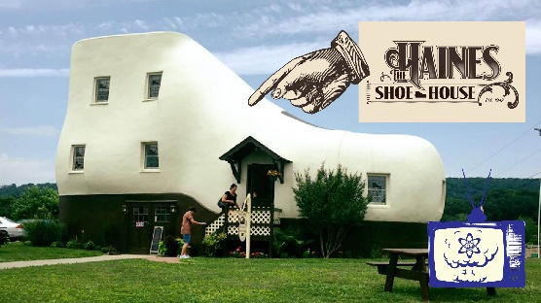
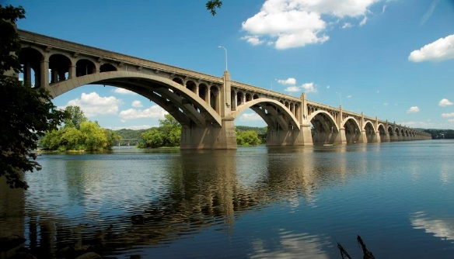
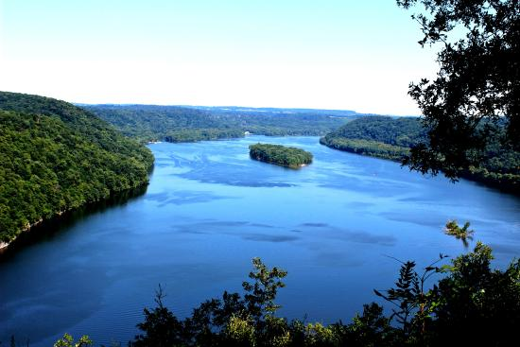
Here’s a cool way to ease into the riding season. If you’re coming in from out of town you are welcome to spend Friday and/or Sunday nights here. We’ll do breakfast at 9 on Saturday and leave at a relaxed 10 AM.
CHOOSE YOUR BIKE! Check out the RetroTours fleet on-line and choose the one you want to ride plus an alternate. We’ll do our best to accommodate your wishes. If you want to ride your own vintage bike and/or have your significant other along, that’ll work too.
You can stay on one bike all weekend or swap with other riders. We’ll ride at a very relaxed pace and stay on wonderful back roads shared with Amish folk in their horse drawn buggies. Fifty miles out we’ll take a short break at a high cliff above the Susquehanna River, then continue to Columbia for lunch by the historic Wrightsville Bridge before visiting the Haines Shoe House: a very quirky vintage roadside attraction on the old Lincoln Highway. Finally, we’ll re-cross the river and make our way past Lancaster towards Ephrata, stopping overnight at our very interesting and comfortable accommodations.
We’ll leave early on Sunday morning and visit the nearby, monthly “Gathering of the Bikes”, where hundreds of café racers, antiques, cruisers, muscle bikes, three wheelers, sport machines, and touring rigs will be on display alongside our bikes. It’s a spectacle you will remember, ANYTHING GOES!
A relaxed pace ride of under 100 miles on Sunday allows us to enjoy more of the scenic country back roads while getting us home by 3 o’clock for a late lunch and your early departure for home.
This RetroTour features short daily mileages, a relaxed pace, and several very interested stops. Good food, wonderful vintage bikes to ride and great camaraderie included.

