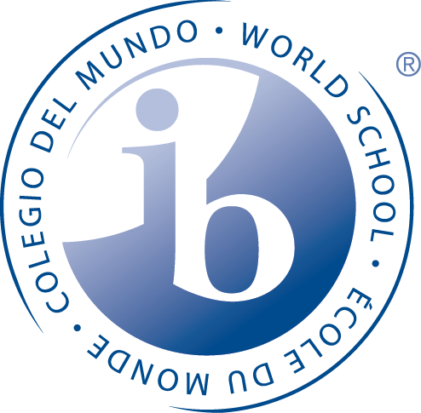
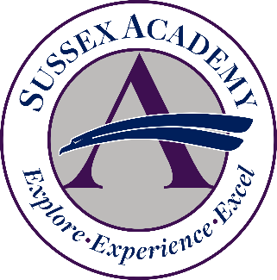
a public charter school
2017-2018
Debbie Fees, Academic Counselor
debbie.fees@saas.k12.de.us

Dr. Patricia S. Oliphant, Director of Curriculum and Instruction
patricia.oliphant@saas.k12.de.us

Allen Stafford, Director of Finance and Operations
allen.stafford@saas.k12.de.us

Janet Owens, Director of Accountability
janet.owens@saas.k12.de.us

CEEB School Code: 080053

OVERVIEW
Sussex Academy originated as Sussex Academy of Arts and Sciences in 2000 as a middle school serving grades 6 to 8. In 2012 the school was approved for a major charter modification to add a high school. In 2013 the school name was changed to Sussex Academy and grade 9 was enrolled. A high school grade was added each year and 2017 marked the first graduating class. Sussex Academy is located in rural Georgetown, Delaware and is the only charter school in Sussex County.
- There are 760 students in grades 6-12
- Authorized International Baccalaureate World School in March 2015
- Sussex Academy named Top Performing School in Delaware by the DE Department of Education in 2015
- Admission to Sussex Academy is through a public lottery
- The Sussex Academy Foundation has raised over $34 million since 2012 for the school expansion
- National Blue Ribbon School, designated by the U.S. Department of Education in September 2016
- Our men’s athletics program offers lacrosse, basketball, swimming, cross country, tennis, golf and soccer
- Our women’s athletic program offers basketball, volleyball, cross country, lacrosse, swimming, tennis, golf, soccer and cheerleading
- Extracurricular activities: National Honor Society, Technology Student Association, Student Government Association, Leo Club, Science Olympiad, Odyssey of the Mind, Chemistry Club, Band, Choir and Theater

MISSION
To foster academic achievement and social responsibility in a small-school environment
where students participate in an accelerated college preparatory program that prepares them for the technological and global challenges of the 21st century and fosters ethical conduct and service to others in their day-to-day lives.

ENROLLMENT 2017-2018
Grade | Number of Students Enrolled
12 | 58
11 | 87
10 | 103
9 | 130

CURRICULUM
Graduation Requirements for the Class of 2018

- 4 credits each of English, Math, Social Studies, Science and World Language
- 3 credits in Career Pathway
- 1 Credit PE, ½ credit Health
- 1 credit Theory of Knowledge (TOK)

- All core courses are taught at the Honors level or higher.
- The State of Delaware requires 3 credits in a Career Pathway.
- Sussex Academy Pathway choices: STEM and Communications; students may take non-chosen pathway courses as electives.
- IB World School; first graduating class of 38 had 13 International Baccalaureate Diploma candidates. There are 17 IB Diploma candidates in the Class of 2018.
- All students are required to complete TOK to the same expectations as IB Diploma candidates.

GRADING SCALE
A | 93-100
B | 85-92
C | 76-84
D | 70-74
F | 69 and below

GPA Weighted GPA reflects +1.0 for IB, AP and other college level coursework. Honors courses
receive +0.5.

RANK Sussex Academy does not rank due to the academically competitive nature of our program.

TEST SCORES

Test | Date Administered | % of Students Tested | Sussex Academy Mean Total Score | State Mean Total Score | National Mean Total Score
SAT | April 2017 | 100% of juniors | 1149 | 971 | 996
PSAT/NMSQT | October 2016 | 98% of juniors | 1076 | 977 | 1018
PSAT 10 | April 2017 | 99% of sophomores | 1056 | 898 | 938
PSAT 8/9 | April 2017 | 85% of freshmen | 1006 | 845 | 879

COURSE OFFERINGS

CLASS OF 2018

ENGLISH | SOCIAL STUDIES | COMMUNICATIONS PATHWAY
Honors English 9 | Honors Civics/Economics | Elements of Writing
Honors English 10 | Honors World History | Integrated Communications
Honors Literature 11 | Honors U.S. History | Drama | Journalism
Honors Literature 12 | Honors U.S. History 2 | Applied Art | Film & Literature
IB Literature HL | IB History HL | Print Media 1 & 2 | Cultural Expression
MATH | SCIENCE | Photography 1 & 2 | Visual Communications
Honors Algebra I | Honors Integrated Science | Programs, Apps, and Creating Media
Honors Geometry | Honors Biology | Research and Writing
Honors Algebra 2 | Honors Chemistry | STEM PATHWAY
Honors Precalculus | Honors Physics | Design and Engineering
IB Math SL | Honors Anatomy | Technological Design
IB Math HL | IB Chemistry SL | IB Design Tech SL
 |  | AP Computer Science Principles
WORLD LANGUAGE | OTHER GRADUATION REQUIREMENTS | OTHER ELECTIVES
Honors Spanish 1-4 | PE 1 & 2 | Psychology | Positive Psych.
IB Spanish SL | Health | Criminal Justice | Lifetime Fitness
IB Spanish HL | Theory of Knowledge | Sociology | Swim Conditioning
DUAL ENROLLMENT COURSES OFFERED  (DELAWARE TECHNICAL AND COMM. COLLEGE) |  | Academic Seminar | Strength and Conditioning
Bus 101: Intro. to Business | CIS 120: Intro to Computer Programming | Driver Ed. | Lifeguarding
OAT 242: Desktop Publishing |  | Educational Aide | Online courses as available

GRADE DISTRIBUTION

Core Classes Grade Distribution: Junior Year (Class of 2018)
 | Percentage of students earning letter grade (total students = 40) |  |  |  |  | Average Grade  (Final %)
 | A | B | C | D | F
Honors English 11 | 14% | 39% | 21% | 21% | 0% | 85%
IB Literature HL 1 | 31 | 53 | 16 | 0 | 0 | 90%
Honors Algebra 2 | 38 | 29 | 13 | 15 | 6 | 86%
IB Math SL 1 | 11 | 53 | 26 | 11 | 0 | 85%
IB Math HL 1 | 44 | 19 | 31 | 6 | 0 | 89%
Honors Chemistry | 3 | 24 | 39 | 18 | 16 | 78%
IB Chemistry SL 1 | 40 | 50 | 10 | 0 | 0 | 89%
IB Design Tech SL 1 | 23 | 42 | 31 | 4 | 0 | 87%
Honors US History | 11 | 47 | 26 | 16 | 0 | 84%
IB History HL 1 | 46 | 37 | 15 | 0 | 2 | 90%
Honors Spanish 3 | 10 | 31 | 41 | 21 | 3 | 81%
IB Spanish SL 1 | 22 | 61 | 17 | 0 | 0 | 87%
TOK | 69 | 22 | 9 | 0 | 0 | 94%

IB RESULTS (first IB DP class, May 2017)
- 13 DP candidates, 7 awarded IB Diploma
- Average grade of DP student = 4.71
- IB Literature HL average score = 5.2
- IB Spanish average score = 4.9 (SL), 5.0 (HL)
- IB History HL average score = 4.5
- IB Chemistry HL average score = 4.6
- IB Design Tech SL average score = 4.4
- Theory of Knowledge = 1 A, 6 B’s, 7 C’s

COLLEGES AND UNIVERSITIES
The first graduating Class of 2017 had 38 graduates.
- 68% were offered admission to a 4-year college (see list below; colleges in bold indicate at least one graduate will be attending the college)
- 29% will be attending Delaware Technical and Community College; most of these students plan to connect to a 4-year degree

Ave Maria University
Bellarmine University
Belmont Abbey College
Boston University
Catholic University
Clarkson University
Drexel University
Immaculata Univeristy
Juniata College
Lafayette College
Lebanon Valley College
Loyola University of Maryland
Lycoming College
Lynchburg College
Marymount University
Marywood University
McDaniel College
Millersville University
Mount St. Mary College
New York University (Stern)
Randolph-Macon College
Rensselaer Polytechnic Institute
Rochester Institute of Technology
Salisbury University
St. Mary's College of Maryland
Susquehanna University
University of Central Florida
University of Dallas
University of Delaware
University of Kentucky
University of Pittsburgh
University of Tennessee
University of Vermont
Ursinus College
Vanderbilt University
Villanova University
Virginia Tech
Wake Forest University
Washington College
Westminster College
Widener University

