Riding a Vintage Motorcycle Through Pennsylvania with Retro Tours
November 15, 2021
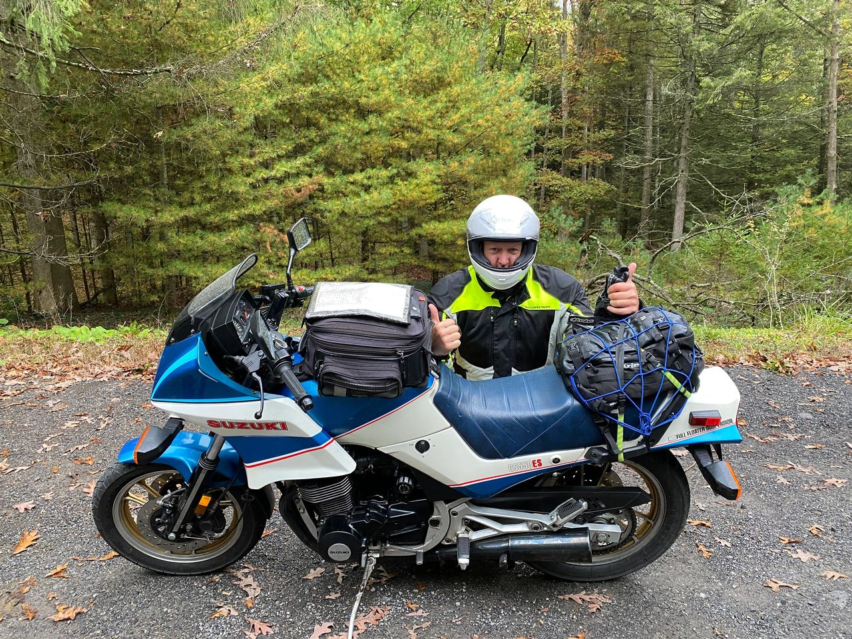
So…I am way behind on posting ride reports. I’ve been meaning to post this one for months, as this was one of the most unique rides I have ever done.
Joel Samick, a former racer, motorcycle dealership owner, and long time vintage motorcycle collector, started Retro Tours to share his love of vintage motorcycles, but also to have a way to keep all of his +/-25 vintage bikes out on the road. He hosts single day and multi-day tours during which guests have an opportunity to ride one or more of his vintage bikes on beautiful back roads around Pennsylvania and neighboring states. I found Joel and his company while searching vintage motorcycles on Google. This concept was just too good to pass up. After a brief exchange of emails last fall, I reserved a spot on his October 2021 Kinzua Skywalk 4 day tour and made my way to Pennsylvania.
After a flight from Denver to Baltimore and a train ride from Baltimore to Wilmington, Joel met me at the train station, loaded my gear and drove me 20 minutes to his home in Pennsylvania, which he and his wife operate as a BnB for his tour guests. We walked into the house through his garage, and I got the first glimpse of his motorcycle collection. He easily had 25 motorcycles strategically parked in his 2 car garage (proving right away that I have room for several more bikes!) Polished tanks sporting badges including Norton, Triumph, Moto Guzzi, BMW, Harley Davidson, Honda, Suzuki, Kawasaki, Yamaha lured me in for a closer look. This garage was like an oil-scented museum. The nostalgia was intoxicating. I knew right away this was going to be a great ride!

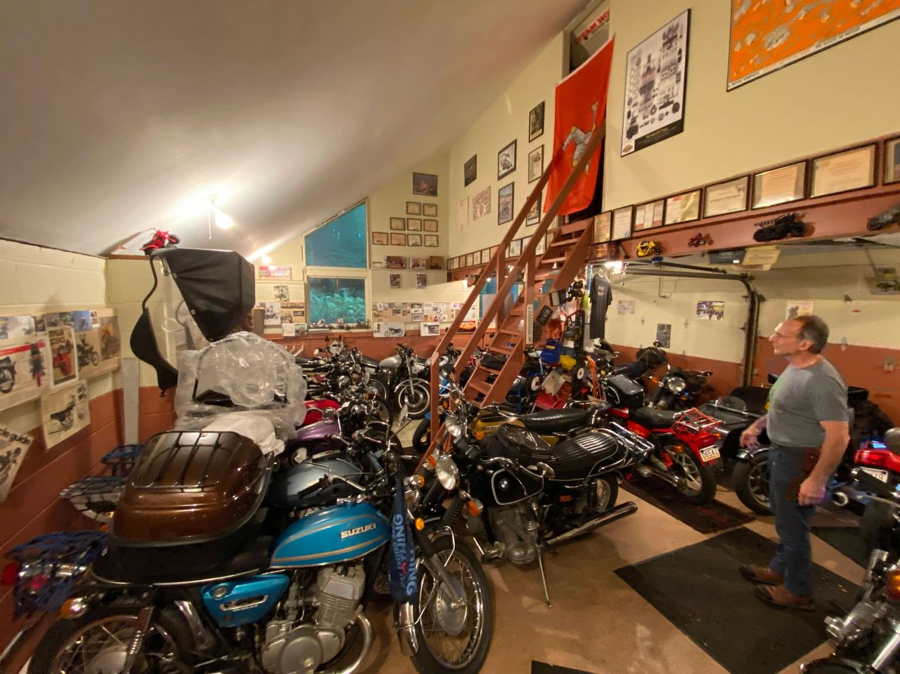Joel's Garage (aka my new goal!)
My tour continued through the basement, which looked like a full service shop with multiple motorcycle lifts and tool chests. As I was the only single rider on this trip, I got the privilege of spending the night in Joel's small office lined with shelf after shelf of what seemed like every motorcycle book ever written in the corner of this motorcycle playground of a basement.
Dropping my gear, I headed upstairs to meet Joel's incredible wife, Lynn, who not only still runs the family's motorcycle dealership, but was instrumental in developing the original curriculum for the MSF Basic Rider Course back in the 1980's. Not only that, she is, as far as I am concerned, a gourmet chef who prepared 2 incredible meals the first and last night of our tour. Sipping on a cold beer, I got to know Joel and Lynn a little as we waited for the other riders to arrive.
Mike and Gina arrived from Boston, and John and Robin arrived from Ohio. We all shared an incredible meal before gathering in the basement to choose our rides for the next 4 days. Gina chose a 1984 Suzuki GS550ES. Mike chose a 1976 Moto Guzzi 850T3. Robin chose a 1984 Moto Guzzi V65SP. John chose a 1976 Kawasaki KZ750. I chose a 1974 BMW R90/6. Joel chose his 1976 Honda GL1000. Bikes chosen, we all retired for the night to rest up for our big adventure.

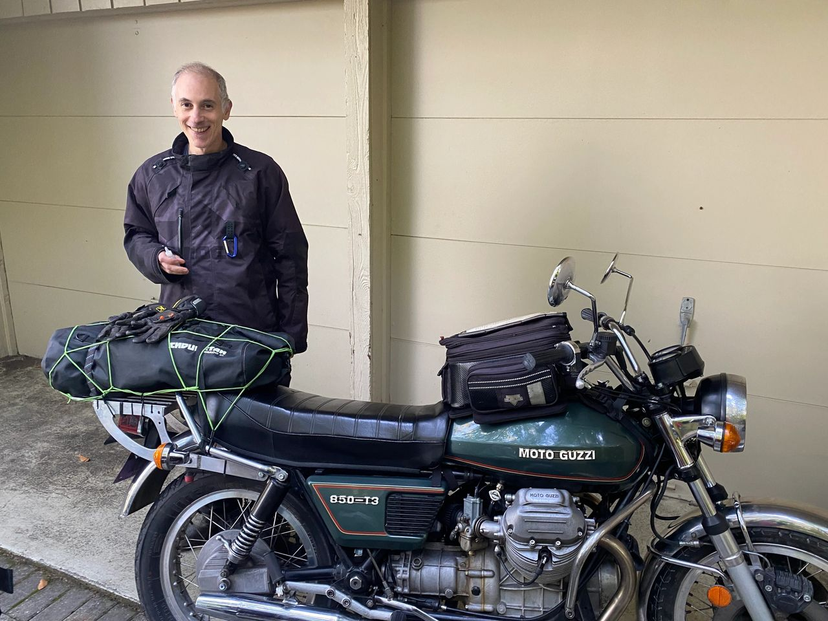Mike with his Moto Guzzi 850
Each bike was fitted with a luggage rack or pillion seat that could accomodate a medium size bag. We loaded our bags onto our bikes and received brief individual introductions to our vintage steeds. The idea with this ride was that every 75 miles, we would switch bikes with the person behind us, passing along the quick tutorial we were given, but leaving our luggage on our original bike. This way, we would all rotate through each bike more than once over 4 days.

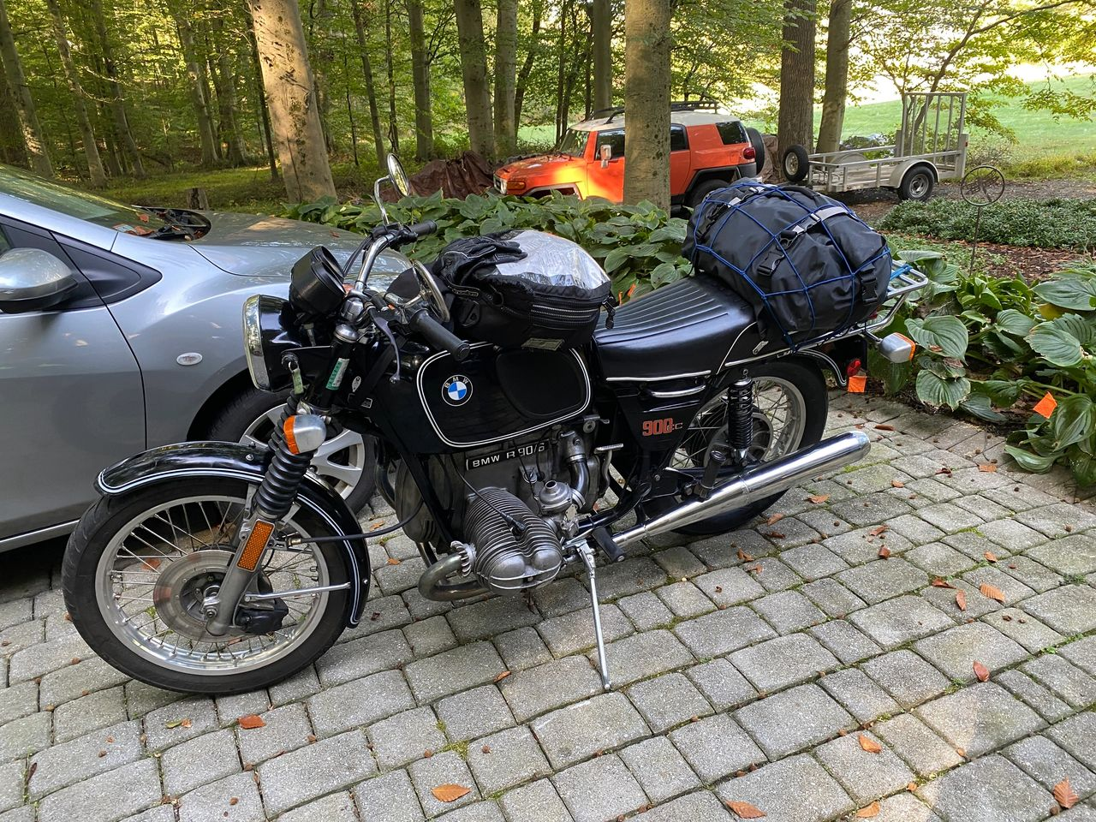1974 BMW R90/6
I have been on several motorcycle tours and rides, but leaving Joel's driveway on a cool fall morning in a group of vintage bikes was a completely new experience. The bikes warmed up as we navigated out of town and onto some incredibly smooth and beautiful Pennsylvania back roads. Straight sections led to long sweeping turns, which led to twisties though woods and along streams with the scent of fall leaves in the air. Every turned seemed better than the last. Each bike had its own unique sound and feel, lending to an experience that really focused on the riding experience, rather than speeding from one destination to the next.
Our small band of vintage motorcycles received several looks and thumbs up as we cruised through the countryside. Joel had an excellent marketing strategy in handing all of us 5 business cards each at the beginning of the tour, and encouraging us to talk to people at our stops and hand out the cards when they asked about the bikes. We made a competition of seeing who could hand out the most cards, and Gina and I became cutthroat guerilla marketers, battling to get cards into people's hands as soon as they even approached us.

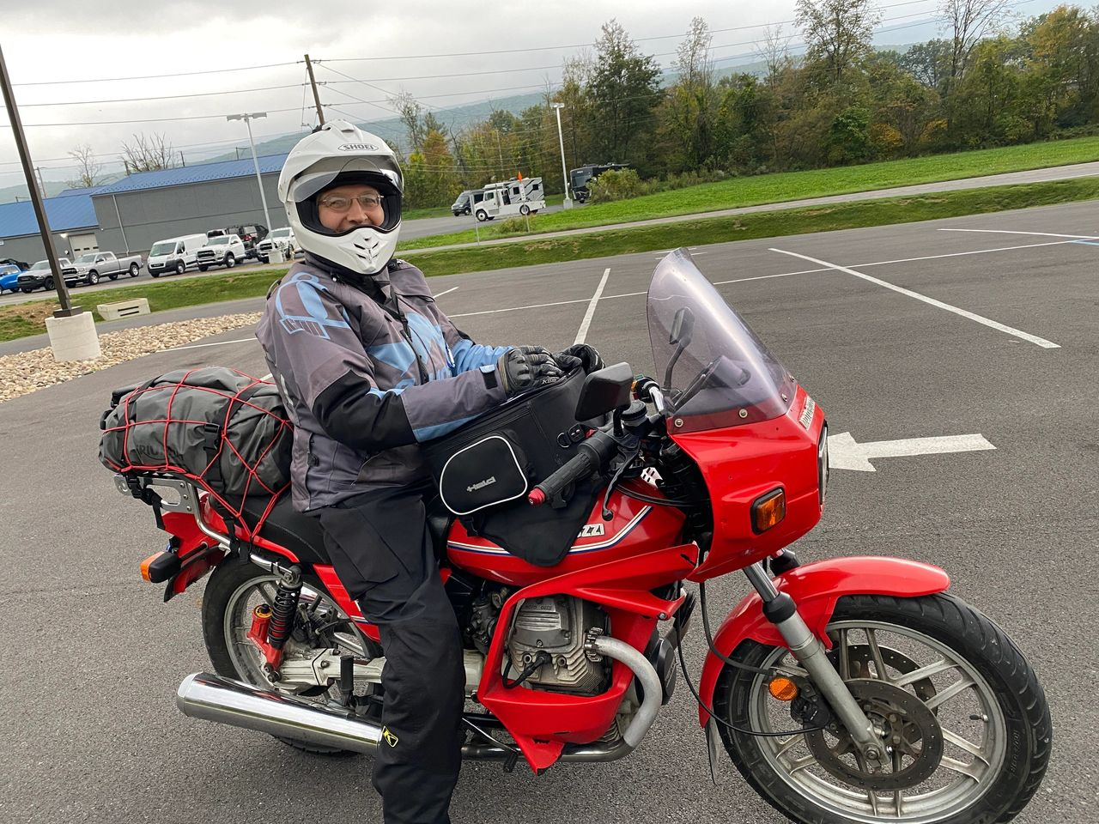Gina riding the Moto Guzzi V65
We spent the first night in a very unique Air BnB at a "Bison Farm". Day two was a wet, but scenic ride to Coudersport, PA, where we went out for dinner and a movie at a very cool old movie theater with a brightly-lit marquee outside and vintage curtains over the screen inside. Day three took us to the main destination of the ride, the Kinzua Skywalk, an old, long railroad trestle that was partially destroyed by a tornado. Locals turned the tragedy into an opportunity, but converting the standing part of the structure into an elevated walkway with a viewing platform at the end overlooking the destroyed trestle section and beautiful fall colors at this time of year.
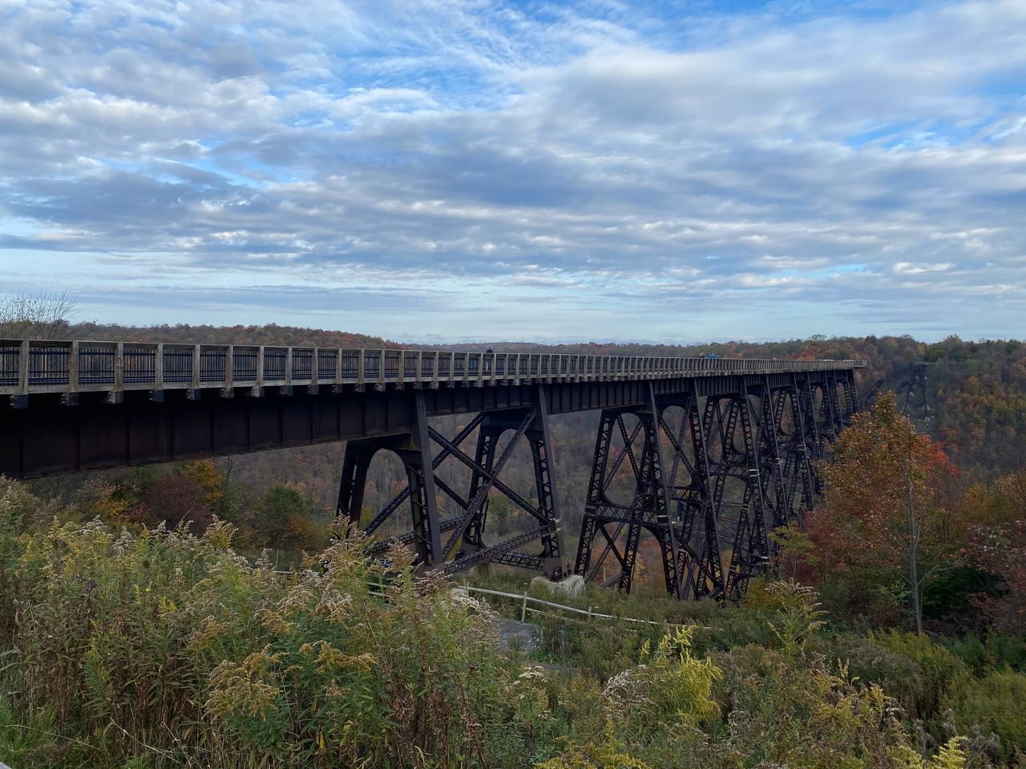The Kinzua Skywalk
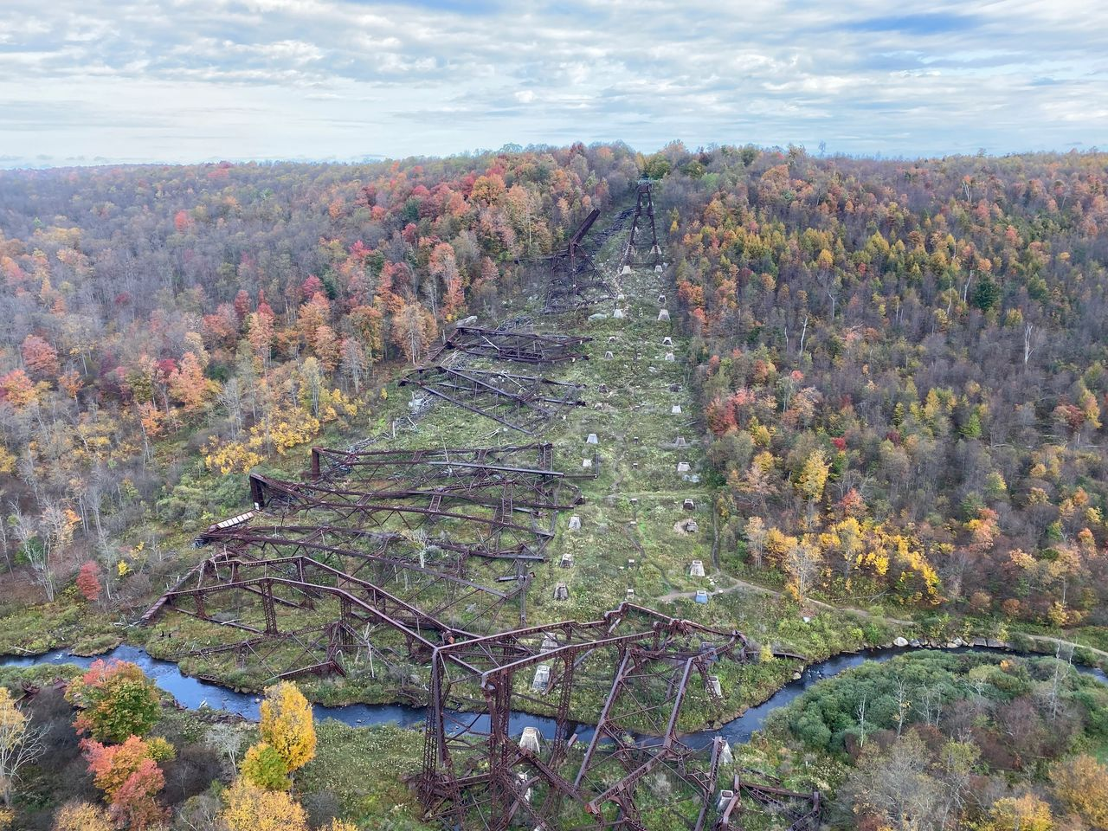Wreckage of the old trestle
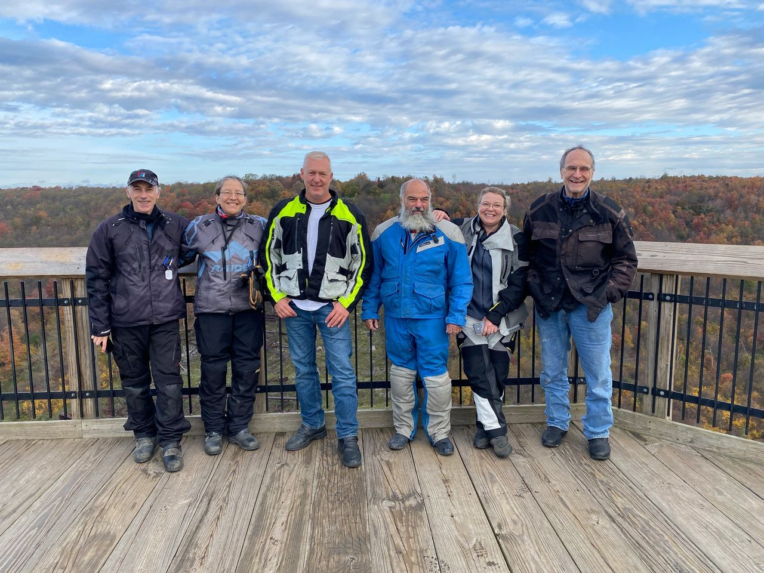The Gang
We spend the third night in Hershey, PA, touring the local transportation museum on the morning of day four, before making our way back to Casa Samick for another wonderful meal prepared by Chef Lynn. My final morning in Pennsylvania found me in the sidecar of Joel's BMW rig as he piloted me back to the train station.

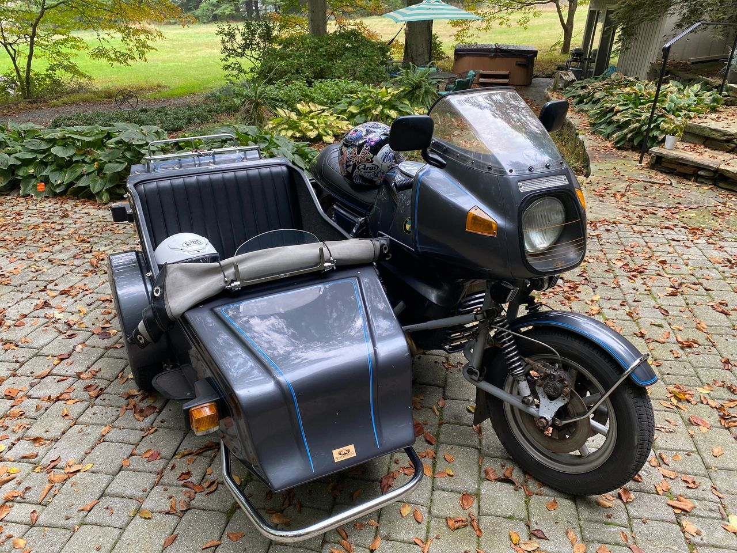
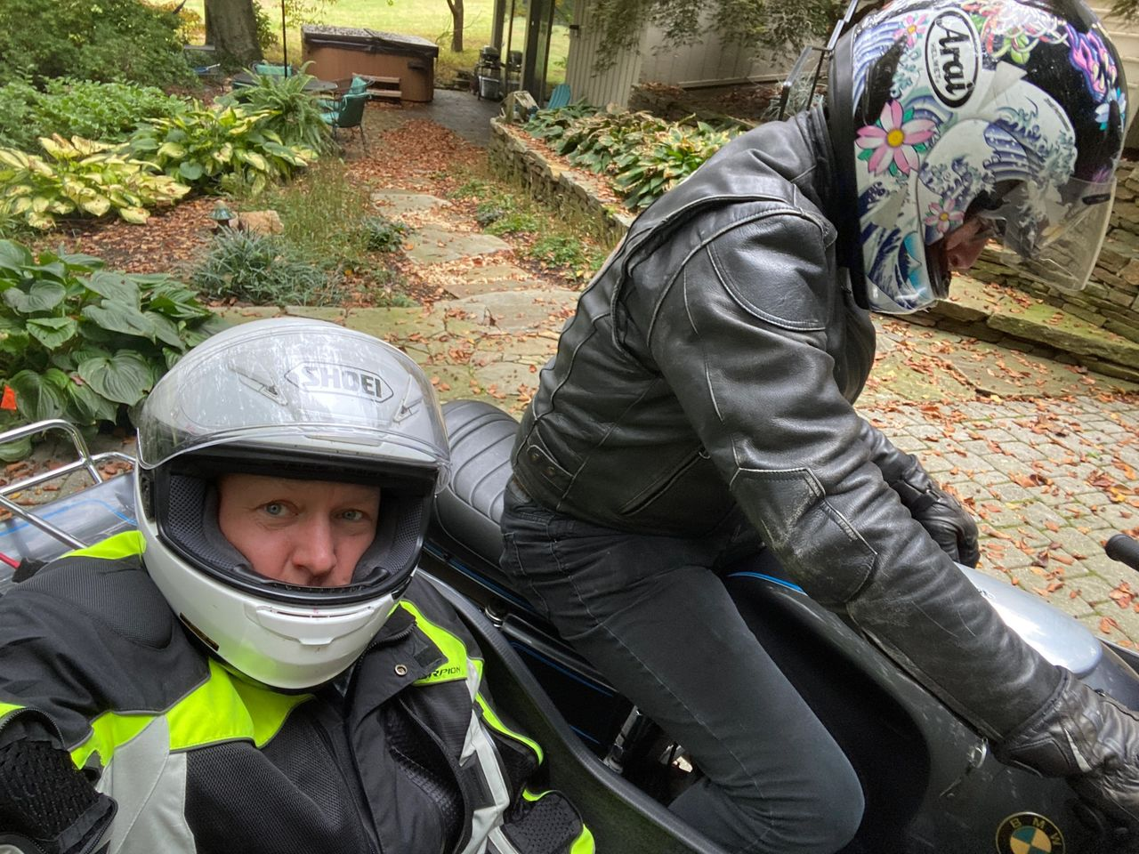Getting a ride back to the train station
All of the bikes were a blast to ride. Each had its own personality and quirks. The 2 Moto Guzzis were definitely a standout, with their unique sound and cool design. The little V65 with its full fairing was a blast to ride. The Suzuki GS550ES was also a ton of fun in a smaller displacement motor. I liked riding the R90 so much that I haven't been able to stop thinking about adding an airhead to my collection since the tour.
All in all, this was a fantastic experience that I would highly recommend to anyone who has a love or appreciation of vintage motorcycles. The ride had a "visceral" feel…just a motor and two wheels with none of the distractions of modern technology. It was motorcycle riding the way motorcycle riding used to be. Aside from that, there was a real "cool factor" to riding these bikes. Joel was a fantastic leader. The routes were well planned and interesting. Lynn was a gracious host. Mike, Gina, John and Robin were all great riding partners. I can't wait to get a chance to head back to Pennsylvania for another ride!
Check out the Retro Tours website for more information on Joel's rides and bikes at www.retrotours.com!

