MAYOR AND COUNCIL

GARY JAYNE, MAYOR
MARGARET GASSINGER, MAYOR PRO-TEM
RICHARD RONAN, COUNCIL MEMBER, SECRETARY
ROBERT CESTONE, COUNCIL MEMBER
JOHN FIELDS, COUNCIL MEMBER
JAY HEADMAN, COUNCIL MEMBER
BONNIE LAMBERTSON, COUNCIL MEMBER

PLANNING COMMISSION

SUE ALLENSPACH
TOM BAKER
JOAN DeSANTIS

JOHN SPEER
RON WUSLICH, CHAIRMAN

TOWN STAFF

MELVIN CUSICK, TOWN MANAGER
DELORIS A. BURBAGE, TOWN CLERK

JOE VOGEL, CODE ENFORCEMENT CONSTABLE
RENEE McDORMAN, FINANCIAL ADMINISTRATOR
PAM SMITH, ADMINISTRATIVE ASSISTANT

OFFICE OF STATE PLANNING

CONSTANCE C. HOLLAND, AICP DIRECTOR

TOWN OF SOUTH BETHANY

COMPREHENSIVE PLAN (CP) FOR YEAR 2006

TABLE OF CONTENTS
Page
VISION STATEMENT FOR THE CP FOR YEAR 2006………………… 4

INTRODUCTION…………………………………………………………… 6
South Bethany Website………………………………………………. 5
The 2000 Comprehensive Plan………………………………………. 7

GOALS OF THE YEAR 2006 CP ………………………………………… 8
IMPLEMENTATION STRATEGIES……………………………………….. 9

SUMMARY OF THE SURVEY OF TOWN PROPERTY OWNERS………… 11

TOWN PROFILE……………………………………………………………….. 13

Location …………………………………………………………………. 13 History…………………………………………………………………… 13
Weather and Climate…………………………………………………….. 15

SOUTH BETHANY TODAY…………………………………………………… 17

Population Housing And
Educational Attainment………………………………………………….. 18
Economic Profile…………………………………………………………. 23
The Effects of Changing Demographics Within South Bethany…………. 26
Surrounding Areas………………………………………………………... 26
Implications………………………………………………………………. 26

LAND USE PLAN……………………………………………………………… 29

Small- Town and Beach Resort Character……………………………….. 29
Land Use………………………………………………………………… 29
Annexation and Surrounding land Uses………………………………… 31
Surrounding Areas………………………………………………………. 32
State and County Development Philosophy and
Intergovernmental Relationships…………………………………. 33

ENVIRONMENT, RECREATION, AND OPEN SPACE…………………….. 34

Environment………………………………………………… 34
Stormwater Management…………………………………… 36 Recreation…………………………………………………… 36
Beach Issues…………………………………………………. 37
Cleanliness…………………………………………………… 37
Replenishment……………………………………………….. 38
Beach Accessibility………………………………………….. 39
Canal Dredging And Maintenance…………………………… 40
Wetlands……………………………………………………... 42
Town Hall and Police Facilities……………………………… 42

TOWN FINANCES…………………………………………………. 43
Revenues……………………………………………………... 44

STREETS AND PARKING……………………………………………. 46
Drainage……………………………………………………….. 46
Speed…………………………………………………………… 46
Evacuation Routes……………………………………………… 46
Landscape………………………………………………………. 47
Parking………………………………………………………….. 47
PUBLIC UTILITIES……………………………………………………. 48
Public Water Supply……………………………………………. 48
Wastewater……………………………………………………… 49
Electricity……………………………………………………… 49

WITH WHOM DOES SOUTH BETHANY NEED TO WORK?……… 51

WHAT CAN SOUTH BETHANY CONTROL?…………………………. 53

PRIORITIES……………………………………………………………… 54

ENFORCEMENT………………………………………………………… 56

CLOSING…………………………………………………………………. 57

ARIAL PHOTOS AND MAPS

APPENDIX A – PUBLIC OPINION SURVEY
APPENDIX B – JUNE 8, 2005, LETTER FROM MAYOR JAYNE TO
PROPERTY OWNERS
APPENDIX C – LIST OF PUBLIC UTILITIES
APPENDIX D – ANNEXATION RECOMMENDATIONS
APPENDIX E – MAP-STORMWATER DRAINAGE AREA

VISION STATEMENT FOR THE

COMPREHENSIVE PLAN (CP) FOR YEAR 2006

To develop the Town into a well-maintained, law-abiding, and single-family community serving residents and visitors with an infrastructure committed to the enhancement of a safe, healthy and attractive lifestyle, while preserving and improving the Town's natural and man-made assets.

SOUTH BETHANY WEBSITE
The Town of South Bethany developed a web page in 2001. The website contains a wealth of information which is updated on a daily basis. Efforts are made to bring property owners the most up-to-date information about their Town as soon as possible.
The pages listed on the website are as follows:
Home Page
Calendar of Events
Mayor and Council
Administrative Staff
Town Council Meetings
Bulletin Board
General Information
History
Local Links
Election Information
Police Department
Beach Patrol
Forms
Hurricane Information
Contact Town Hall

In addition, there are local links which include:

Delaware Air National Guard
State of Delaware
The News Journal
The Coastal Point
Sussex County
Artesian Water
Bethany-Fenwick Chamber
The Wave Newspaper
Delaware Beachcomber

The Website address for the Town of South Bethany is: www.southbethany.org

COMPREHENSIVE PLAN FOR
SOUTH BETHANY, DELAWARE
2006
INTRODUCTION
This Comprehensive Plan (CP) is intended to serve as a guideline for the future development of South Bethany. It has been adopted by the Town Council and is given official recognition as a guide for future planning efforts as a considered reflection of the wishes of the community and its representatives. The legal means for the implementation of the goals and objectives of this plan are included in zoning codes and other municipal codes and ordinances. This plan is a flexible guideline, and the updating or revision of planning goals and objectives is essential to keep the planning program responsive to the changing needs of the community. The public’s understanding of the role and contribution to the efforts of the Planning Commission are needed to keep the community’s best interest aligned with the Town’s growth and development plans for the future. Community interest and cooperative commitment to practical planning and the timely implementation of the goals and objectives of Comprehensive Planning will contribute to a higher quality of life in South Bethany.
The plan is also an informational document for the public. Citizens, business people, and government officials can turn to the plan to learn more about South Bethany’s policies for future land use decisions. Potential new residents can use the documents as an informational resource about the Town, including its characteristics and facilities, to help them make decisions about moving to South Bethany. This document contains the most current information on population, housing, and the environment, which may be of interest to land developers, economic-development professionals, and others.
The Comprehensive Plan is a legal document. The Delaware Code specifies that “…any incorporated municipality under this chapter shall prepare a comprehensive plan for the city or town or portions thereof as the commission deems appropriate.” The code further specifies, “after a comprehensive plan or portion thereof has been adopted by the municipality in accordance with this chapter, the comprehensive plan shall have the force of law and no development shall be permitted except as consistent with the plan” (ξ 702, Title 22, Delaware Code).
This CP contains administrative recommendations to implement the 2006 CP and to address additional issues raised by property owners. This document updates information in the 2000 plan and refines the recommendations based on subsequent input from property owners.
The 2000 Comprehensive Plan
The previous CP was adopted in the fall of 2000 and contains a review of conditions current at that time and recommended guidance and actions. The plan recognized changes taking place in the Town as more full-time residents moved into the Town and as current part-time residents were converting to full-time residents. The plan also recognized the increasing development in the surrounding region and those effects on the Town. The plan served as a guide for the future development of the Town. A summary report of the 1999 survey of property owners is included as an appendix to this plan. (See Appendix A).
The Planning Commission began updating the 2000 CP on April 12, 2005.
.

Goals of the Year 2006 CP
- Maintain and improve the appearance of the community.
- Maintain the single-family nature of the community.
- Maintain and improve the canals to promote water quality and usability.
- Maintain, restore, and improve beach appearance.
• Provide high quality public utilities to Town residents.
- Maintain a full-time, year-round police department.
- Improve access to emergency health care.
- Provide Town services in a customer- friendly manner.

Implementation Strategies
- Town Administration and Capital Improvement
- Maintain and improve sound financial and budgeting practices to ensure proper operation and maintenance of public services.
- Evaluate improvements in municipal facilities.
- Use best management practices to improve municipal services.
- Planning and Zoning
- Maintain single-family community character of South Bethany. All vacant properties are currently zoned for single-family homes.
- Ensure rigorous and uniform enforcement of codes and ordinances.
- Improve the appearance of the Town through voluntary improvement of commercial properties and adding plantings along major roadways.
- Recommend against annexation, except as noted in the Annexation and Surrounding Land Uses section of this CP.
- Modify Code to require garbage can bins throughout the Town.
- Continue regional relationships such as Sussex County Association of Towns
- Make efforts to improve access to emergency health care.
- Initiate and maintain significant Town beautification efforts.
Infrastructure
- Monitor public utilities to ensure highest quality.
- Evaluate placing all above-ground utilities underground.
- Where feasible add pedestrian walkways and bikeways throughout Town.
- Improve stormwater management and drainage throughout the Town.
- Evaluate road elevation and propose improvements.
- Improve evacuation routes.
- Improve appearance along East end of Route 1 adjacent to
homeowner’s property lines.
- Install a fence at the East end of the Anchorage Canal similar to the fence
around the perimeter of the retention pond.
• Environment, Recreation and Open Space
- Dredge canals as appropriate to improve overall water quality and navigation.
- Preserve Town-owned wetlands.
- Continue to request and obtain funding for beach replenishment.
- Maintain beach cleanliness and safety.

SUMMARY OF THE SURVEY OF TOWN PROPERTY OWNERS

An extensive survey instrument was developed in 1999 by the University of Delaware Institute of Public Administration (IPA) in collaboration with the Town of South Bethany CP Committee. The survey instrument was designed to solicit South Bethany property owners’ opinions and priorities related to a wide range of community issues. Several open-ended questions were included to ensure that the survey respondents could bring any issues, which may not have been anticipated during the design of the instrument, to the attention of the committee.
The 1999 survey of Town property owners is summarized in the background report entitled "Comprehensive Plan Public Opinion Survey." The findings of the survey were consistent with guiding principles of the CP of 1995 and reflect the general belief that the property owners would like to see the Town of South Bethany remain a single-family, home-resort community with improvements to transportation, public safety preparedness, governmental services, and environmental conditions. The survey demonstrated that the property owners share the belief that development pressures have increased in the last five years and that the resulting traffic and congestion reduce the quality of life within the Town and surrounding areas. The property owners value the family atmosphere as well as peace and quiet within the community based upon the 1999 survey. They also want to see environmental conditions improved through the cleaning and dredging of the canals.
Additionally, a proposed list of goals and objectives to be included in the 2006 CP was mailed to property owners in June of 2005 asking for their input (see Appendix B). Also, a public meeting was held to review the proposed 2006 CP prior to its completion.
The question of development within and surrounding the Town forms an important part of this update of the CP because of the rapid pace of development in southeastern Sussex County. The survey respondents indicated that the pace of development was an issue. The use of annexation was only seen by half of the respondents as a proper course of action for the Town. The use of strict guidelines was important to the community in order to prevent unintended consequences. Higher taxes and reduced services were two reasons seen by property owners why annexation might be a poor path. Planning and land use are important issues. Additionally, enforcement of building and zoning codes concern a large portion of the property owners.
The environment and quality of life issues that concern the property owners are consistent with the primary objectives and activities of South Bethany. Property owners are concerned about the cleanliness and long-term replenishment of the beach, the canal water quality, and usability of the canals that serve their community. The respondents view these issues as important enough to be addressed. The respondents were also concerned about evacuation routes during storm events, general transportation issues, and bicycle and pedestrian access. Also, property appearance, maintenance, and beautification are important issues.
TOWN PROFILE

Location
The Town of South Bethany is located in the southeastern part of Sussex County, Delaware, between the Atlantic Coast and Little Assawoman Bay and Assawoman Canal. The towns near South Bethany are Bethany Beach, Ocean View, Millville, and Fenwick Island. State Rt. 1 bisects the Town from north to south. There are unincorporated parts of Sussex County adjacent to the Town’s borders.

Town History

South Bethany was originally part of a land patent known as South Petherton, granted in 1695. In 1926, George McClellan, a resident of Long Island, New York, purchased four adjoining land tracts totaling 140 acres and conveyed them to the Delaware Shore Land Corporation. In 1952, Mr. and Mrs. Richard Hall purchased about 130 acres from the Delaware Shore Land Corporation and called the land “South Bethany”. By 1959 there were 500 property owners throughout South Bethany. Mrs. Hall initiated a move for incorporation without success. After moving into his house on S 4th Street and Ocean Drive, Jim Cleveland, with the help of some other residents including Mae Felerski and Lew Jarrell, organized the first association to address community needs. The meetings were held in Mr. Cleveland’s garage. In 1962 there were 37 homes built directly on the dunes when South Bethany was severely disrupted by an exceptionally destructive storm in March.
In December, 1965, Governor Terry signed the bill for incorporating South Bethany; however, the Town was not ready. Jim Cleveland and others, including Newt Porter, Bob Terrill and Jack Williamson, drafted the incorporation papers. In April, 1966 the first Charter was presented for Town referendum and was firmly defeated. Finally, in 1969 the Charter was accepted by referendum, and on June 18 Governor Russell Peterson signed Senate Bill 246 providing for the incorporation of the Town. The first election was held for seven commission seats, and Jim Cleveland was elected the first Mayor. A few years later, a short street on the bayside toward the north end of South Bethany was named “Cleveland Drive” in honor of Mr. Cleveland’s commitment to the Town. Mae Felerski, a devoted citizen, helped to establish a Town government, became Town Clerk, and held Town Commission meetings in her living room. By then South Bethany had 240 homes, 496 property owners, and a year-round population of 15 families. In 1971 Harry Nelson became South Bethany’s first police Officer, and on June 18th the first Lifeguard crew of Captain Roger Knox and Lifeguards Ron Clausen and Granny Grant set up their freshly painted white towers on South Bethany’s beach.
In 1972 York Beach and Paradise Shores were annexed to South Bethany, and Sussex County placed a moratorium on building permits within 1,000 feet of the ocean in an attempt to ensure restoration of the primary dune. Also, in 1972 installation of the public sewer began. In 1977 South Bethany received a federal grant to build a Town Hall on land donated by Mrs. Hall, traffic lights were installed at each end of Town, and the sewer system was completed. In January, 1981, the Delaware Supreme Court cleared the way for renewed beach development, lifting the moratorium on permits for construction on the dune. In August, 1983, the South Bethany Beach Property Owners Association was formed, and South Bethany’s population grew to 1,282 pieces of property, 748 houses, and 105 year-round residents. In the mid 1980’s a beach replenishment program was initiated giving South Bethany an engineered beach to recover sand lost during major storms.
On November 19, 1987 the area known as “Cat Hill” became part of South Bethany.
On March 22, 1992, 22 acres of wetlands were conveyed to the Town from Cat Hill.
Located within Cat Hill is the historic “Cat Hill Cemetery”. Buried there are the remains of several prominent Delaware families that were instrumental in the early development of Sussex County.
In 1998 the Town entered into an agreement with Artesian Water Company to put water lines throughout the Town and a water tower on Town Hall property at which time the Town obtained clear title. Also at that time, Chesapeake Utilities installed lines adjacent to the water lines in anticipation of one day being able to provide South Bethany residents with propane gas provided by Sharp Energy. In 2004 an underground gas storage facility was installed behind the Town Hall.

Weather and Climate
South Bethany is located in the mid-latitudes of the east coast and is primarily influenced by migratory weather patterns from the west. This weather pattern is variable. Air masses that influence South Bethany are primarily maritime tropical during summer and continental polar in winter. Over 40% of the low-pressure areas in the U.S. pass directly northeastward, close enough to influence weather conditions locally. The general climate is mild. Summers are warm (typically, July is the hottest month with a maximum afternoon temperature average of 85F) and humid with only a few brief hot, humid periods. Winters are cool to cold with small amounts of snow. The mean annual temperature has varied from 55- 58 degrees F with no significant change measured during the last 75 years.
Precipitation averages about 42 inches for the year, which is well distributed, ranging from ½ inch to between 5 and 7 inches reported monthly. Severe thunderstorms usually occur between May and August. The ocean temperature is controlled primarily by air temperature. The temperature of the ocean off the coast of South Bethany varies from 33 – 38 degrees F in the winter to 70 – 75 degrees F in the summer. The depth of South Bethany’s coastal waters varies from ten feet, near the shore, increasing gradually to 60 feet in the offshore shipping lanes.

SOUTH BETHANY TODAY
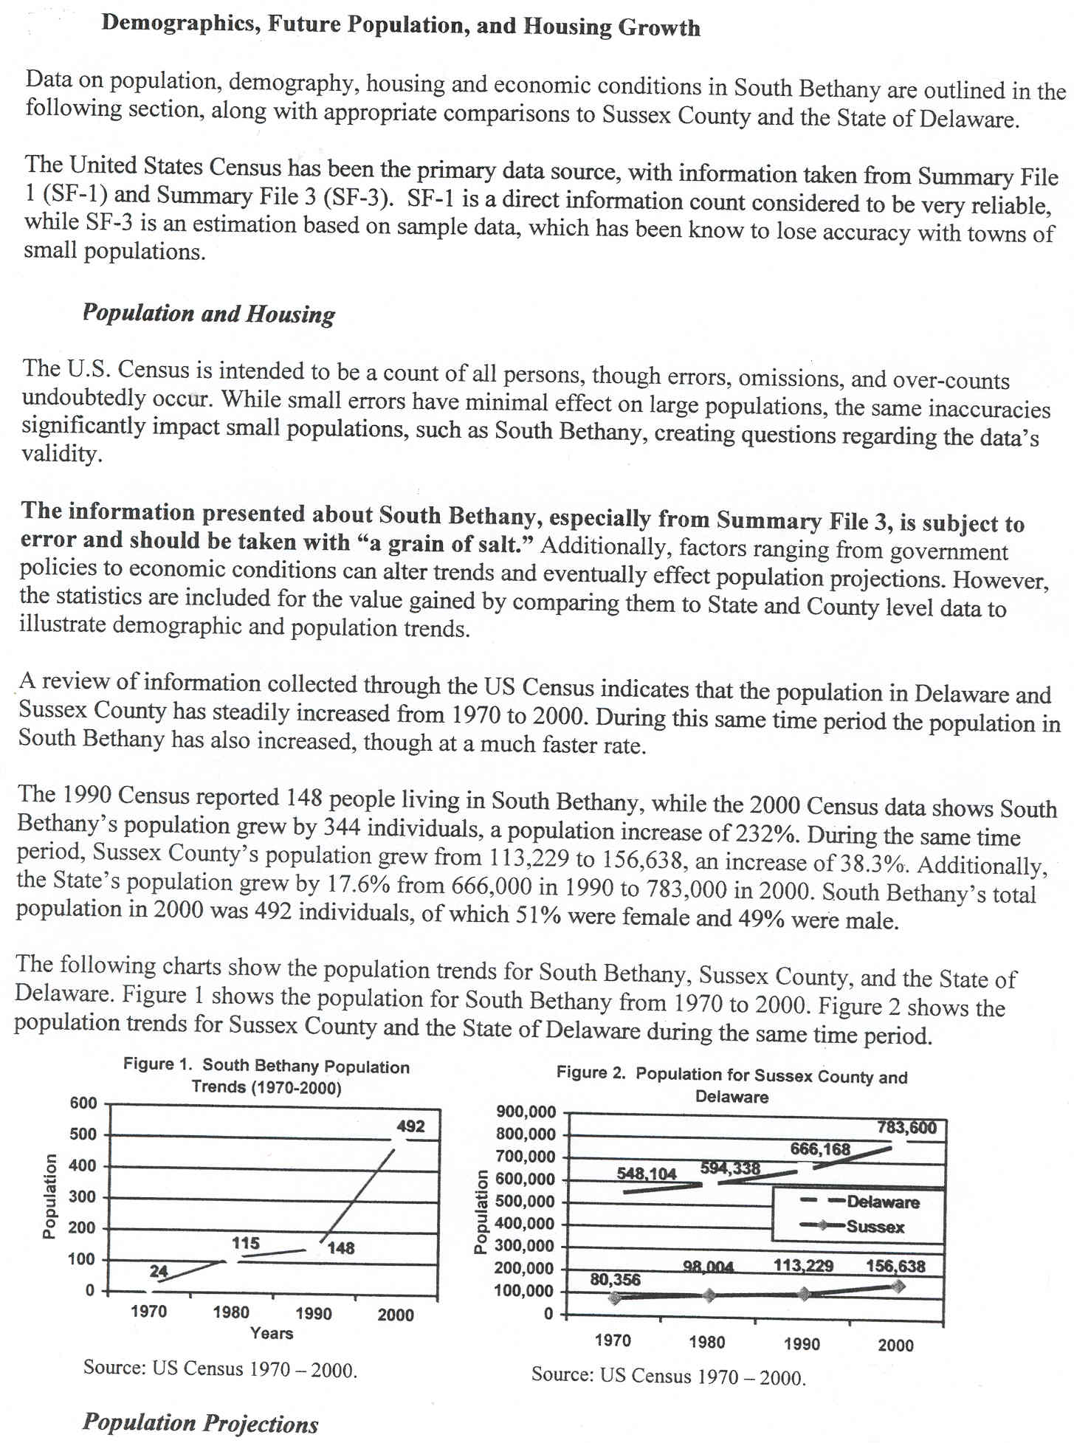
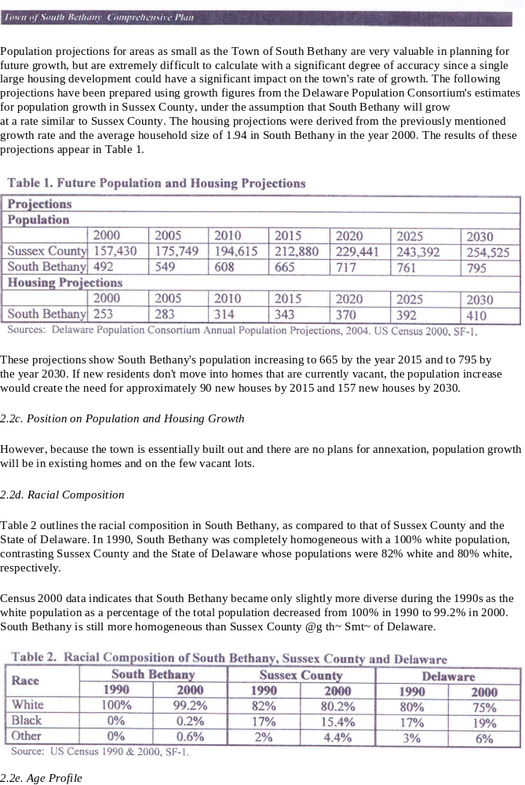
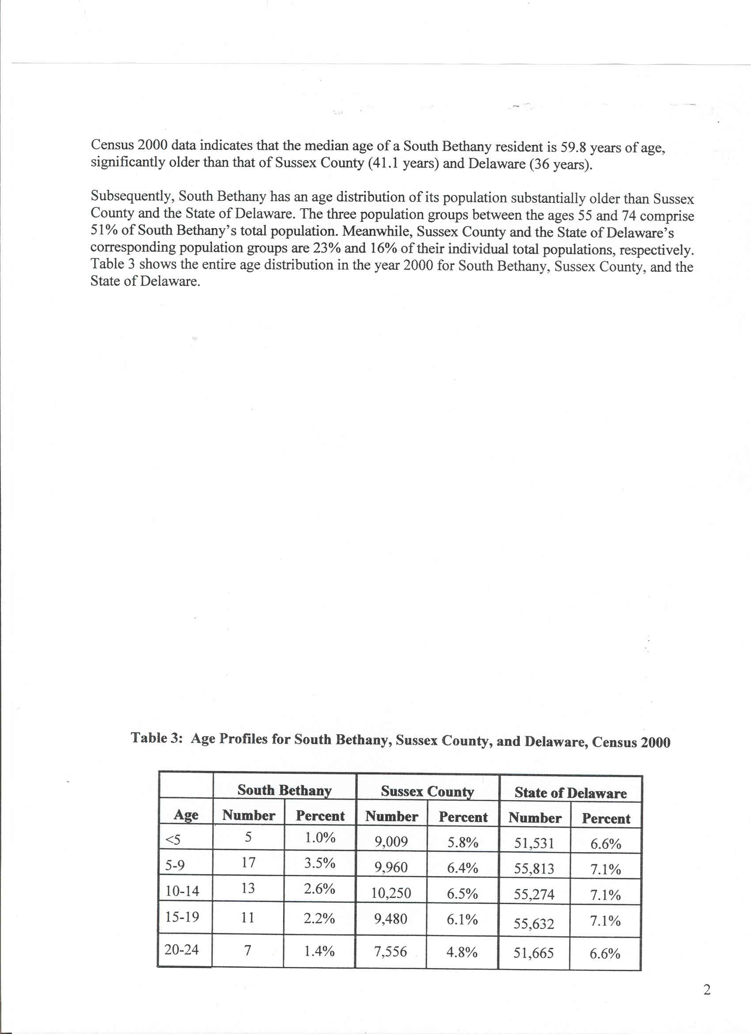

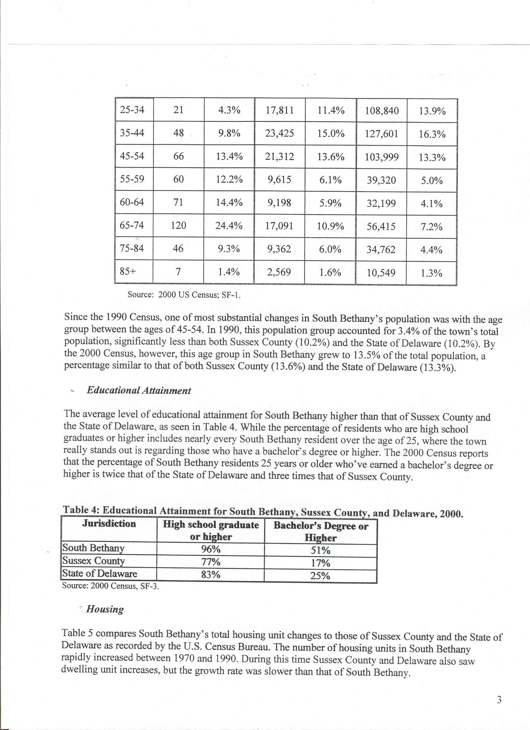

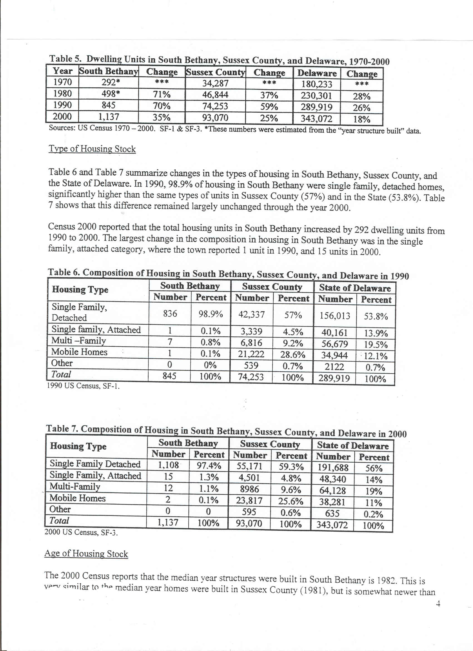

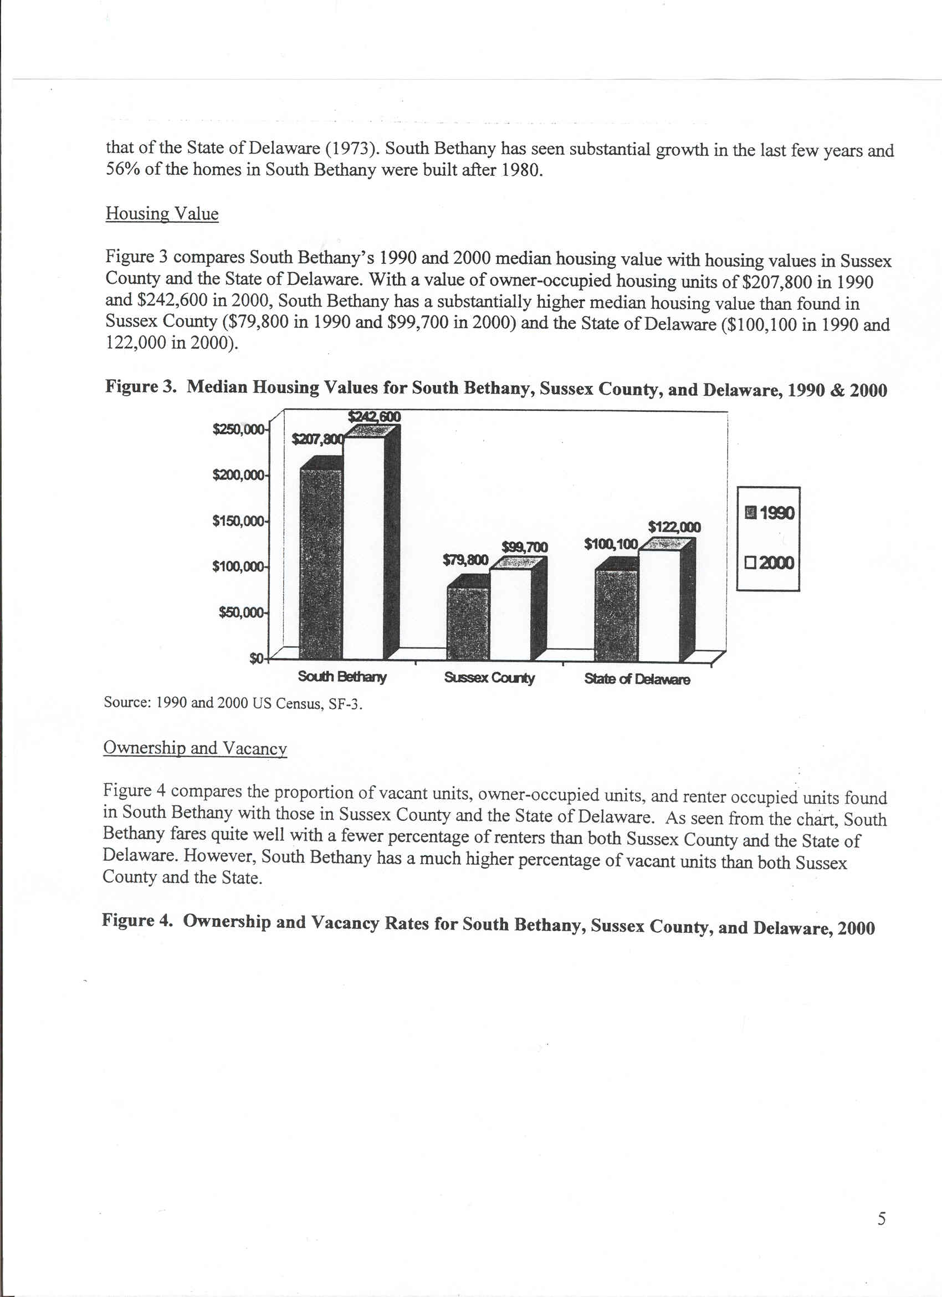
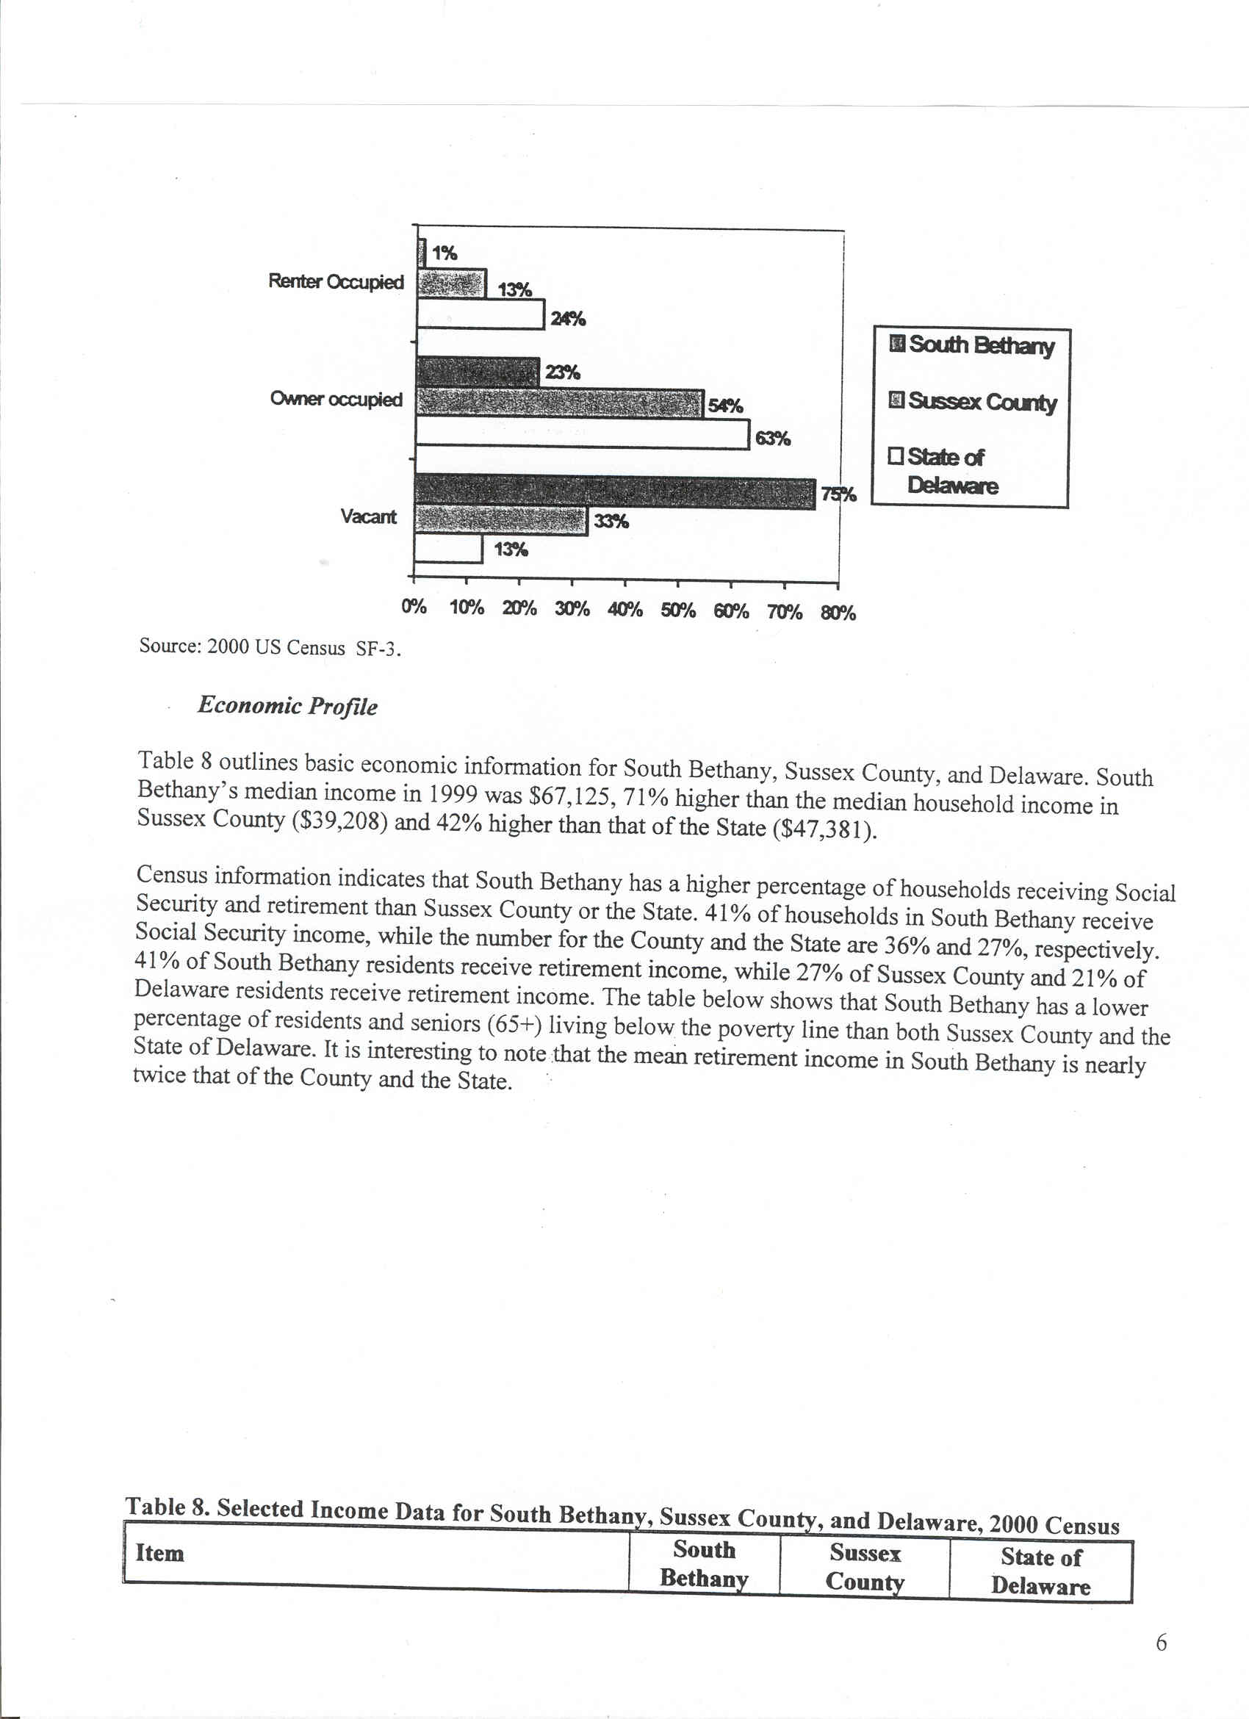

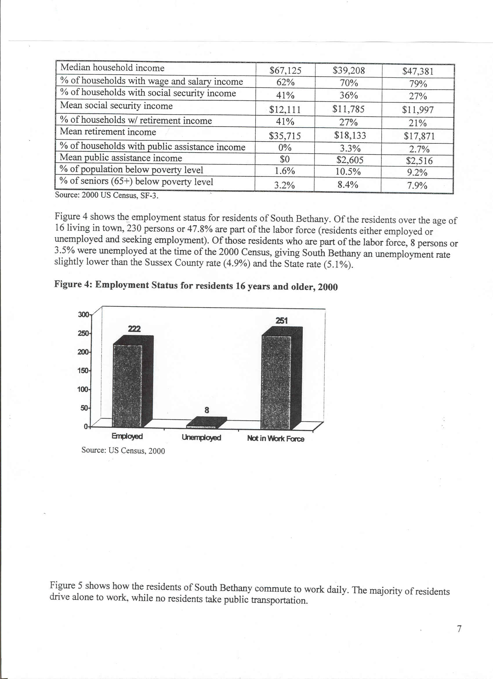

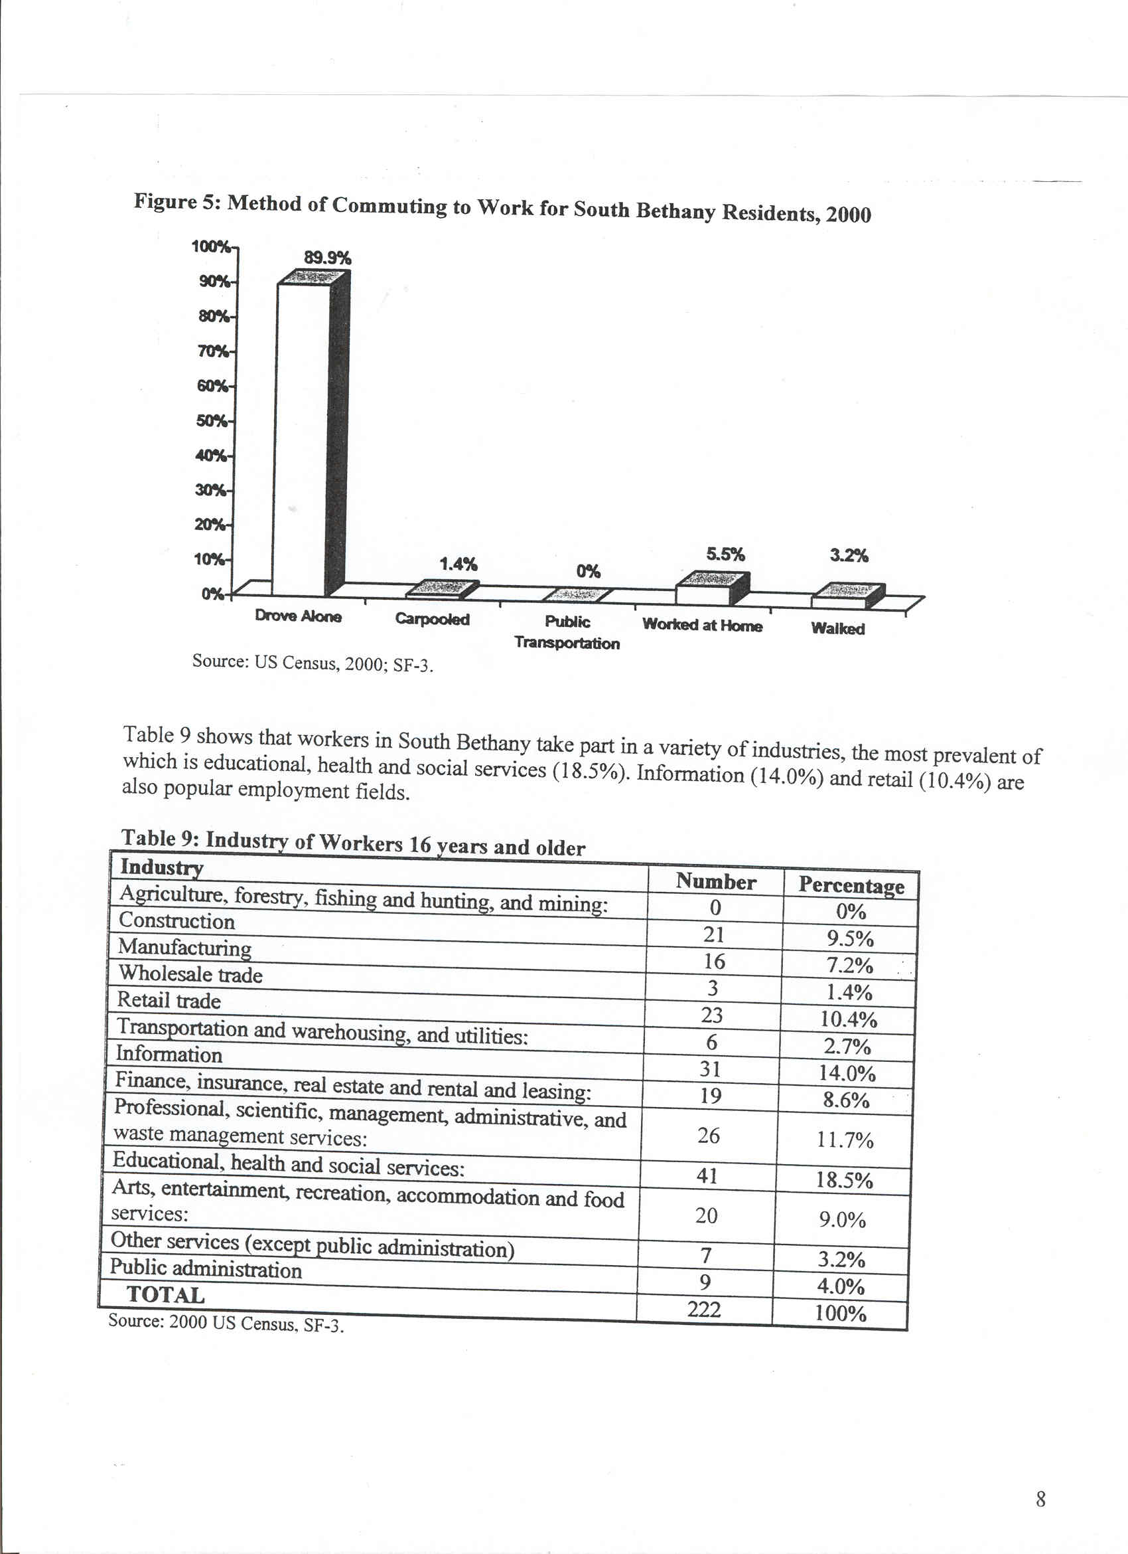
The Effects of Changing Demographics Within South Bethany
The Town has experienced a steady level of build-out over the past ten years. At present, the Town is over 90% built-out. All land has been subdivided into single, residential lots with a small number of two-lot parcels. The Town’s only commercial zone consists of 1.86 acres. Thus, land use within the Town is fixed and the pattern for growth is known. The population growth caused by year-round resident increases will be greater than any population growth resulting from increases in the number of housing units.

Surrounding Areas
In the past five years, the area west of Town has been rapidly developing. Major single-family home developments have already affected the character of South Bethany with many more homes and people to come. Development in the Ocean View area will bring another 2,000 plus homes to the South Bethany area. Also projected are 2,200 new homes west of Fenwick Island. The South Coastal area is now one of the two fastest growing areas in the State.

Implications
The beach is a major draw for people moving to the area as seasonal and year-round residents. South Bethany and surrounding beaches have experienced overcrowding conditions compared to historical trends during recent summer weekends. The number of people visiting and living near the shore will increase. The areas surrounding South Bethany, those east of U. S. Rt. 113, are designated for development in the County Land Use Plan. Their build-out will further exacerbate beach overcrowding.
These trends will require additional municipal services such as parking, road maintenance, lifeguard services, and beach maintenance. The rapid increase in summer and year-round population has stressed local road capacity and evacuation plans for storm events, which will need to be updated. In the area west of Rt. 113, the effort of Sussex County has been to attract high-paying jobs to bolster the healthy agricultural and resort/vacation economies in the area, thereby stressing the aforementioned services further.
LAND USE PLAN

Small Town and Beach Resort Character
The 1999 survey clearly indicated the property owners of South Bethany want to maintain the Town as a single-family community with no expansion of the commercial district. Also, there is a limited interest in annexation, as they prefer South Bethany to remain a small community. The majority of property owners came here because of the beautiful beach. They want to continue to enjoy free access to the beach and maintain high water quality in the canals. The property owners are concerned about the extensive growth taking place outside the Town limits of South Bethany and encourage the Mayor and Council to maintain the single-family character while minimizing further intrusion from developments outside of Town.
The property owners prefer South Bethany as it exists with strict enforcement of all zoning codes, thereby fostering a simple, safe, and small-town atmosphere. There appears to be little interest in increasing or passing of new ordinances that would make South Bethany more like a big city than a small, peaceful, and quiet community. Many people originally purchased a second home in South Bethany with the intention of relocating to this area.

Land Use
The nature of land use planning in South Bethany has been defined by the Town Charter. The Articles of Incorporation for the Town and the Town Charter specifically state that South Bethany shall be a single-family, residential community. Almost 75% of the respondents to the 1999 Property Owners Survey continue to support this position.
The Town has adhered to its original subdivision plan, and thus, the precedence has been established for South Bethany to allow only single-family housing units. Almost all the Town is zoned R-1, single-family, detached residential. The Planning Commission has mapped the Town and found a total of 1,328 building lots in the Town (Ocean side 293, Bayside 1035). Of those, 128 remain undeveloped (Ocean side 12, Bayside 116). The timetable for total build-out of the Town cannot be predicted, as new building varies with the general economy. Many of the original homes in Town, dating to the 1960’s, are being replaced with multi-level, single-family dwellings.
The Town needs to be vigilant that current zoning ordinances are being enforced. Additionally, the Town needs to be aware of a phenomenon, which is occurring in the suburbs of nearby metropolitan cities, whereby a single buyer is grouping lots and very large houses are being built. Ordinance 122-03 was passed in 2004 which limits the size and the character of single family residential dwellings.
There is one parcel in the C-1, commercial zone. Although the current zoning ordinance describes the types of businesses permitted, it does not set specific square footage requirements. Inasmuch as this commercial district has brought issues to the Town Council, the committee recommends that Paragraph 145-36 of the South Bethany Code be modified to limit the use of this commercial parcel such that all future uses shall be limited to the existing square footage. The plan recommends changes that detail the maximum lot coverage which now exists, make the existing floor area the future limit to be developed, determine a minimum number of separate commercial establishments on the property, set the parking requirement to the existing parking, and change the height limit to the current building height.
The Town has five areas of public space as follows: The beach, canals, Town Hall complex, Town park, and wildlife preserve west of Canal Drive. The first three items are addressed in the environmental section of this report. The Town park and the nature preserve should be maintained as outlined in the donors’ wishes; i.e., a park and wildlife preserve. The Town should monitor the wetlands for any changes that will decrease the area’s quality. Such changes should be examined in concert with competent professionals.

Annexation and Surrounding Land Uses
The Town of South Bethany is surrounded by the Atlantic Ocean on the east, a Delaware State Park and Bay View Park on the south, the Assawoman Canal on the west, and the community of Middlesex on the north. The Town and surrounding area are in the Environmentally Sensitive Developing Area according to the 2003 Sussex County Comprehensive Plan update. While it may be possible to annex property across a body of water, the plan recommends that no annexation be considered at this time. This recommendation is based on the 1999 survey results, a review of land uses, and an examination of infrastructure and public service provisions. However, in order to provide police enforcement to improve public safety, the Town may desire to annex certain limited areas of Route One at the north and south ends of Town, ( south of and parallel to York Road, a portion of Kent Avenue and a portion of Evergreen Road). Appendix D contains legal descriptions and a map highlighting the four parcels the Town wishes to annex. This recommendation does not preclude the Town from entering into an arrangement for providing services beyond its current borders if it can do so profitably.
Arguments favoring annexation:
- Town policing and administrative service costs would be spread over a wider tax base.
- Additional control over development surrounding the Town.
- Additional control of our bay and canal anti-pollution efforts and preservation of the environment.
- Reduced taxes.
Arguments against annexation:
- Lack of harmony with existing building, zoning, and character provisions.
- A less unified community of interests (beach vs. inland points of view).
- Additional taxes.
- Requirements for additional beach parking.

Surrounding Areas
Historically, petitions for annexation throughout the State have been precipitated by the need to be included in municipal sewer systems. The County operates the sewer system in the South Coastal zone. Water service by Artesian, a private public utility, would not require annexation to a municipality. Most other services and resources, at this time, are freely available to communities in the area without the added cost of a municipal tax.

State and County Development Philosophy and Intergovernmental Relationships
Both State and County land use plans and documents advocate the clustering of development around existing municipalities in the interest of preserving farmland and natural areas and controlling the cost of infrastructure and services.
The Town has entered into an intergovernmental agreement with Sussex County, which provides for notification and participation in land use and development decisions within a mile of Town borders and reciprocally within the Town. The Town should seek to have the limit increased and a longer notification period established.
The Town participates in the newly formed South Coastal Planning Group, encompassing territory and municipalities from the Maryland line to Indian River and the ocean to Rt. 113. We participate in other regional groups, which affect South Bethany surrounds, such as:
- Sussex County Association of Towns (SCAT).
- Various inland bay committees under the auspices of the Center For Inland Bays.
- Groups formed to plan Rt. 26 and Rt. 54 upgrades and improvements.
- Association of Coastal Towns (ACT) consists of Mayors and Town Managers of Coastal Towns from Lewes to Fenwick Island.
- Bethany-Fenwick Chamber of Commerce.
- Delaware League of Local Governments – statewide issues.

ENVIRONMENT, RECREATION, AND OPEN SPACE

Environment
The protection and improvement of the environment has been recognized as an important goal by the Town of South Bethany. The CP for Year 2006 recommends the continued protection of the environment, maintaining a strong community commitment to property maintenance to ensure attainment of environmental goals, and working with State and Federal agencies to improve the environmental conditions of the Town and surrounding areas. The main environmental concerns for the Town are the water quality in the canals, the beach replenishment and cleanliness, the maintenance of the environmentally sensitive wetland area owned by the Town, and the overall regional environmental conditions.
The Town of South Bethany faces a series of environmental issues that will need to be addressed over the period of this CP. Ensuring the water quality of canals and inland bsays is crucial for continued environmental health and attractiveness of the community. The protection of the canals will come through property owner maintenance of the bulkheading along the canals, the reduction of nutrient flow from the residential properties surrounding the canals, and discouragement of feeding wildlife. Also, efforts should be undertaken to continue to eliminate external pollutant sources, such as Route One drainage into the canals. The Town must maintain its bulkheads and reduce nutrient flow from its properties

CANALS
It is worth mentioning here that the Town’s dead-end canals are the catch basin for storm water runoff from more that fifty grates located on DelDot easements adjacent to Route 1. The subject drainage area begins at the north end of Sea Colony and runs south along Route 1 to York Road. This drainage area is approximately two miles long by five hundred feet wide. A map of the stormwater drainage area is included in Appendix E
The speed of watercraft also affects the water quality. Therefore, residents should be encouraged to limit their speed and reduce the damage to the waterways.
The CP of Year 2006 recommends continued enforcement of bulkhead repair and replacement. The plan also recommends that the Town work with property owners and developers/builders of new houses to reduce nutrient and sediment flows into the canals. Furthermore, the condition of an existing bulkhead should be taken into consideration prior to the issuance of a building permit. Recommended actions include planting vegetative buffer strips along the canals, prohibition on disposal of grass clippings or other plant material in the canals, and prohibition on feeding ducks and other waterfowl. Also, during new housing construction, codes to limit runoff into the canals must strictly be enforced. In addition, the Town should prohibit the discharge from outdoor showers into the canals via direct discharge.
TMDLs
With the adoption of Total maximum Daily Loads (TMDLs) as a “nutrient-runoff-mitigation strategy” for reducing nutrients in the Inland Bays watershed, reduction of nitrogen and phosphorus loading from all land use activities within the Town of South Bethany will be mandatory. A TMDL is the maximum level of pollution allowed for a given pollutant below which a “water quality limited water body” can assimilate and still meet water quality standards to the extent necessary to support use goals such as, swimming, fishing, drinking water and shell fish harvesting. Although TMDLs are authorized under federal code, states are charged with developing and implementing standards to support those desired use goals. Provisions in Section 5.6 of Delaware’s “Surface Water Quality standards” (as amended July 11, 2004), specify that all designated ERES waters and receiving tributaries develop a “pollution control strategy” to reduce non-point sources of pollutants through implementation of Best Management Practices (BMPs). Best Management Practices as defined in subsection 5.6.3.5 of this section, expressly authorizes the Department to provide standards for controlling the addition of pollutants and reducing them to the greatest degree achievable and, where practicable, implementation of a standard requiring no discharge of pollutants.
Nutrient reductions prescribed under TMDLs are assigned to those watersheds or subwatersheds on the basis of recognized water quality impairments. I n the Inland Bays the primary source of water quality impairment is associated with nutrient run off from agricultural and/or residential development. In order to mitigate the aforementioned impairments, TMDL reduction level of 40 percent will be required for nitrogen and phosphorus, respectively. Any proposed development within the Inland Bys subwatershed will have to demonstrate (via scientifically-defensible nutrient budget calculations) that said developments will reduce nutrients to the level specified by the individual or collective TMDL(s).”

Stormwater Management
Periodic stormwater problems plague the Town. This occurs after heavy summer storms and during winter/spring storm events. It involves ponding in low areas from canal-to-canal flooding.
The Town commissioned a Stormwater Study in the 1990’s. That report should be reviewed and updated periodically. The Town should continue to address this issue and implement required improvements.
Solutions as complex as stormwater collection and disposal, or as simple as French drain system expansion, should be ongoing. Any program that includes disposal into our canals should include devices to collect sediment before it enters the canals and backwater valves to prevent backflow in high tides. Furthermore, the Town should work with DelDOT to add a filtration system at the east end of Anchorage Canal to filter Route One water runoff prior to entering the retention pond. This would eliminate oil residue, which is lighter than water, from entering our Canals.
Additionally, at the next cycle of street paving, efforts should be made to raise all crowns above typical flood stage so that all roads remain passable in storm conditions.

Recreation
Currently, the main sources of recreation include:
- Beach (bathing, swimming, surf-fishing, etc.)
- Boating
- Crabbing
- Fishing
- Biking
- Walking/running
- Town Picnic
Although some community members expressed the need for additional recreational facilities and programs, as well as entertainment facilities, the overwhelming majority felt that no improvements were necessary.

Beach Issues
The ocean, beach, and canals have been recognized as primary reasons for the existence and prosperity of South Bethany. In the 1999 survey of property owners, the beach rated the highest of places utilized by the public at 92.4%, followed by use of the canals at 66.5%. Protecting and maintaining these resources is essential for the Town and its property owners in order to continue receiving revenue such as property and real estate transfer taxes.

Cleanliness
The opinion survey respondents ranked beach cleanliness as being:
- 3rd highest in importance of areas of concern (out of 25).
- 7th highest in order of priority to be considered during the next year (out of 39).
- Purchasing mechanical beach-cleaning equipment to improve community living had the 8th highest priority (out of 13).
- 9th highest as being in need of improvement (out of 39).

Replenishment
There are two beach replenishment projects. Replenishment to date has simply restored the beach without creating a major dune east of Ocean Drive homes. It is anticipated this type of replenishment will take place 2006.
The second type of replenishment is the 50-year project proposed by the U.S. Army Corps of Engineers to protect oceanfront homes along Ocean Drive from storm damage. This is a well-documented project. Needs, costs, and economics are provided in the Corps of Engineers Feasibility Reports. The source of funding for this type of replenishment is 65% from Federal funds and 35% from State funds. Both Rehoboth Beach and Dewey Beach are now having their beaches restored to meet the 50 year standards. Pending Federal approval and adequate appropriations, South Bethany and Bethany Beach are scheduled for late 2006.
Inasmuch as our beach is one our Town’s main sources of recreation, the Town Council established an Emergency Reserve Fund to ensure that our beach is properly maintained. Some of these funds were recently used in conjunction with similar funds from Bethany Beach to ensure the U.S. Congress is aware of our needs.
Property owners supported beach replenishment in the 1999 survey, even though the beach was replenished in 1998. FEMA will no longer fund storm damage repairs to Ocean Drive as it has in the past. The Town should maintain close contact with the State and Federal offices to ensure replenishment funds are provided. It is doubtful that the Town could replenish the beaches without significant funding from the Federal and State governments. Loss of beach replenishment funding would be a catastrophe for South Bethany resulting in:

- Reduced and eventually lost beaches which draw property owners and renters.
- Catastrophic losses to oceanfront property and eventually to property farther west.
- Damage and eventual erosion of the roads and utility services to oceanside homes.
- Lost revenue; i.e., rental taxes, property taxes, and especially transfer taxes at the State, County and Town levels.
Other issues need to be reviewed in the Corps’ project as follows:
- Additional sand may be needed beyond the Corps’ 35 foot berm for beachgoers, although this will probably be handled by the State and the hotel/motel room tax.
- Who should pay for taper zones north (Middlesex) and south (State Park).

Beach Accessibility
Providing beach accessibility is rated as a moderately important item and is listed as 9^{th-} highest of the 26 potential areas of concern in the opinion survey. Currently, 45.2% of the respondents ranked beachfront parking as adequate, while 37.9% rated it as inadequate. A majority of 52.4% favored a charge for beachfront parking, while 36.7% preferred it to be free. Due to the relatively small size of our Town and its unique configuration, there may not be a reasonable means of providing additional beachfront parking.

Canal Dredging and Maintenance

In the 1999 survey “improving the canals” was identified by respondents as the most significant major improvement “that would make living in South Bethany better”.
Currently, there are three projects underway in the planning stage that could significantly improve the water quality of the Town’s canals:
* Dredging of the Assawoman Canal.
* Dredging of the Town Canals.
* Tidal Flush Pump Project.
It is anticipated that dredging of the Assawoman Canal may have a positive impact on the water quality in the Town’s Canals. DNREC has been studying the dredging of the canal for over twenty years. Nevertheless, the Sierra Club has successfully blocked the project. The Club is currently contesting the current DNREC permit. If the permit is upheld, dredging could start in the fall of 2006 and continue each fall for two to three years.
Extensive scientific studies have documented the susceptibility of dead-end canals to poor ecological conditions. These poor conditions are attributed primarily to low oxygen levels and the accumulation of contaminated sediments due to stormwater runoff. Similar studies, which have been completed for the Anchorage and Petherton Canals, indicate there is a high content of “Escherichia coli bacteria (hereinafter E. coli). Due to this content of “e-coli”, it is strongly recommended that no one swim in the canals of South Bethany. Stormwater runoff is another problem that contaminates and pollutes the canal and has an adverse effect on the quality of water in the canals.
Also, from time to time, the Town’s canals become unnavigable due to the extensive growth of cheatamorpha. This is a macro algae that is rooted into the sediment at the bottom of the canals and grows rapidly as the water temperature rises. It is highly
fibrous, which makes it difficult to destroy. DNREC harvested the cheatamorpha in 1999 and may have to do so again.
In April of 2005 the Town applied to DNREC for a permit to dredge its canals (other than Assawoman). The estimated cost to complete this dredging is approximately $150,000 to $250,000. If a permit is received by the Town, this project could begin in 2006 in conjunction with the Assawoman Canal dredging. This Town dredging project will result in a good exchange of water between the Assawoman Canal and the canals of South Bethany.
Lastly, the Town has engaged an engineering firm to conduct a Tidal Flush Pump feasibility study. This is a process currently being used in Florida where buried pipes carry tidal water from the ocean to inland bays and back with changes in the tides. The University of Delaware believes, in principle, that this project could yield positive results.
Despite attempts to educate property owners regarding taking precautions not to allow grass clippings to enter the canals, no noticeable impact has occurred. This is especially true regarding contractors hired to periodically cut lawns. Their primary motive appears to be to complete the grass cutting as quickly as possible. The Planning Commission believes a Town Hall contact should be established where residents can report incidents where grass clippings are allowed to enter the canal.

Wetlands
Regulatory Protection of wetlands is mandated under Federal 404 provisions of the Federal Clean Water Act. Tidal wetlands are accorded additional regulatory protection under Title 7 Chapter 66 provisions of the State of Delaware’s Code. Compliance with these statutes may require an army Corps of Engineers approved field wetlands delineation and/or DNREC approval.
Town Hall and Police Facilities
As of this writing, the Town Council has approved two alternatives with regard to securing suitable office space for the Mayor, Council, Police, Town Manager and his staff: modular construction and on-site or “stick built” construction. Preliminary cost estimates of $970,000 give a slight nod in favor of modular buildings. Included in the $970,000 are two buildings, one for Town Hall (2695 sq. ft.) and a separate building (1800 sq. ft.) for the Police Department. The Planning Commission supports this concept. Furthermore, the Planning Commission recommends that stick built construction be selected if the difference between the two alternatives is marginal.
As of this writing this expenditure has been approved by the voters in a referendum election.

TOWN FINANCES

The Town is in a sound financial position with an audited bank balance in excess of $2.5 million as of April 30, 2005. In addition, the Town revenues surpassed expenses by a range of approximately $130 to $180 thousand for each of the last three years.
The Town should be able to provide surplus to current expenditure levels annually provided that:
- Revenue streams remain constant.
- The overall Town bank balance of $2.5 million can be maintained.
- Expense levels continue to be rigidly monitored.
- The Town continues to maintain $500,000 dedicated to handle a major catastrophe.
Recommendations to increase the surplus of revenues over expenditures to fund the various projects are discussed in the “Priorities” section. The Public Opinion Survey responses mentioned South Bethany’s low taxes as being one of the “best aspects of day-to-day life in South Bethany” and one of the “most frequently identified benefits of South Bethany that respondents wanted to preserve.”
There was almost a 50/50 split regarding agreement/disagreement “to reassess all real property to bring parity in taxes.” Accordingly, neither increase in property taxes nor reassessment is recommended. The Town should maintain current tax rates and assessments, funding only those projects that will fit into the annual funds surplus. If either the County or the State initiates a reassessment, the Town tax rates will have to be revised to maintain a revenue neutral position for the first two years following the reassessment. The Town wants to continue operating on a cash basis. The Charter provides measures for the Town to secure approval by referendum to float a bond to borrow funds for a large project. Also, the Town may elect to proceed with some major projects in phases over several years to stay within its revenues.

Revenues
A comparison of Town revenues for the year ended April 30, 2005,to those for the 2000 CP is shown below. Values shown are percentages of gross revenues. Total revenues for 2000 were $1,251,380 and 2005 were $1,609,766.
2000 CP 2005 Actual
(Year ending 1999)
A. Taxes 63% 67%
B. License and Permits 7 9
C. Fines 6 5
D. Intergovernmental grants 7 2
E. Trash Assessment 10 13
F. Interest 5 2
G. Franchise Fees 2 2
H. Water Lease 0 0
I. Gas Lease 0 0
J. Other 0 0

.Expenditures
The Town’s expenditures for the year ending April 30, 2005, remain consistent with the growth and inflation rate of the economy.
With the Town’s annual budget now exceeding $1,000,000, it may be desirable to include a contingency amount in future budgets in the amount of $50,000 to $100,000 for unexpected events, like minor storm repairs or unanticipated requirements/ opportunities, which may arise.
STREETS AND PARKING

Drainage
The majority of the roads in Town have adequate storm drainage. The most serious problem was in Cat Hill. However, recent improvements have virtually eliminated this problem.
At the present time, there are problems regarding standing water on streets west of Route 1 such as New Castle Drive that need to be addressed. During a recent northeaster water depth on New Castle Drive exceeded five inches.

Speed
The overall speed limit on all the streets in Town is 20 M.P.H., with the exception of Route One, which is 35 M.P.H. There is difficulty crossing Route 1 because of summer traffic. Recently, the Town installed a traffic light at Layton Drive and Route 1. This slows the traffic and permits safer crossing at other streets along Route 1. There are currently three traffic lights on Route 1.

Evacuation Routes
There is an established evacuation route for the Town through Cat Hill. The roads are narrow and winding. Statewide emergency-evacuation routes have been established for the Bethany Beach area by Sussex County and the State of Delaware. Three primary evacuation routes exist in Bethany Beach: S.R. 1 northbound to the Kent County line, S.R. 26 westbound to U.S. 113 north, and County Road 361 (Kent Avenue) south to State Route 20.

Landscape
The landscaping at the approaches to the Town and along the walkway is very attractive. In order to assist in the maintenance of these areas, water should be provided for plant maintenance. Each year the Town should budget for regular maintenance of existing landscaping. A study needs to be made to develop a phased master plan for the Town. It then should be budgeted each year.
Parking
Permit parking on the East side of Route 1 is required from May 15th through September 15th. This practice should be continued. Parking permits are not required on the West side of Route 1. Possible congestion should continue to be monitored to assure emergency passage.
PUBLIC UTILITIES

The Town is fortunate to have five main public utilities available to most property owners: sewer, electricity, cable, water and propane. See Appendix C for a list of the Town’s service providers. The long-range goal should be to deliver natural gas through the network currently being used to deliver propane.
Public Water Supply
The South Bethany water system provides public water service to over ninety-eight percent of the Town’s residents. A limited number of homes have elected to continue using their own wells. Owned and operated by the Artesian Water Company, the underground system was completed in 1999. The primary source of water are two wells located on the grounds of Town Hall, each having a capacity of 1,500 gpm. The elevated tank, also located adjacent to the own Hall, has a holding capacity of 500,000 gallons. Currently, all water is treated for iron removal, chlorine (for disinfection), phosphate (for corrosion control), fluoride and sodium hydroxide (for pH control). The plants total capacity is 2.0 million gallons per day.
At certain times of the year, the South Bethany facility goes off line and the Town’s water is obtained from Artesian’s Bayville facility located west of Fenwick Island. This alternative water supply is normally tapped in the winter months when the number of year round residents in South Bethany is at its lowest. The Bayville facility has two wells, each with a 700 gpm capacity and a tank capable of storing 1,000,000 gallons. Total capacity of this facility is one half of the South Bethany operation and all water is treated in the same manner.

Wastewater
The Town’s wastewater and subsequent treatment is performed by the Sussex County Sanitary Sewer District. Prior to construction of a central sewer system, residents relied on septic tanks coupled to rather small size septic fields. Due to the high-water table throughout the area, this posed potential health questions and in times of heavy precipitation contamination of the Towns numerous canals. The outfall is located just North of Sea Colony and extends approximately one mile into the ocean. According to County officials, recent and on-going upgrades to its facilities provide assurance that current and future needs of the Town will be met.
Electricity
At the present time about 40% of the Town is served with underground electric, telephone, and cable wires. The benefit of an underground system is safety in a major wind event. In the 1999 Comprehensive Plan, 67% rated an underground wire system as “very important” or “important.” Many years ago the electric utility was proceeding to relocate its lines underground when cable interests successfully lobbied the Town to stop the effort so cable wires could be installed cheaper overhead. Inasmuch as the Delaware Public Service Commission is now requiring all new services to be installed underground and many of the pole-mounted transformers are nearing the end of their useful life, the Town should strive to see that all electric utility lines throughout the Town are located underground. An improved aesthetic environment is one benefit from removing the poles. The Town should investigate placing all remaining overhead wires underground. Since this will benefit the utilities as much as the Town, the Town should work with utilities to have this work done at a reasonable cost to their customers.
Coincidental with moving the utilities underground, the Town should investigate a system of streetlights to improve safety. These should not be the pole-mounted “monstrosities” we have in parts of Town now, but an architecturally sensitive design that would not shine into homes and would provide good vision at street level.
There are a number of new technologies being developed that may be offered to South Bethany property owners in the future. Some of these technologies are wireless and will be delivered with minimal effect on the Town, others are cable based.
WITH WHOM DOES SOUTH BETHANY NEED TO WORK?

Inasmuch as South Bethany is a single-family, residential community with limited commercial activity, it is crucial we maintain a strong relationship with all local towns. Further, with extensive development taking place surrounding South Bethany, it is imperative the Town takes a proactive stance with its neighbors to promote a smart growth plan that the County and State will accept.
To that end, South Bethany should work directly with Bethany Beach, Middlesex Beach, Sea Colony, Fenwick Island, Ocean View and Millville. They should maintain ties with Dewey Beach and Rehoboth Beach. Noting that each of these towns has commercial districts, South Bethany should be aware of changes within those areas that may affect the residents of South Bethany.
At the State level, the Town must maintain strong ties with two particular departments: Natural Resources and Transportation. Maintaining strong relationships with those at the management level of these departments will ensure consistent respect for South Bethany during changes in administrations. Strong relations with the leaders of these departments will allow us to effectively lobby our position on major issues.
The Town should maintain its leadership positions in all regional committees in which it now participates. These include the Sussex County Association of Towns (SCAT), the Association of Coastal Towns (ACT), and the Delaware League of Local Governments. It should also take a proactive stance on proposed regional planning groups and on special task forces that may be developed to tackle specific issues.
Also, at least once a year, State and County elected officials should be invited to attend one of our Council meetings. This will keep the Town’s needs on their agenda. Sussex County Councilmen should be included among the invitees.
As stated in the opening paragraph of this section, the Town needs to work with all regional municipalities to develop a smart growth plan that will be adopted at the County level. Smart growth is not about limiting development; it is about being sure development occurs where it is needed and wanted. It is to make certain infrastructure is not overloaded. It is about being sure road and school capacity are adequate before development occurs, and it is about being sure our environment is protected.

WHAT CAN SOUTH BETHANY CONTROL?

South Bethany should try to control the condition of its canals, the cleanliness of the beach, and the condition of the landscaping throughout Town. It should maintain a friendly and effective Town staff and police force. It must monitor the Town and enforce all ordinances fairly and equally.
The Town Council should develop a proactive lobbying plan at both the County and State levels. It should work to get the “Intergovernmental Agreement” revised to cover a larger geographic area and give us more time to research and evaluate changes that impact the Town. It must maintain leadership positions in our regional councils.
Likewise, an effective management and lobbying plan should be developed for the State and the Federal Government. Working with our local elected officials is imperative to know what is happening at the State level. The same attention should be given to State Departments such as DNREC and DelDOT.

PRIORITIES

In addition to the items outlined above, this CP recommends the Town use its revenues and some of its reserves to undertake the improvements property owners want. This priority list was developed from the 1999 Property Owners Survey, with a weighted value placed on each of the priorities set forth under the heading “Community Facilities and Services” (see Appendix A to CP).
The following are the property owners’ priorities of the concerns they want addressed:
- Improve the water quality in the canals.
- Ensure continued beach replenishment.
- Improve canal maintenance.
- Enforce current zoning restrictions.
- Ensure environmental protection of nearby bays.
- Ensure uniform enforcement of building codes.
- Ensure beach cleanliness.
- Ensure uniform enforcement of ordinances and laws.
The following are the property owners’ priorities of the services and facilities they want improved:
- Clean up the canals.
- Dredge the canals.
- Maintain the streets.

- Provide beach replenishment.
- Improve storm damage.
- Enforce speed limits.
- Improve bicycle/walking facilities.
- Provide beach cleaning.
Also from the Property Owners Survey, the following are the priorities for the “Suggested Improvements for South Bethany”:
- Inform rental tenants of Town ordinances.
- Develop emergency evacuation routes.
- Relocate overhead utilities underground.
- Improve east-west access across Rt. 1.
- Establish an emergency planning committee.
- Expand the landscaping program throughout the Town.
- Develop walking and bicycling paths in Town.
- Upgrade Town Hall to provide better facilities.
“Statistically Significant Recommendations Received In Response To The Mayor’s Letter Of June 8, 2005, To Property Owners (see Appendix B) Not Previously Noted”

• Increase the extent of bicycle and walking paths especially on East to
West Streets.

• Maintain fulltime police dispatchers.

• Provide Town boat ramp.

ENFORCEMENT
The subject of enforcement of existing Ordinances and Codes must be addressed in any Comprehensive Plan. In any governmental entity appropriate and equitable enforcement is expected by voters and is essential to the well being of the community. The passing of regulations without due enforcement leads to chaos and misunderstanding.
Town Council and voting residents pass regulations; the Town Office, under the direction of the Town Manager, implements and enforces these necessary mandates. The
1999 survey shows that nearly 85% of voting residents agree that enforcement of building and zoning codes is essential to South Bethany. Additionally, written comments received this summer from property owners responding to the Mayor’s letter of June 8, 2005 ranked greater enforcement of Town ordinances and codes as having a very high priority. Only beach replenishment and canal clean up were ranked ahead of enforcement.
We urge all persons whose job descriptions include enforcement to be constant in showing due diligence in carrying out their duties. Furthermore, it is suggested that the Town Manager emphasize to his staff the importance of this responsibility.

CLOSING

We have purposely left these priorities in general terms, as each item has more than one component and some have multiple solutions. The Town Council should seek public input on each item, carefully research and examine multiple solutions, and implement them in a way most beneficial to the Town.
Each year, as part of its annual report, the Town Council should include a review of the CP for Year 2006, describing what was implemented in that year and what is planned for the following year.
The Town Council has never had such a complete and well-researched document as this on which to base decisions. The Planning Commission hopes this CP for Year 2006 for the Town of South Bethany will be used, modified, and enacted in a continual manner for the betterment of our Town.
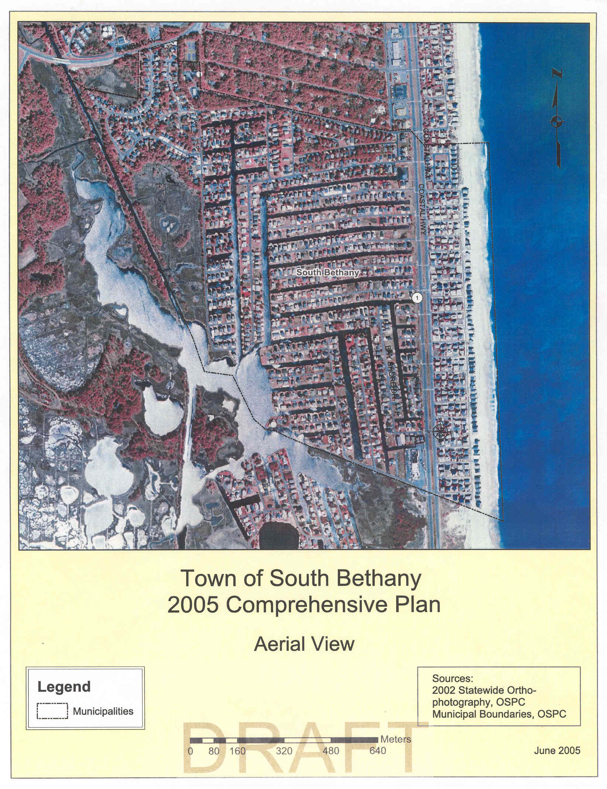

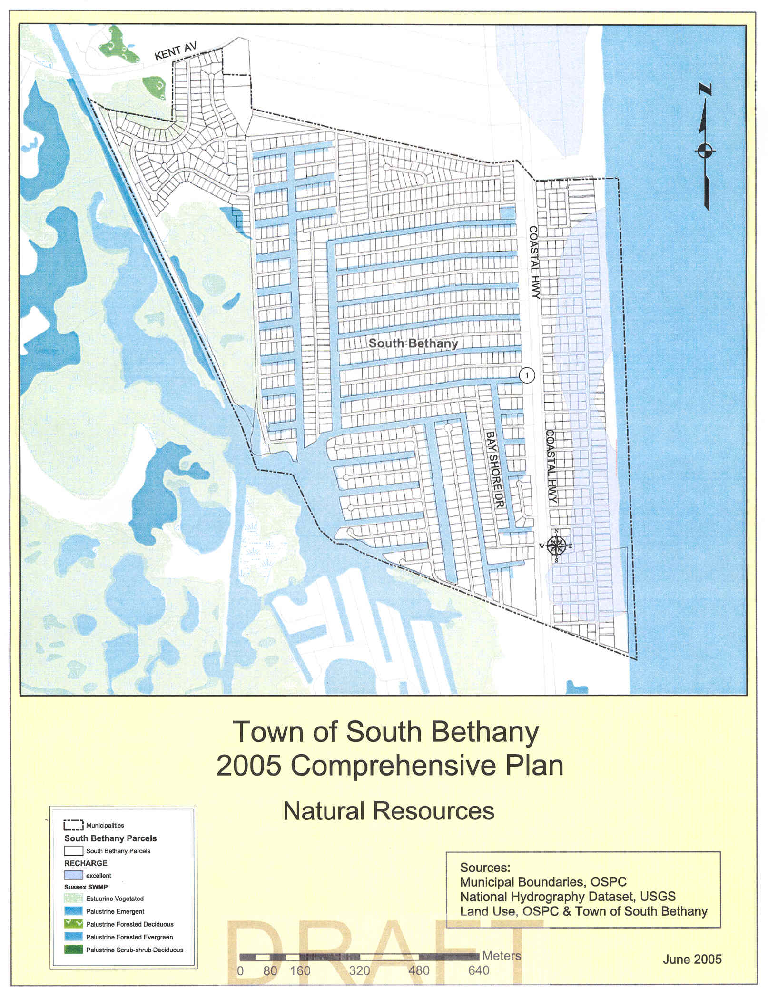

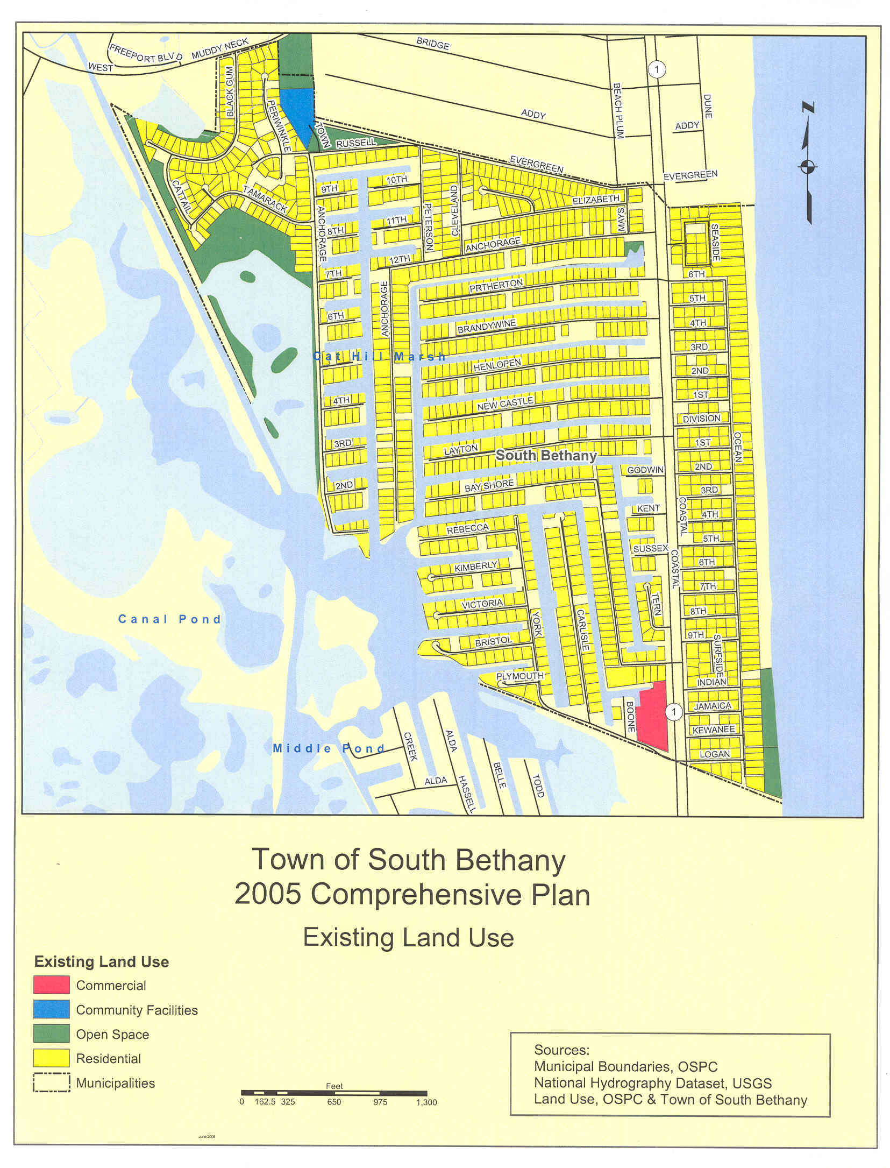

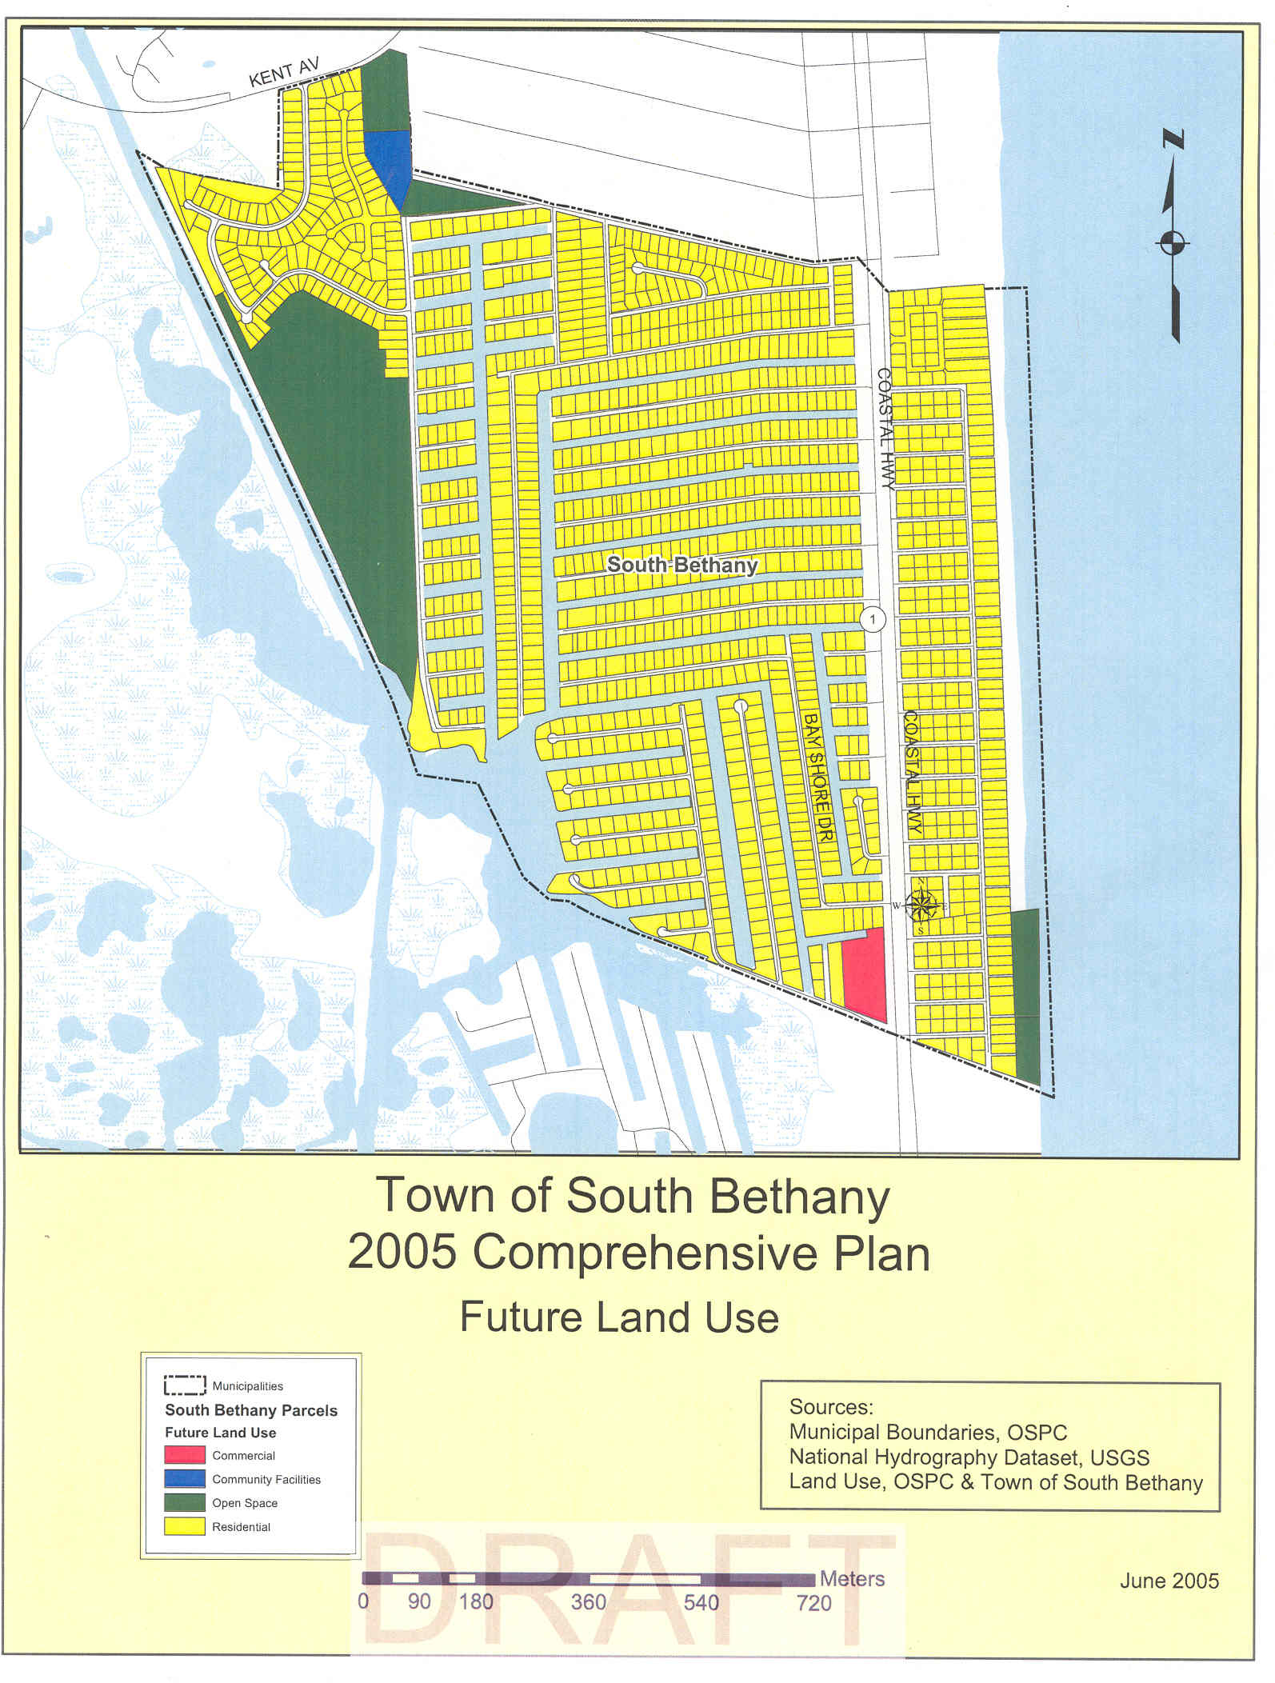

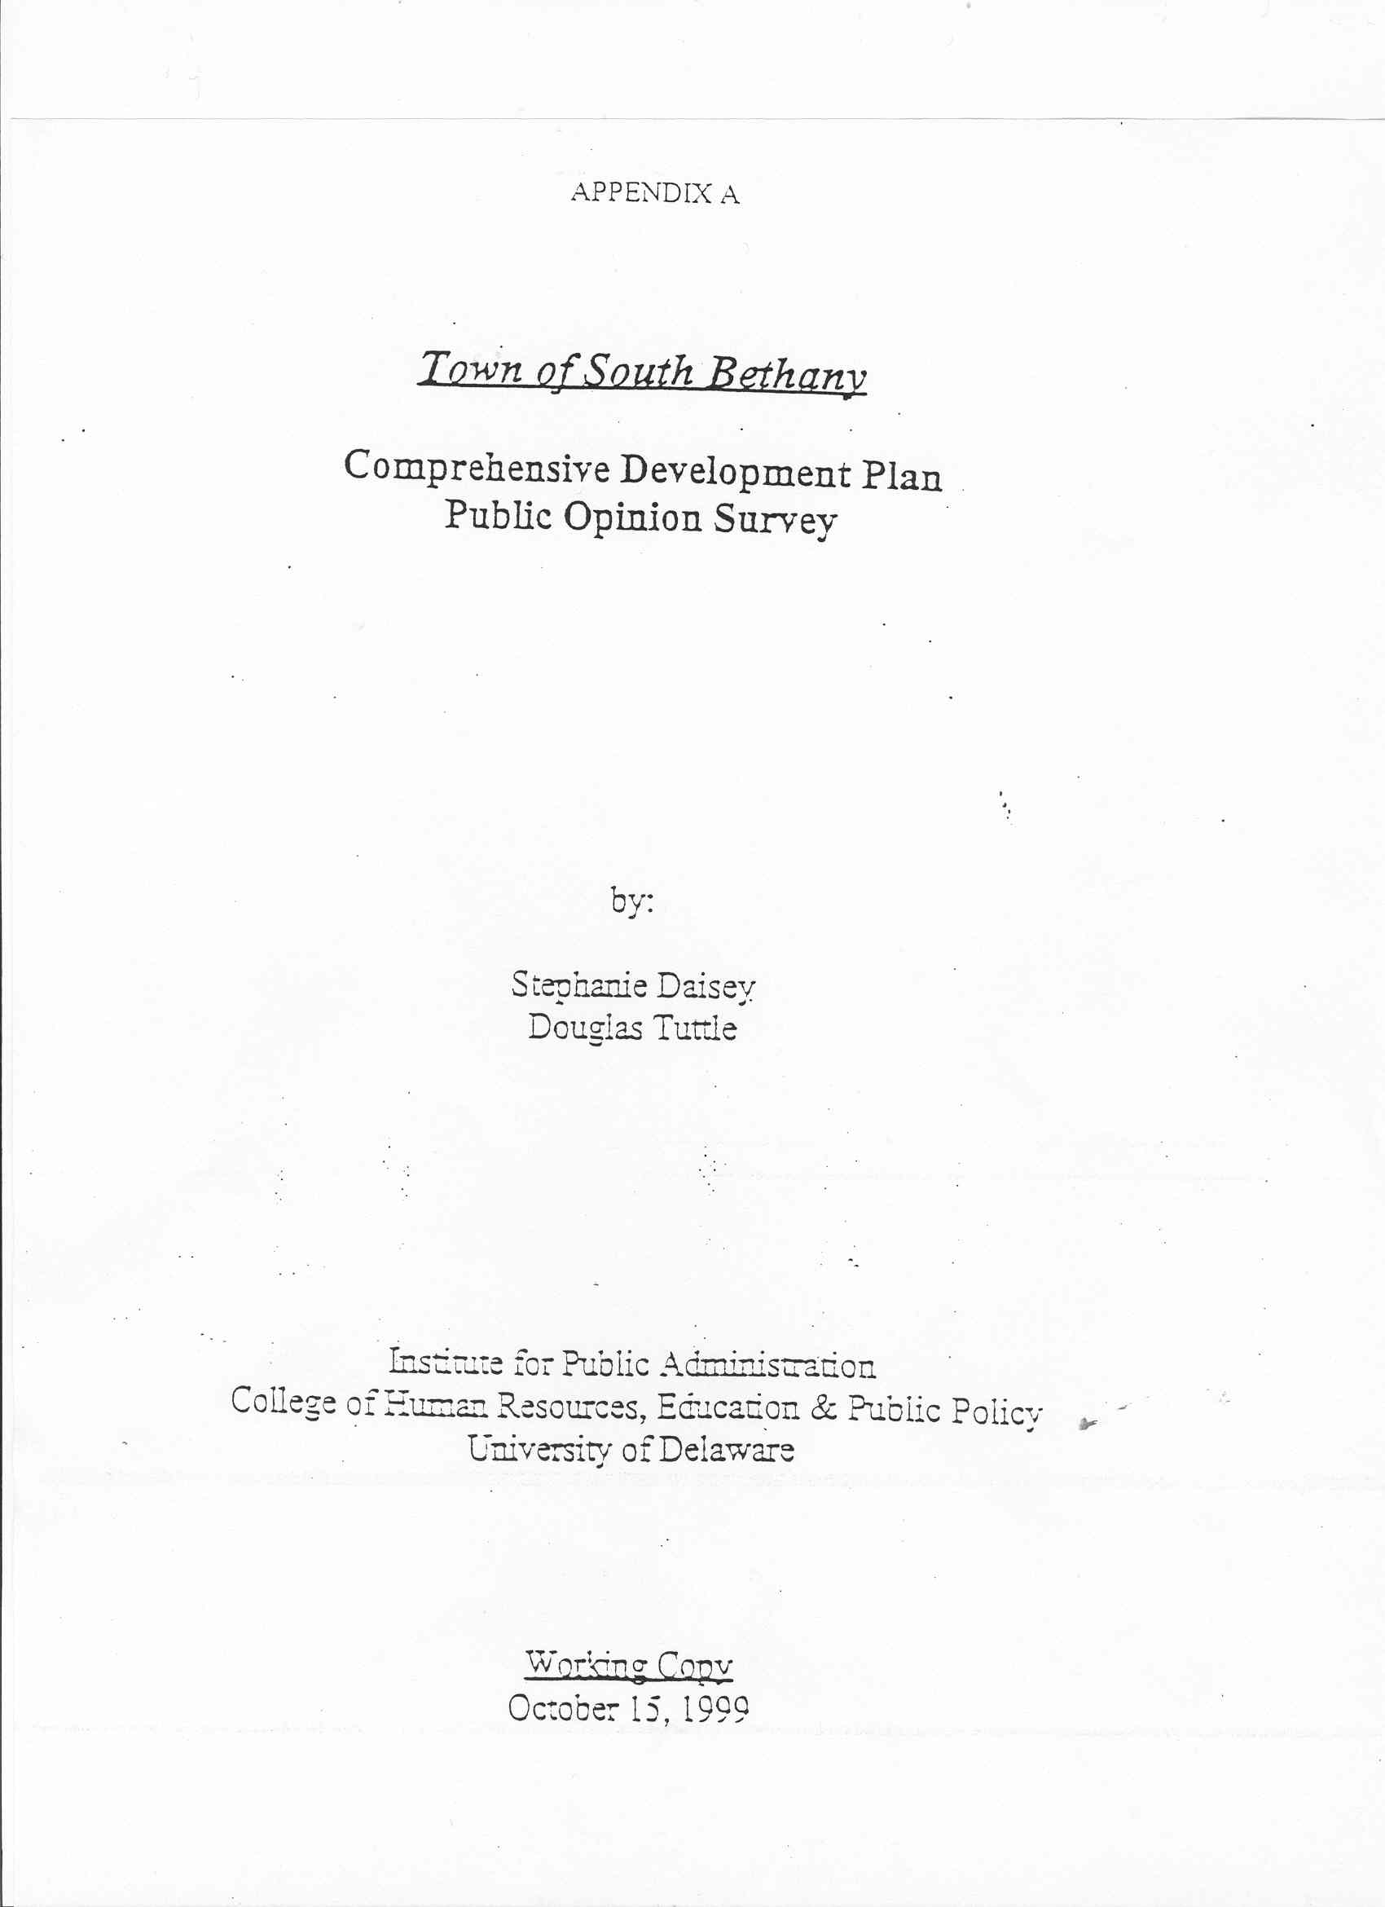

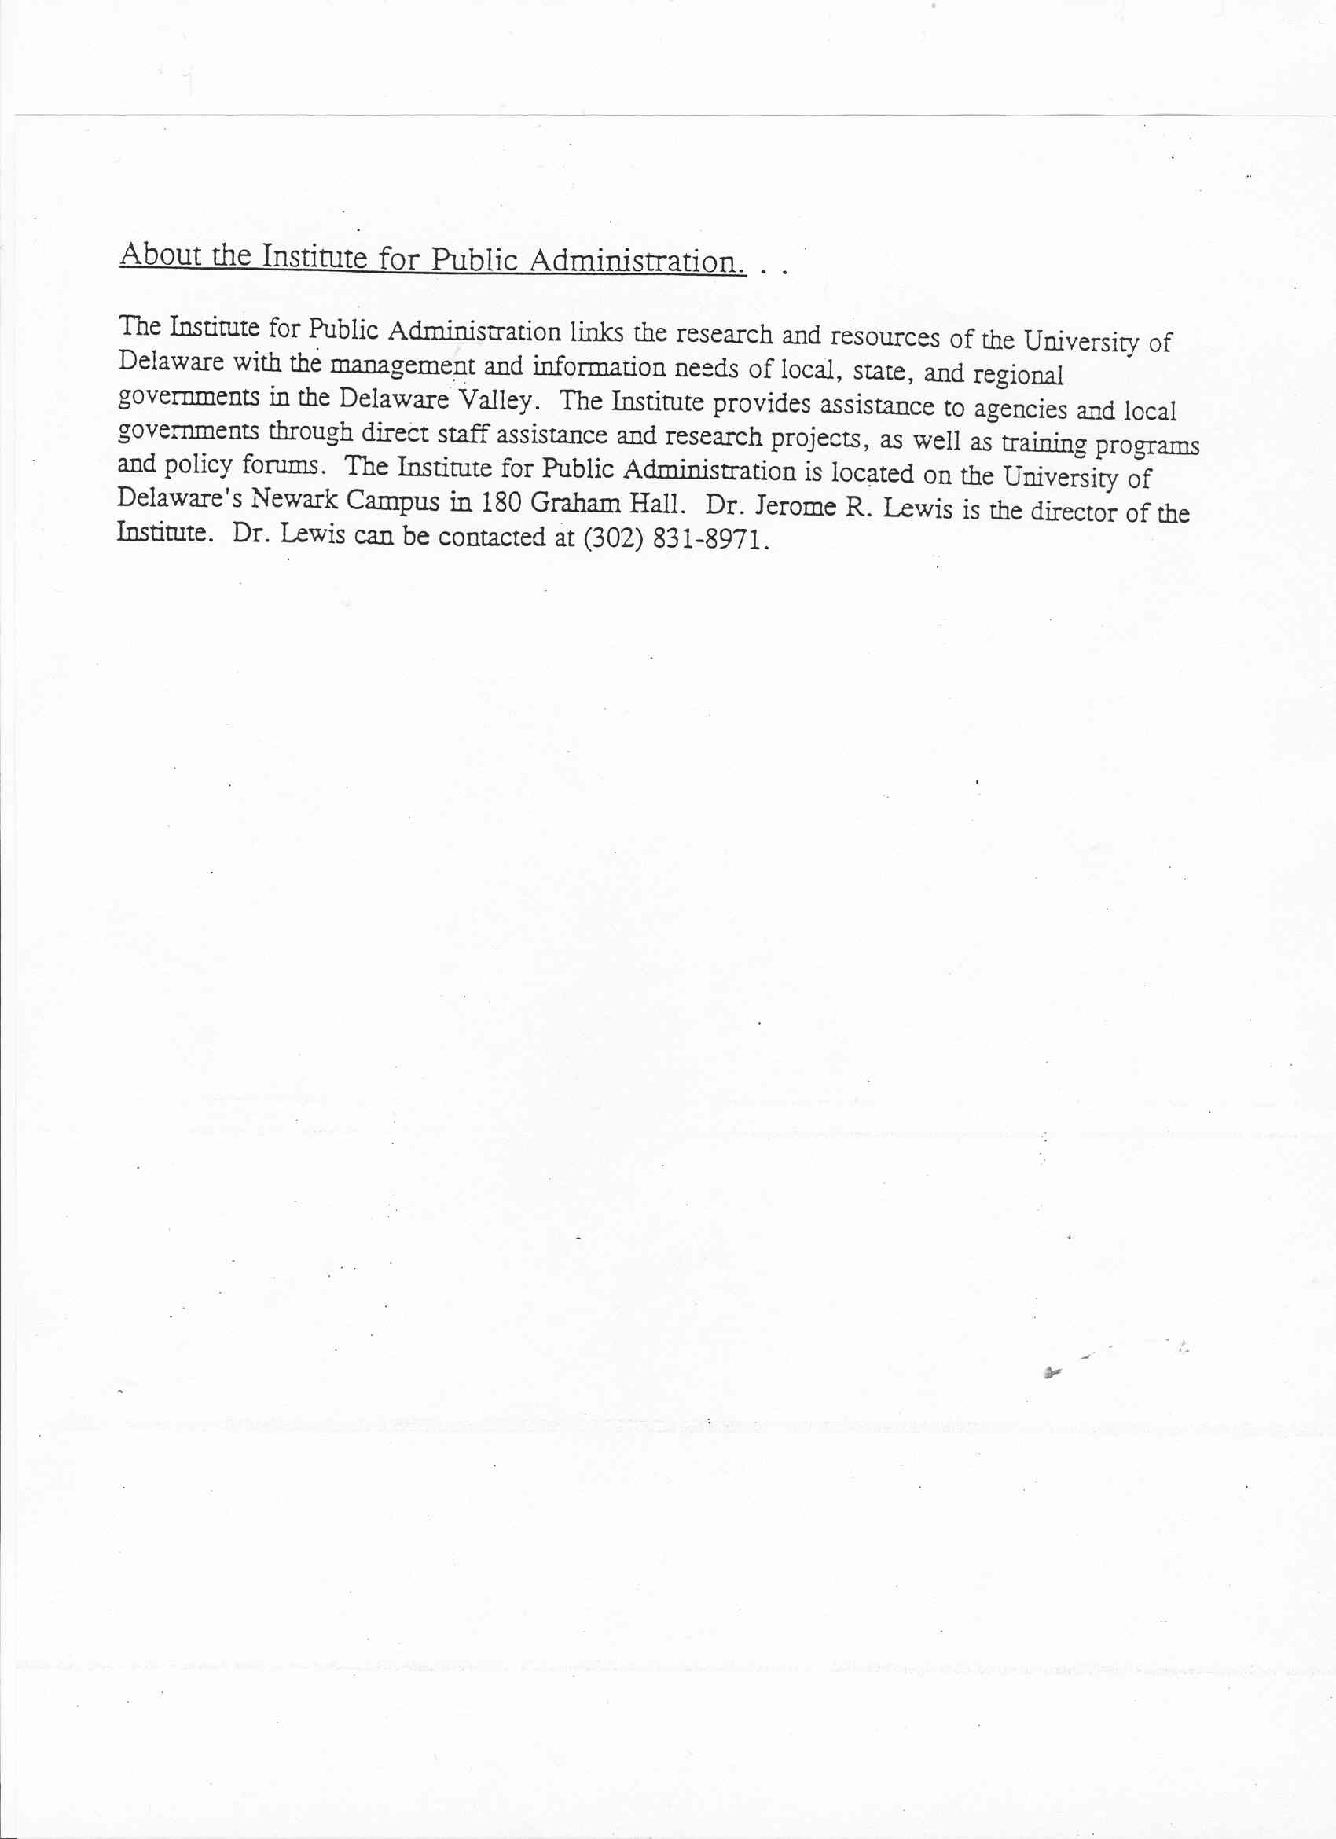

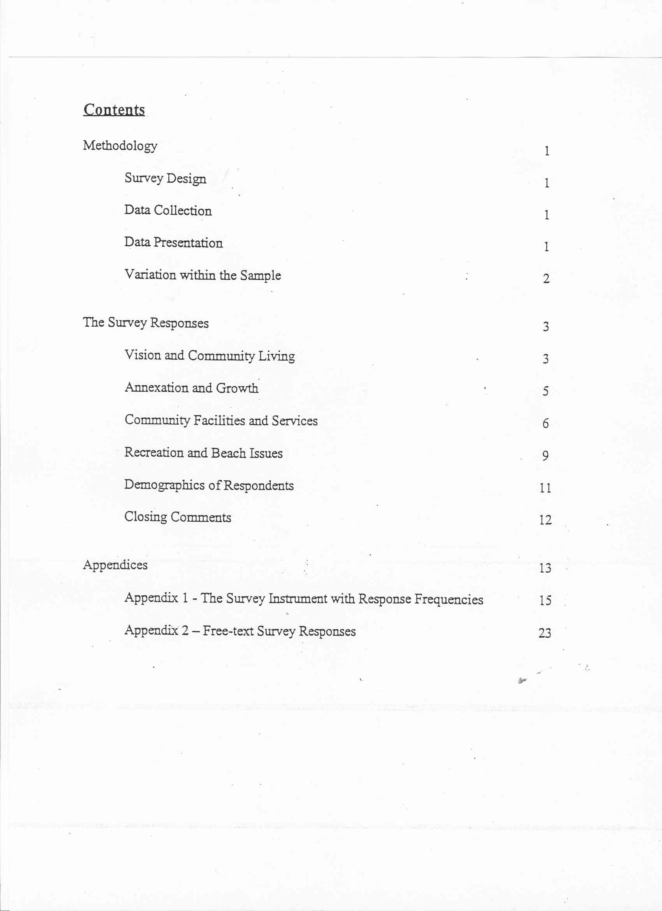

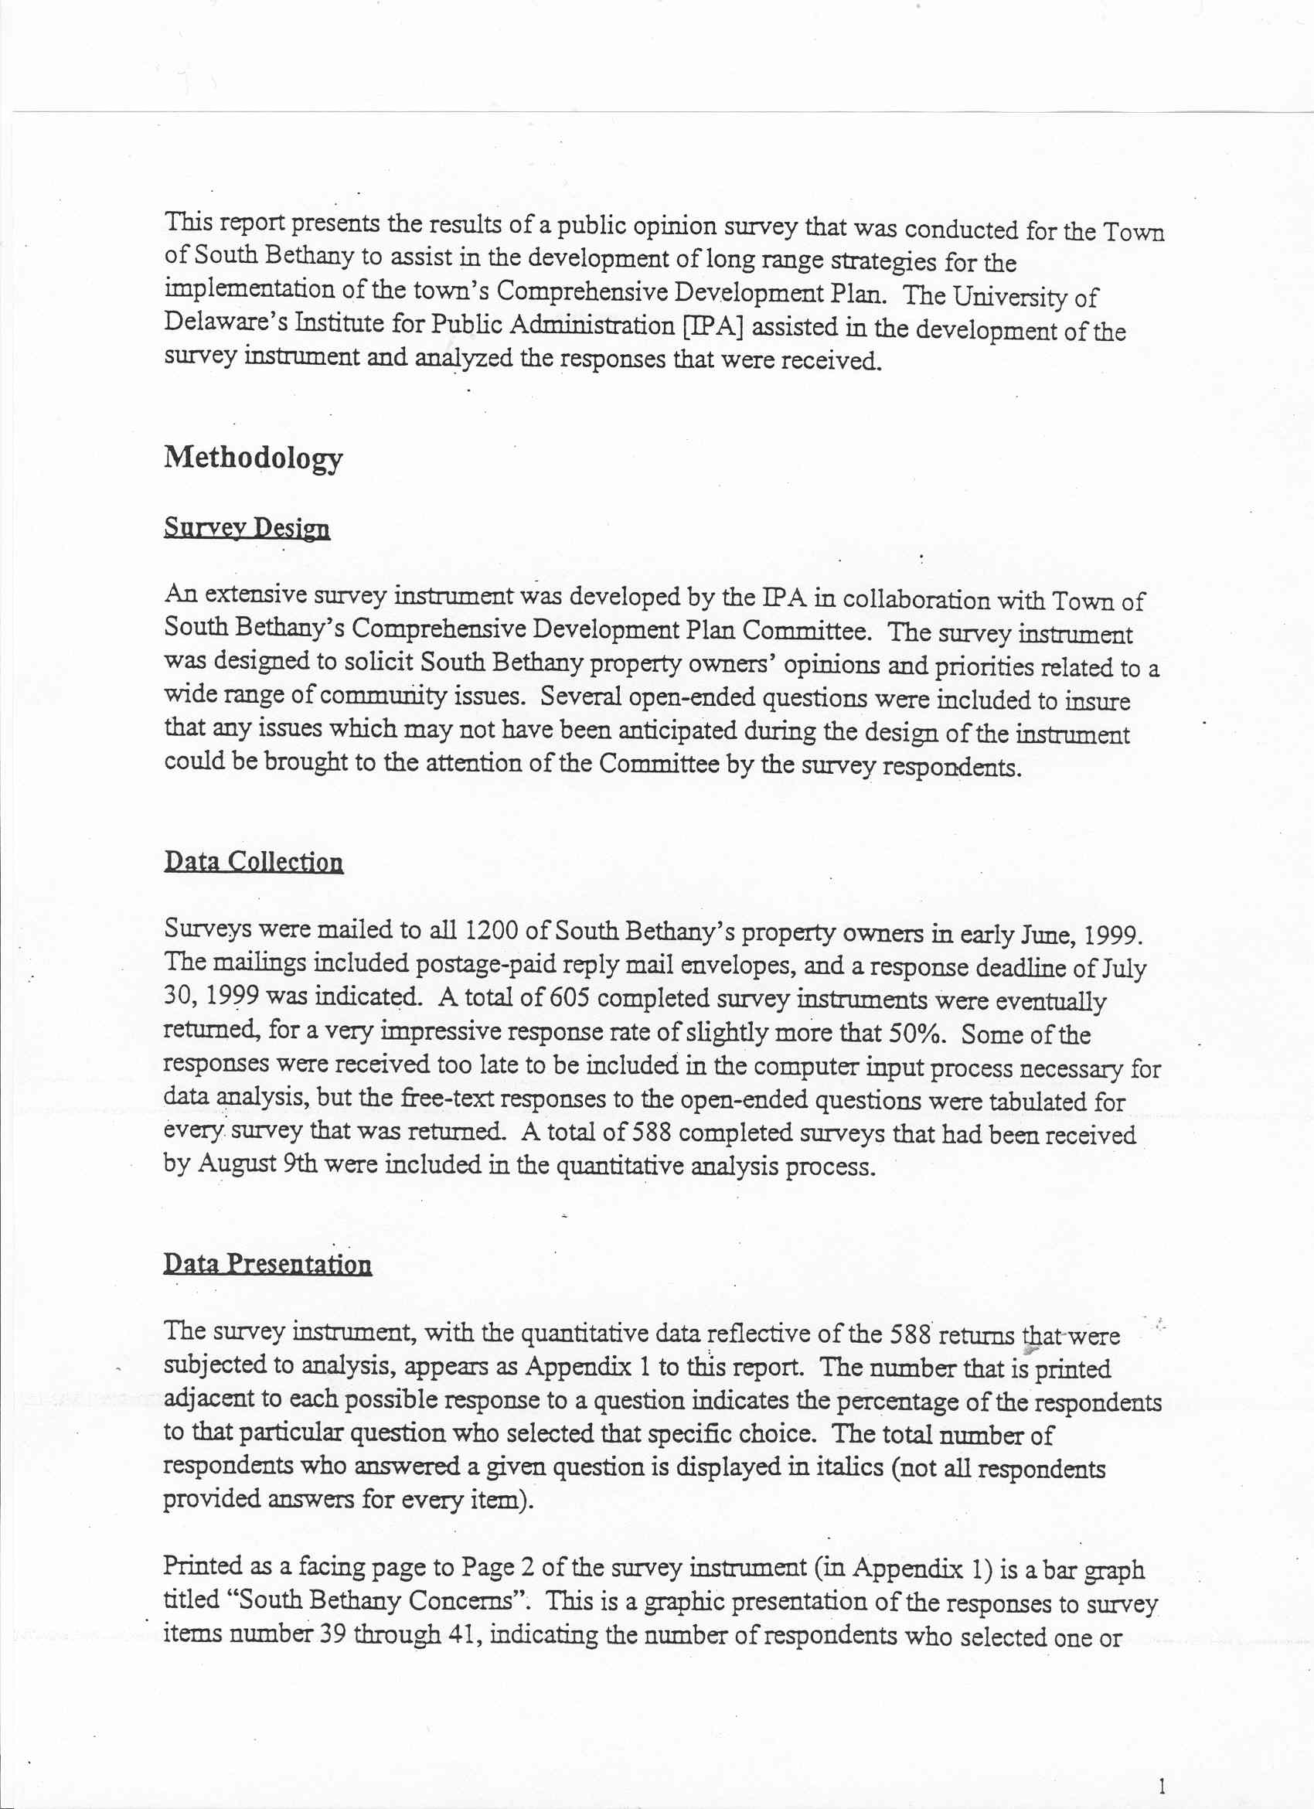

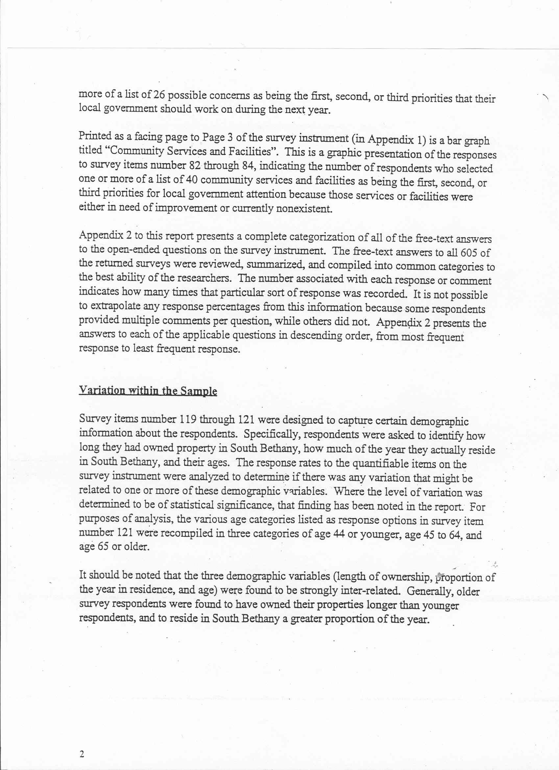

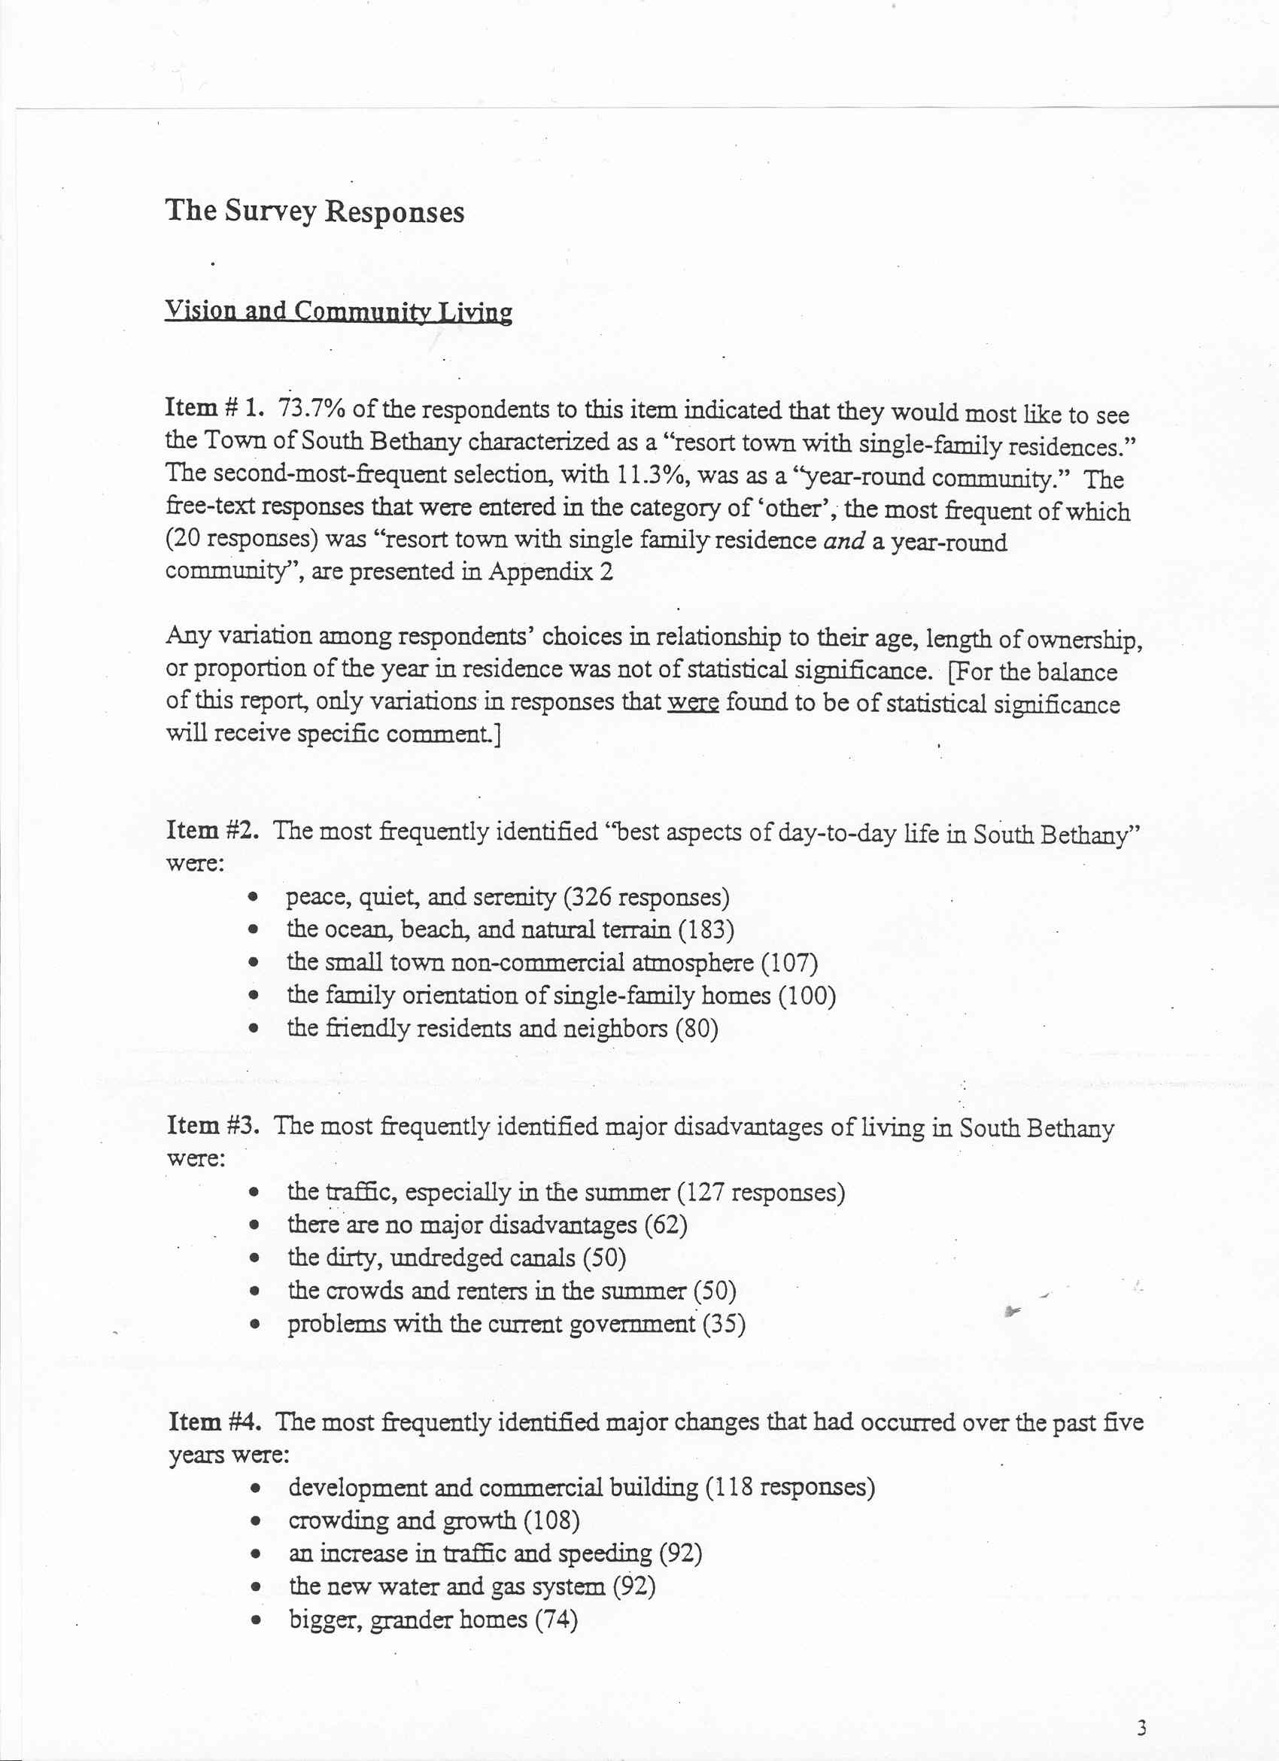

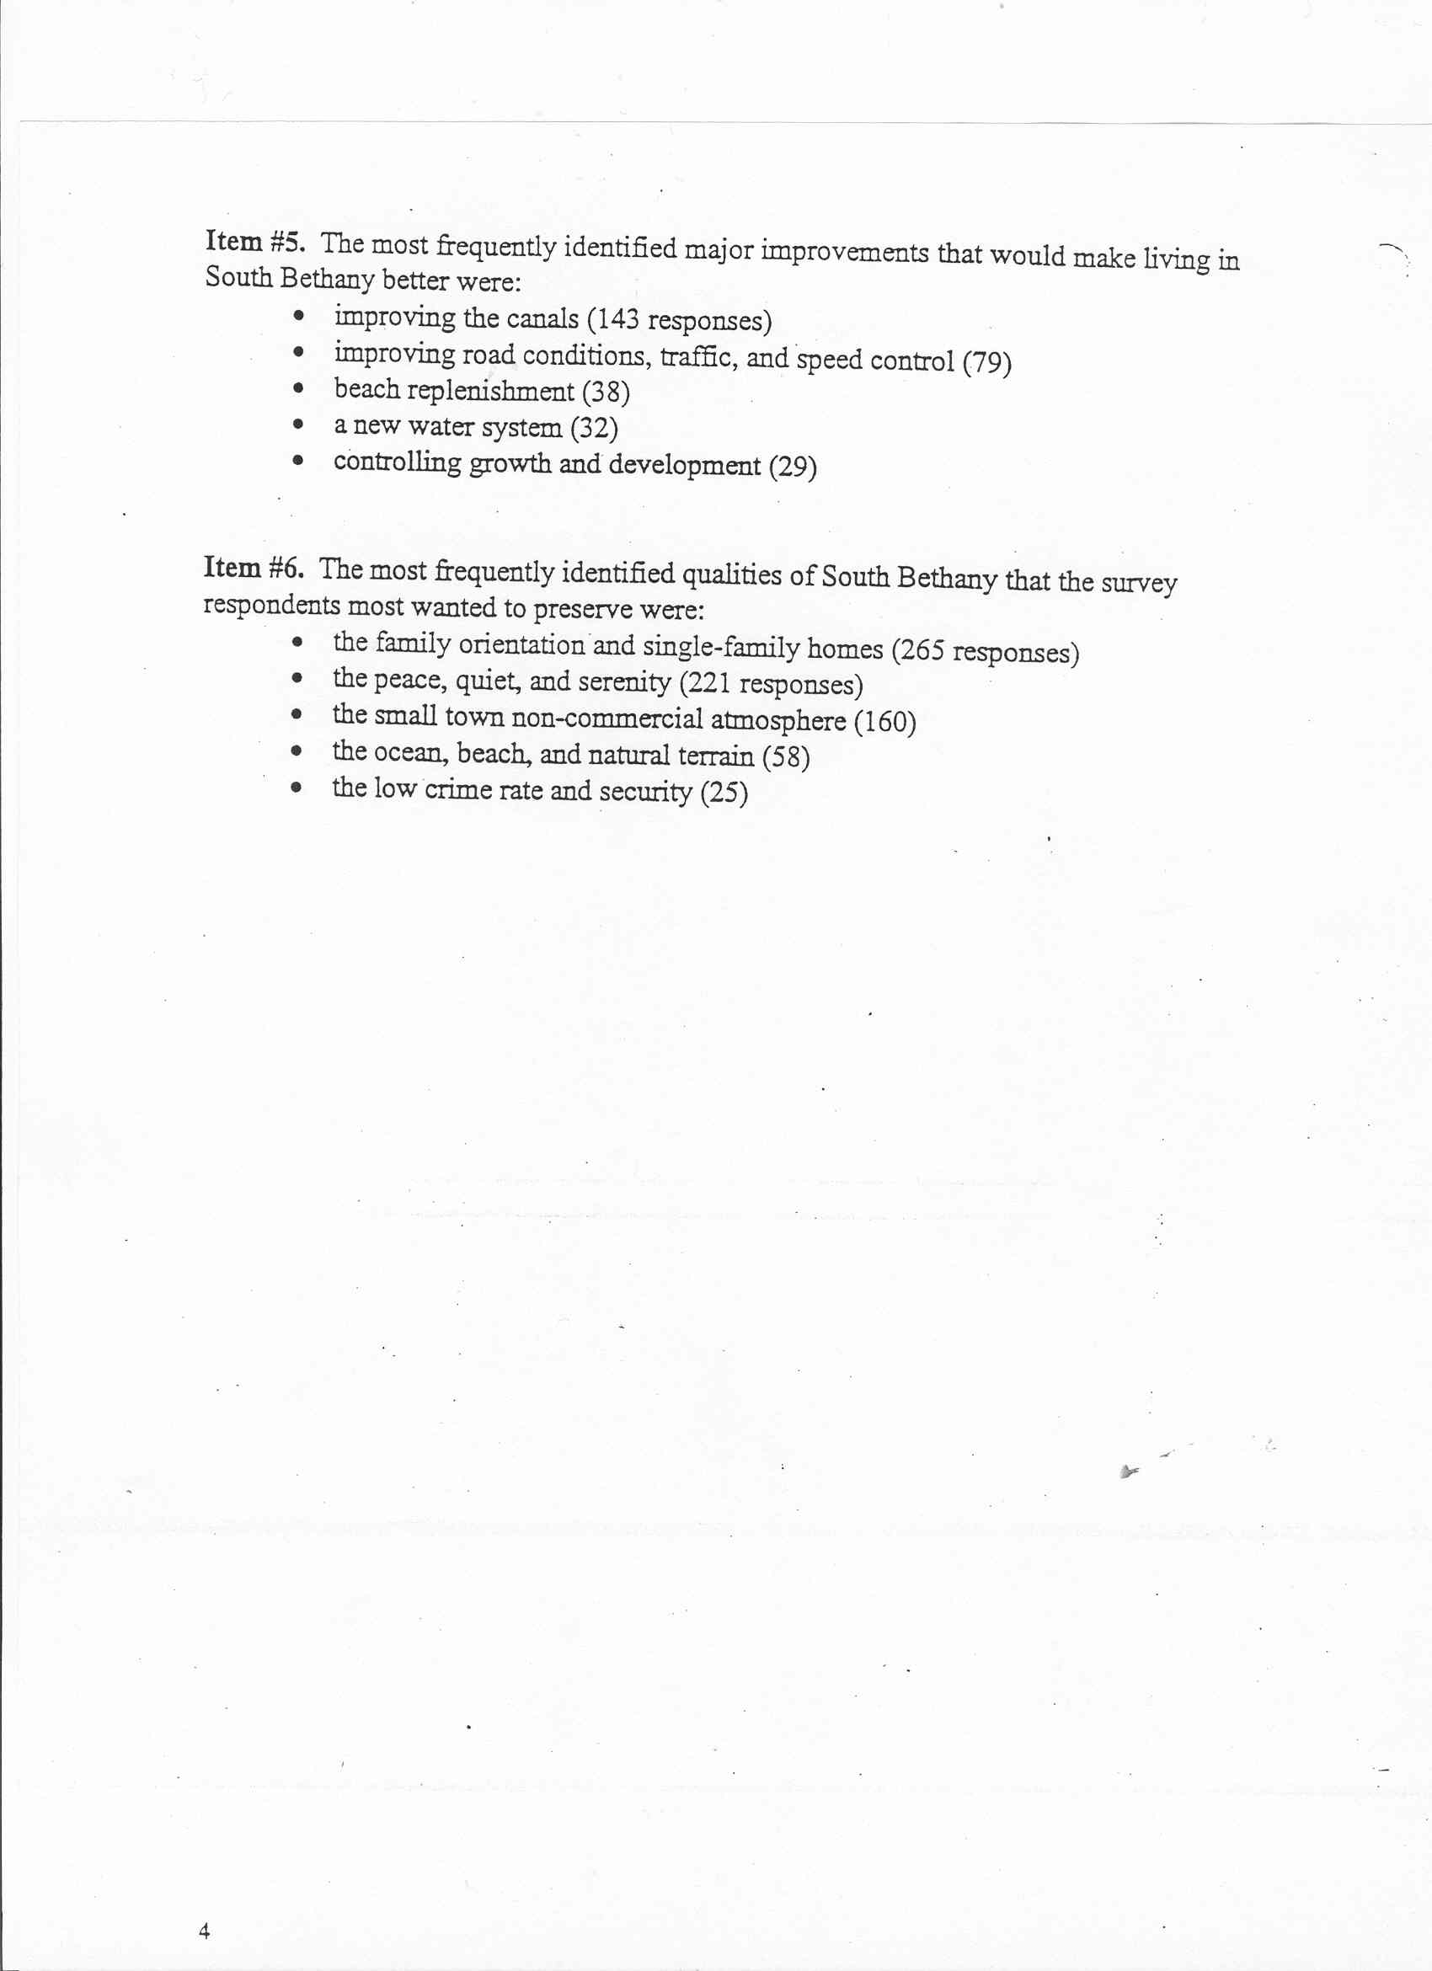

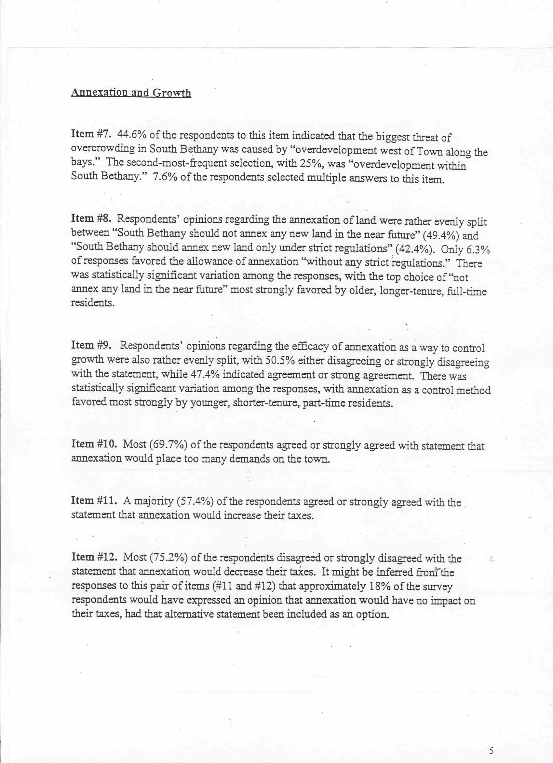

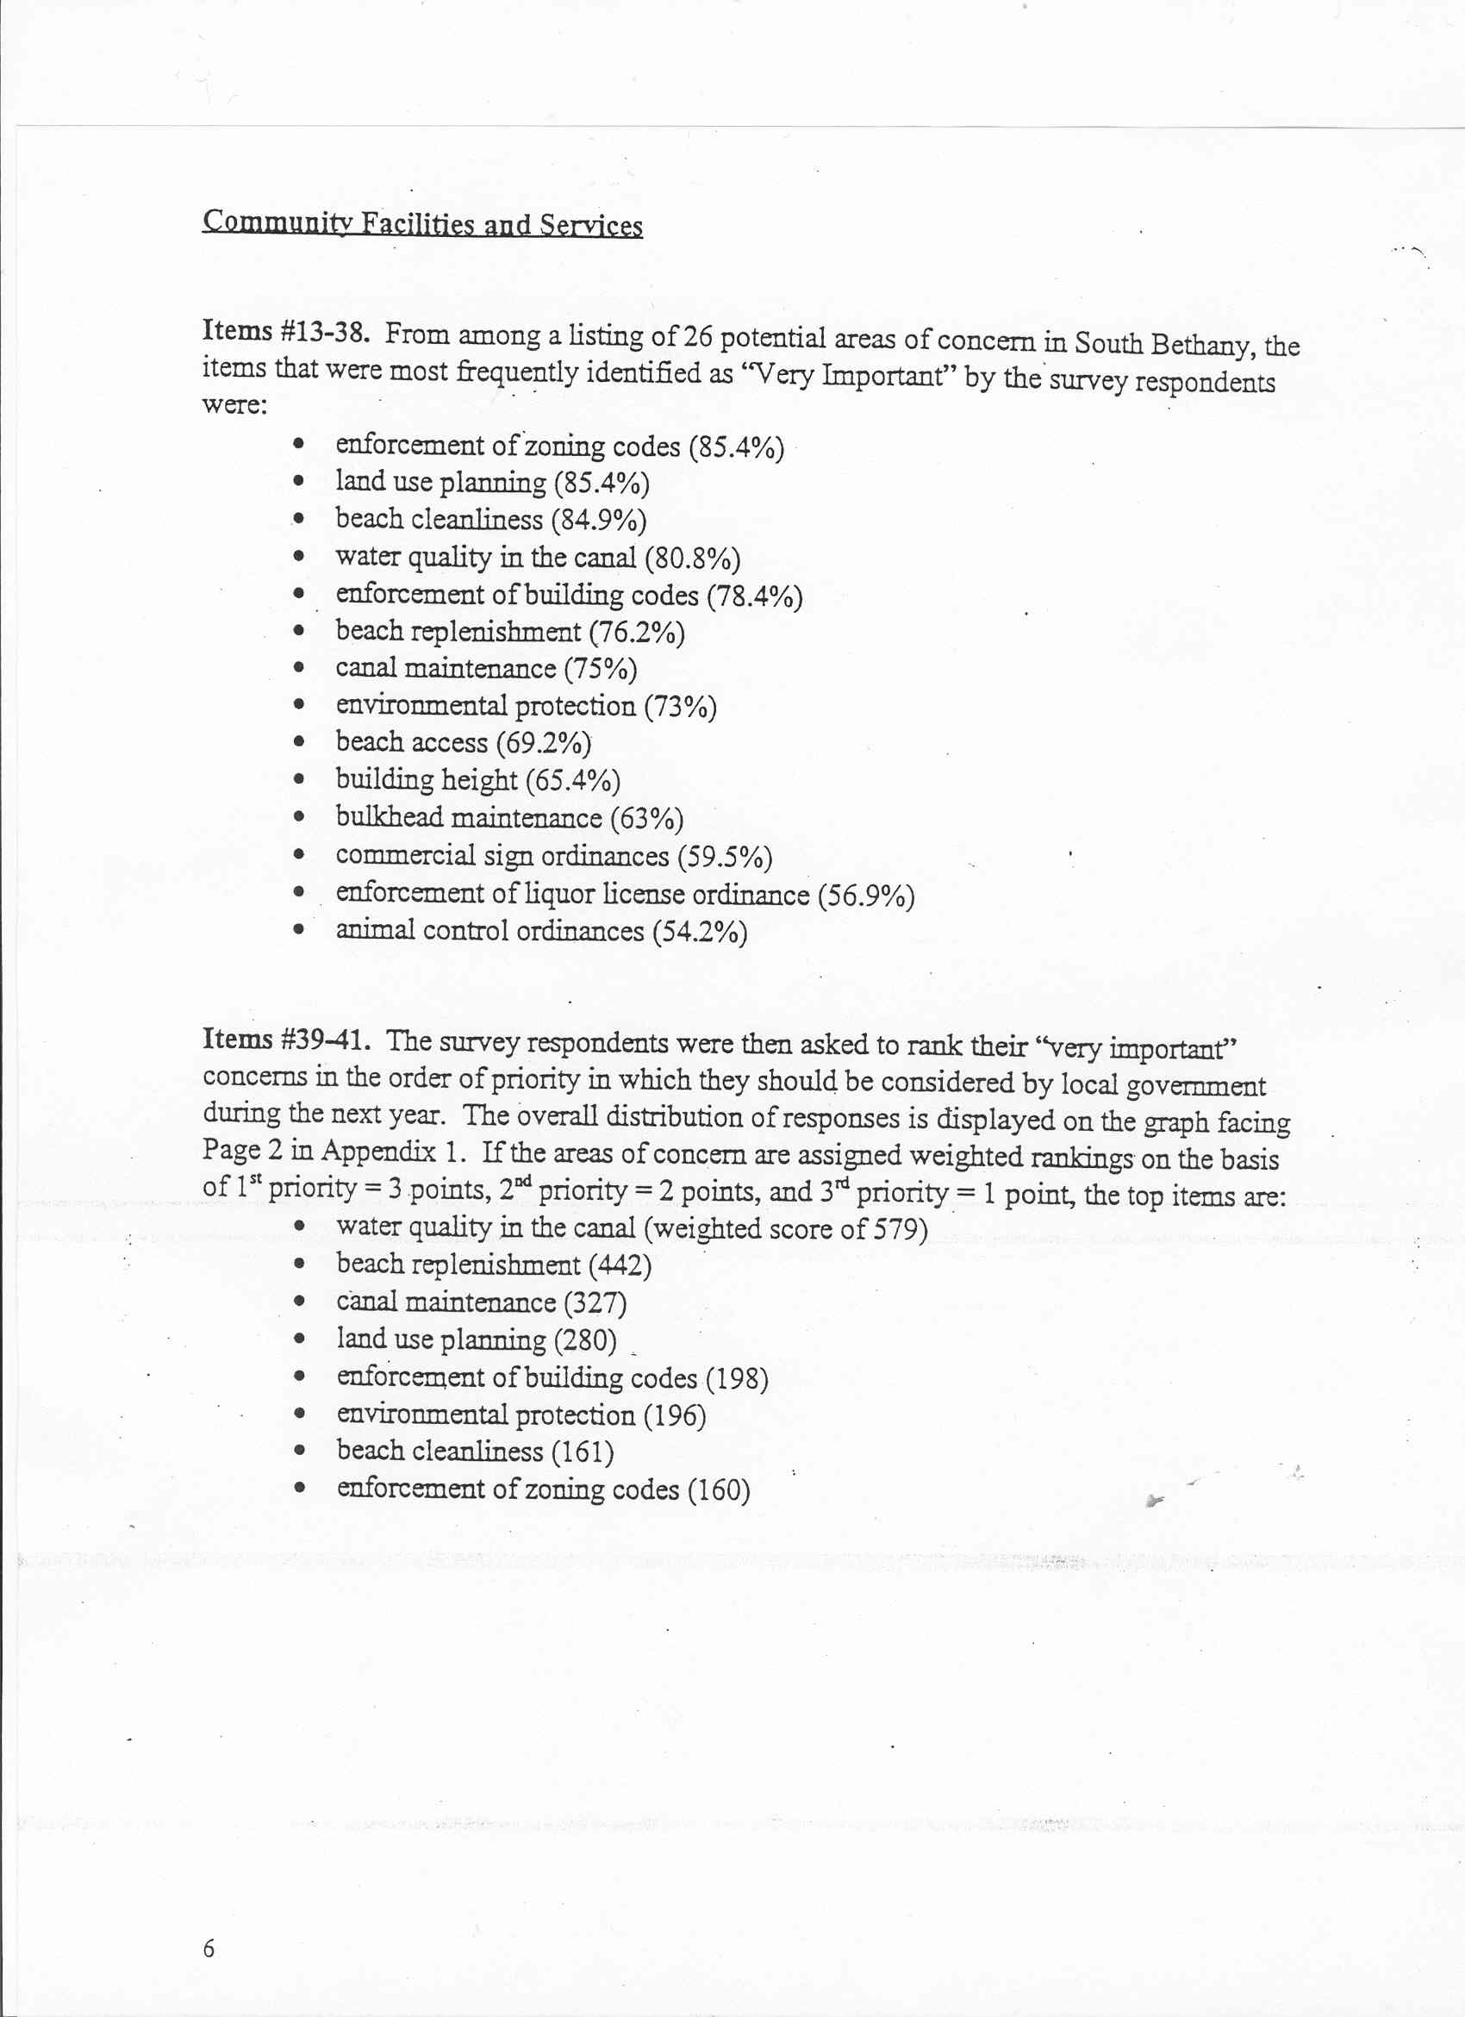

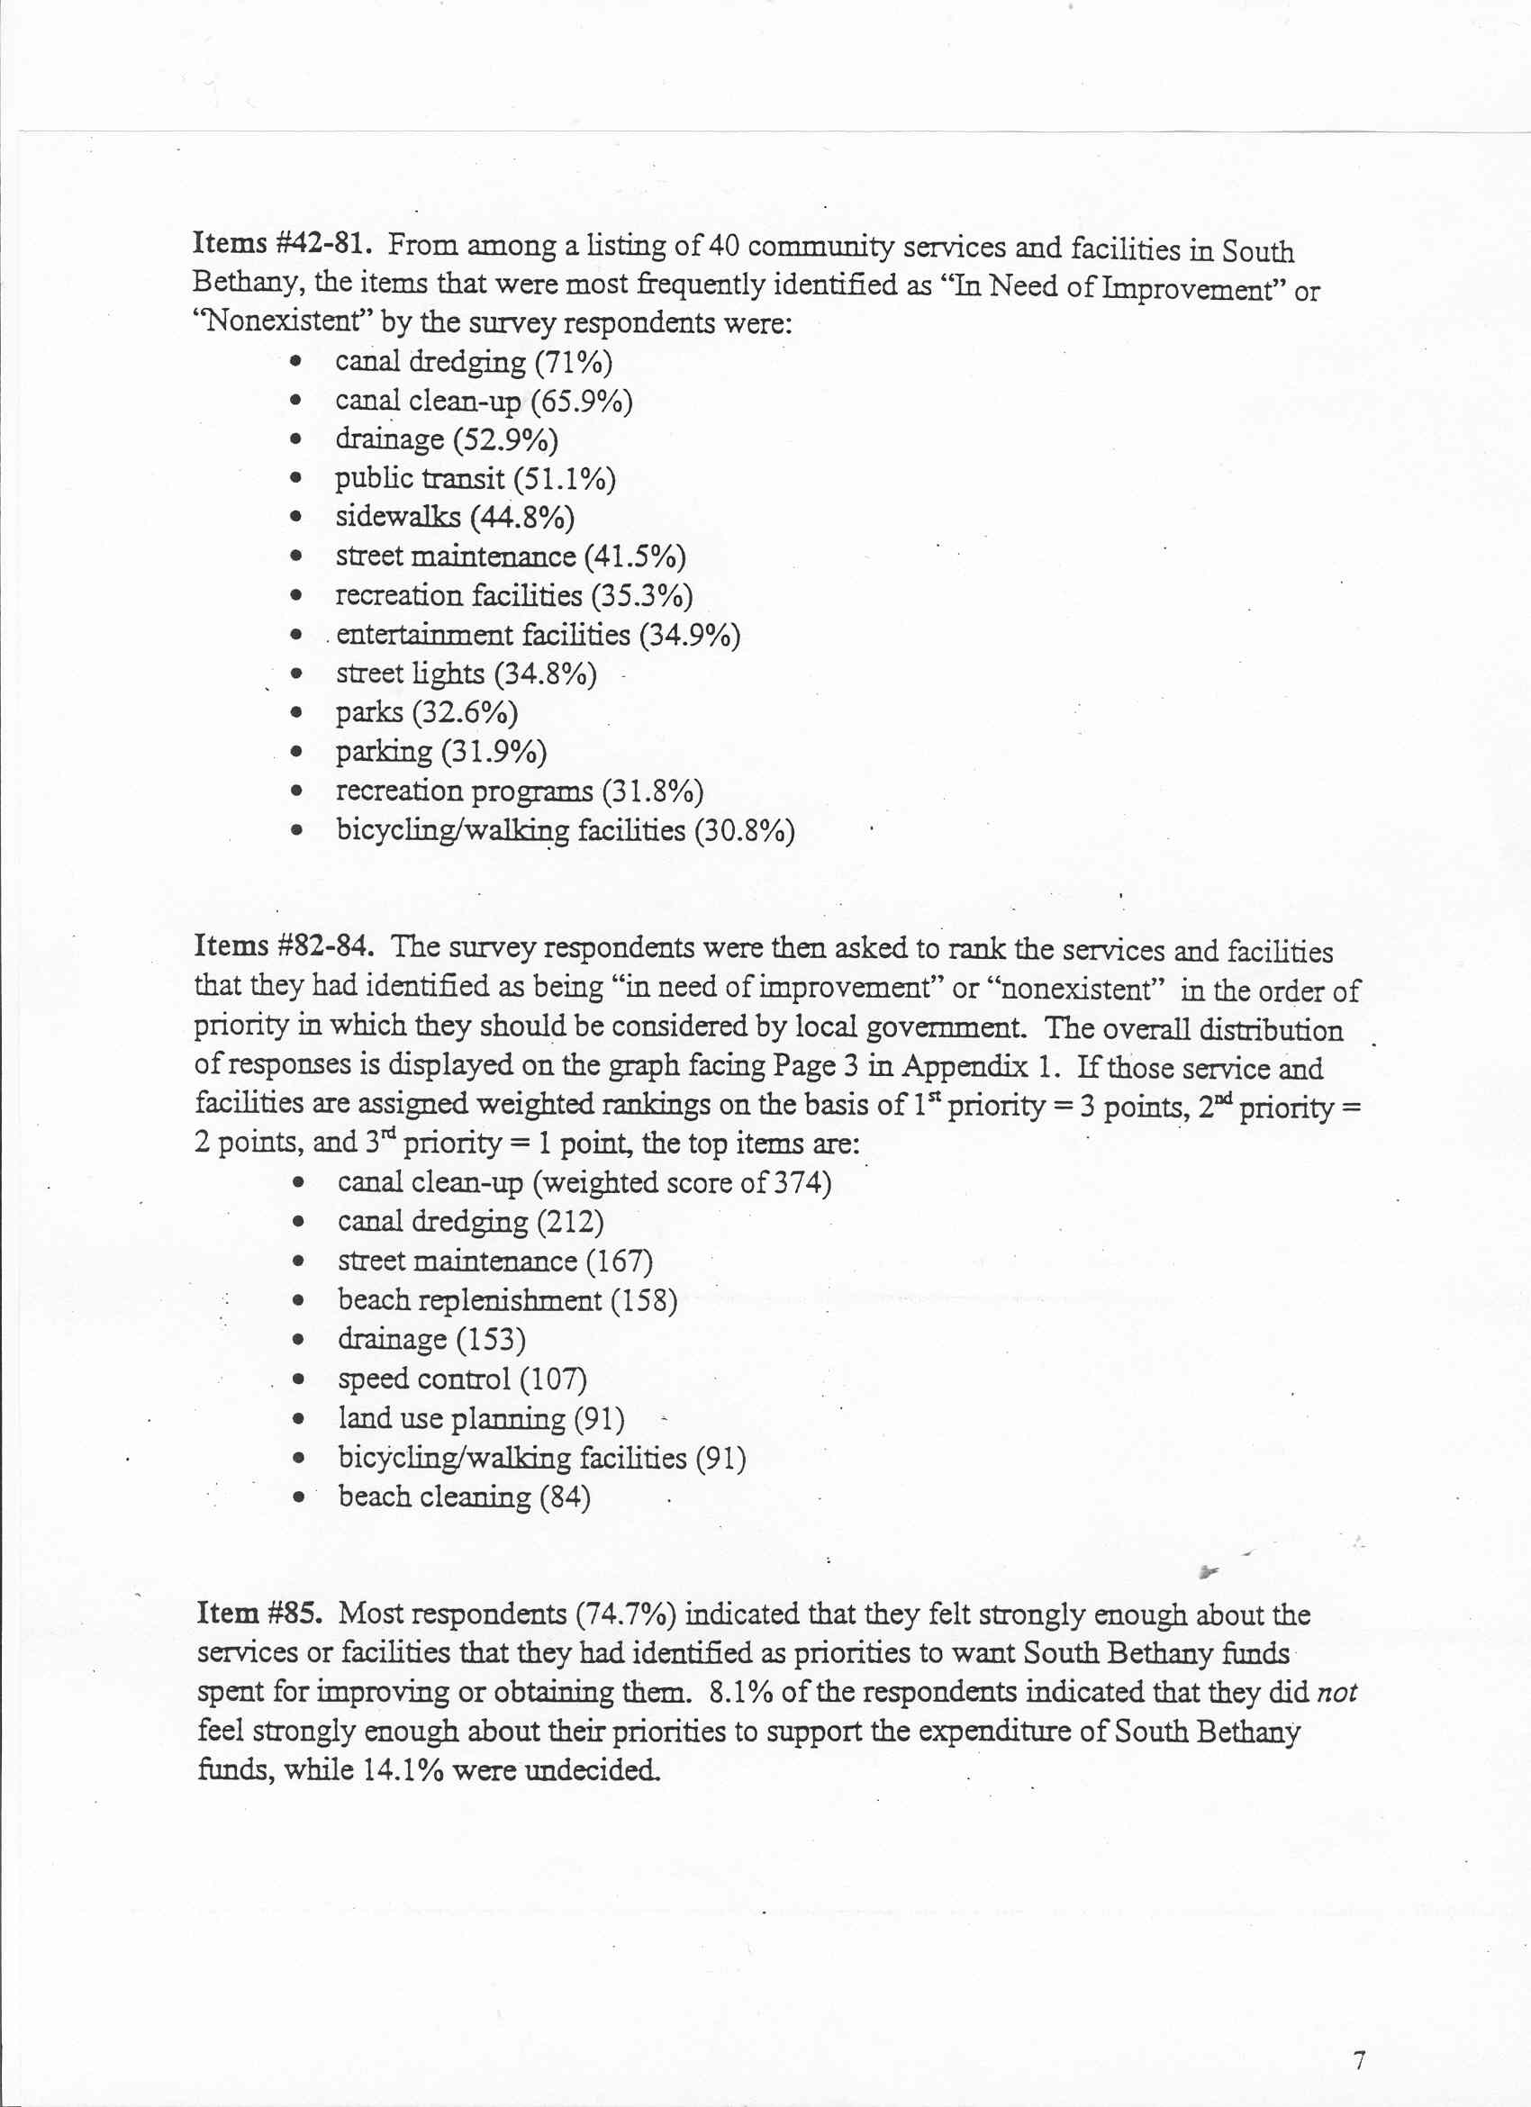

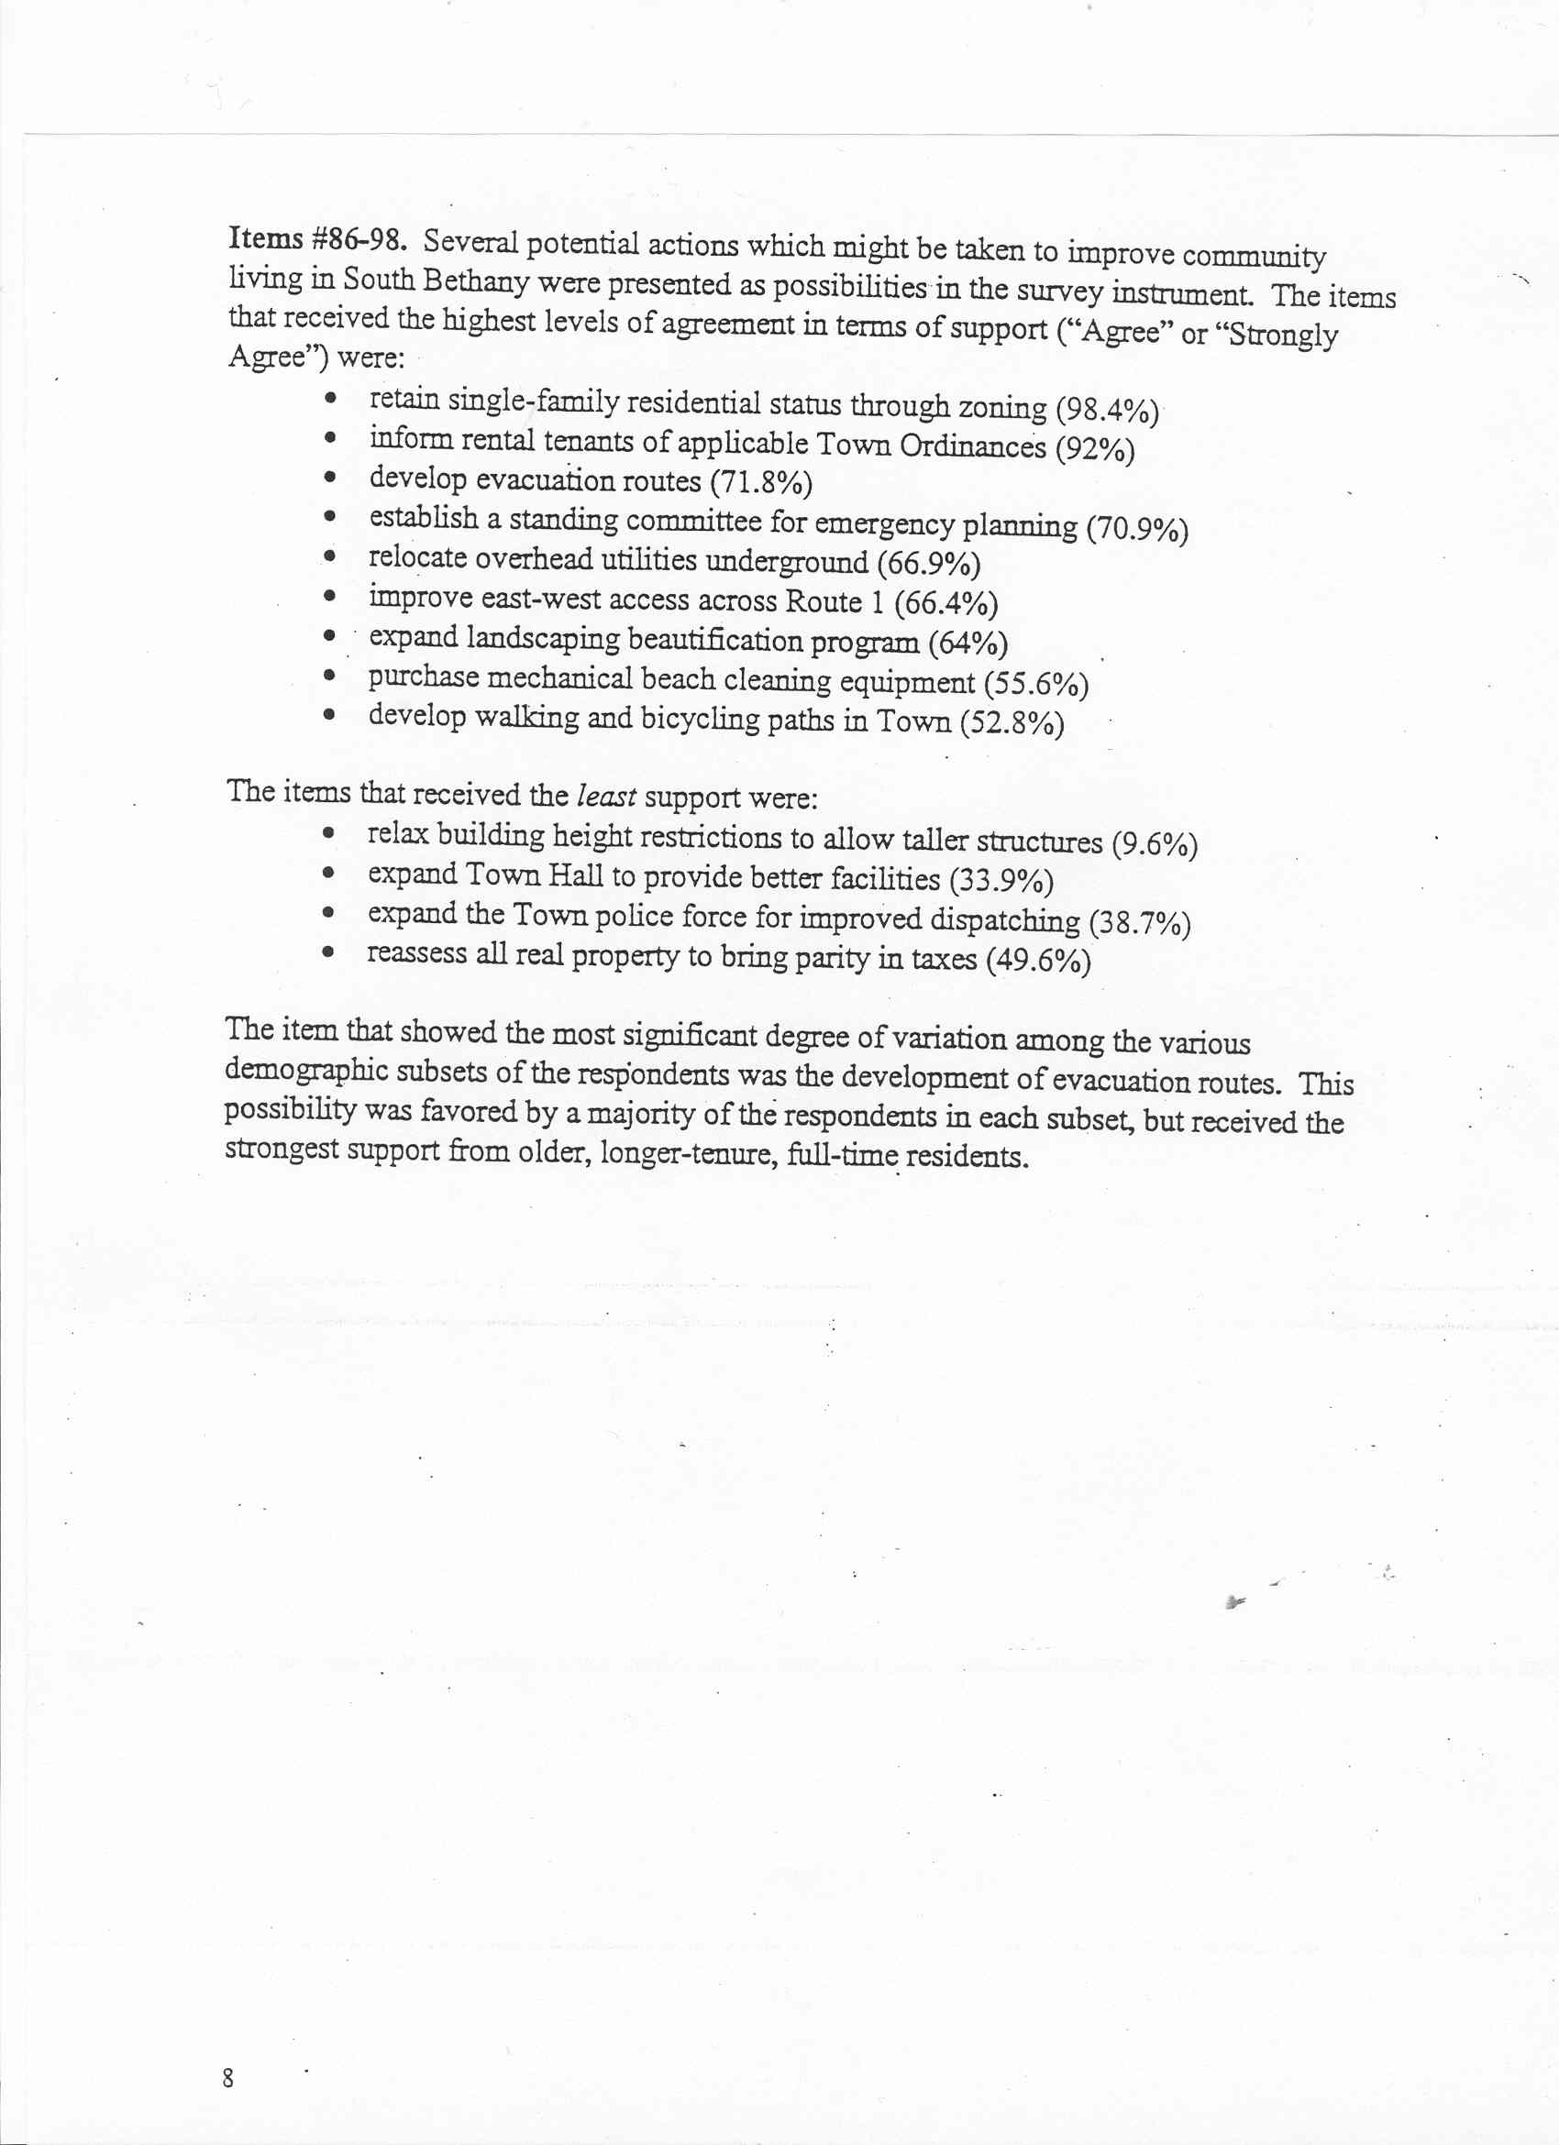

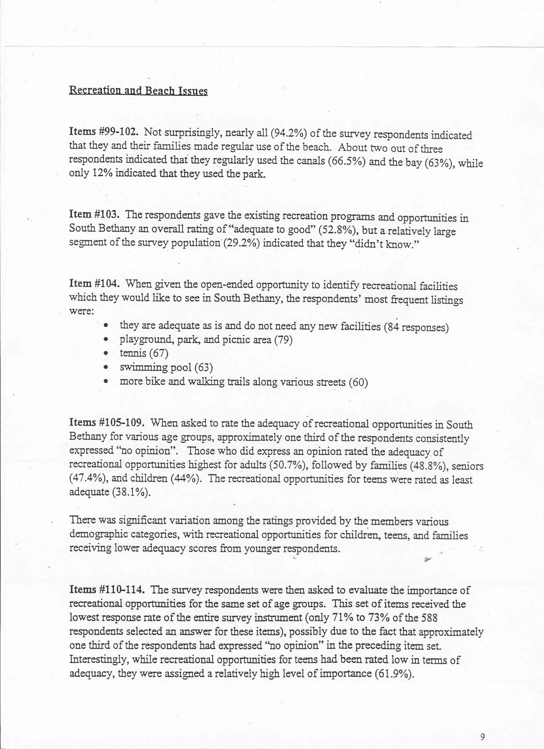

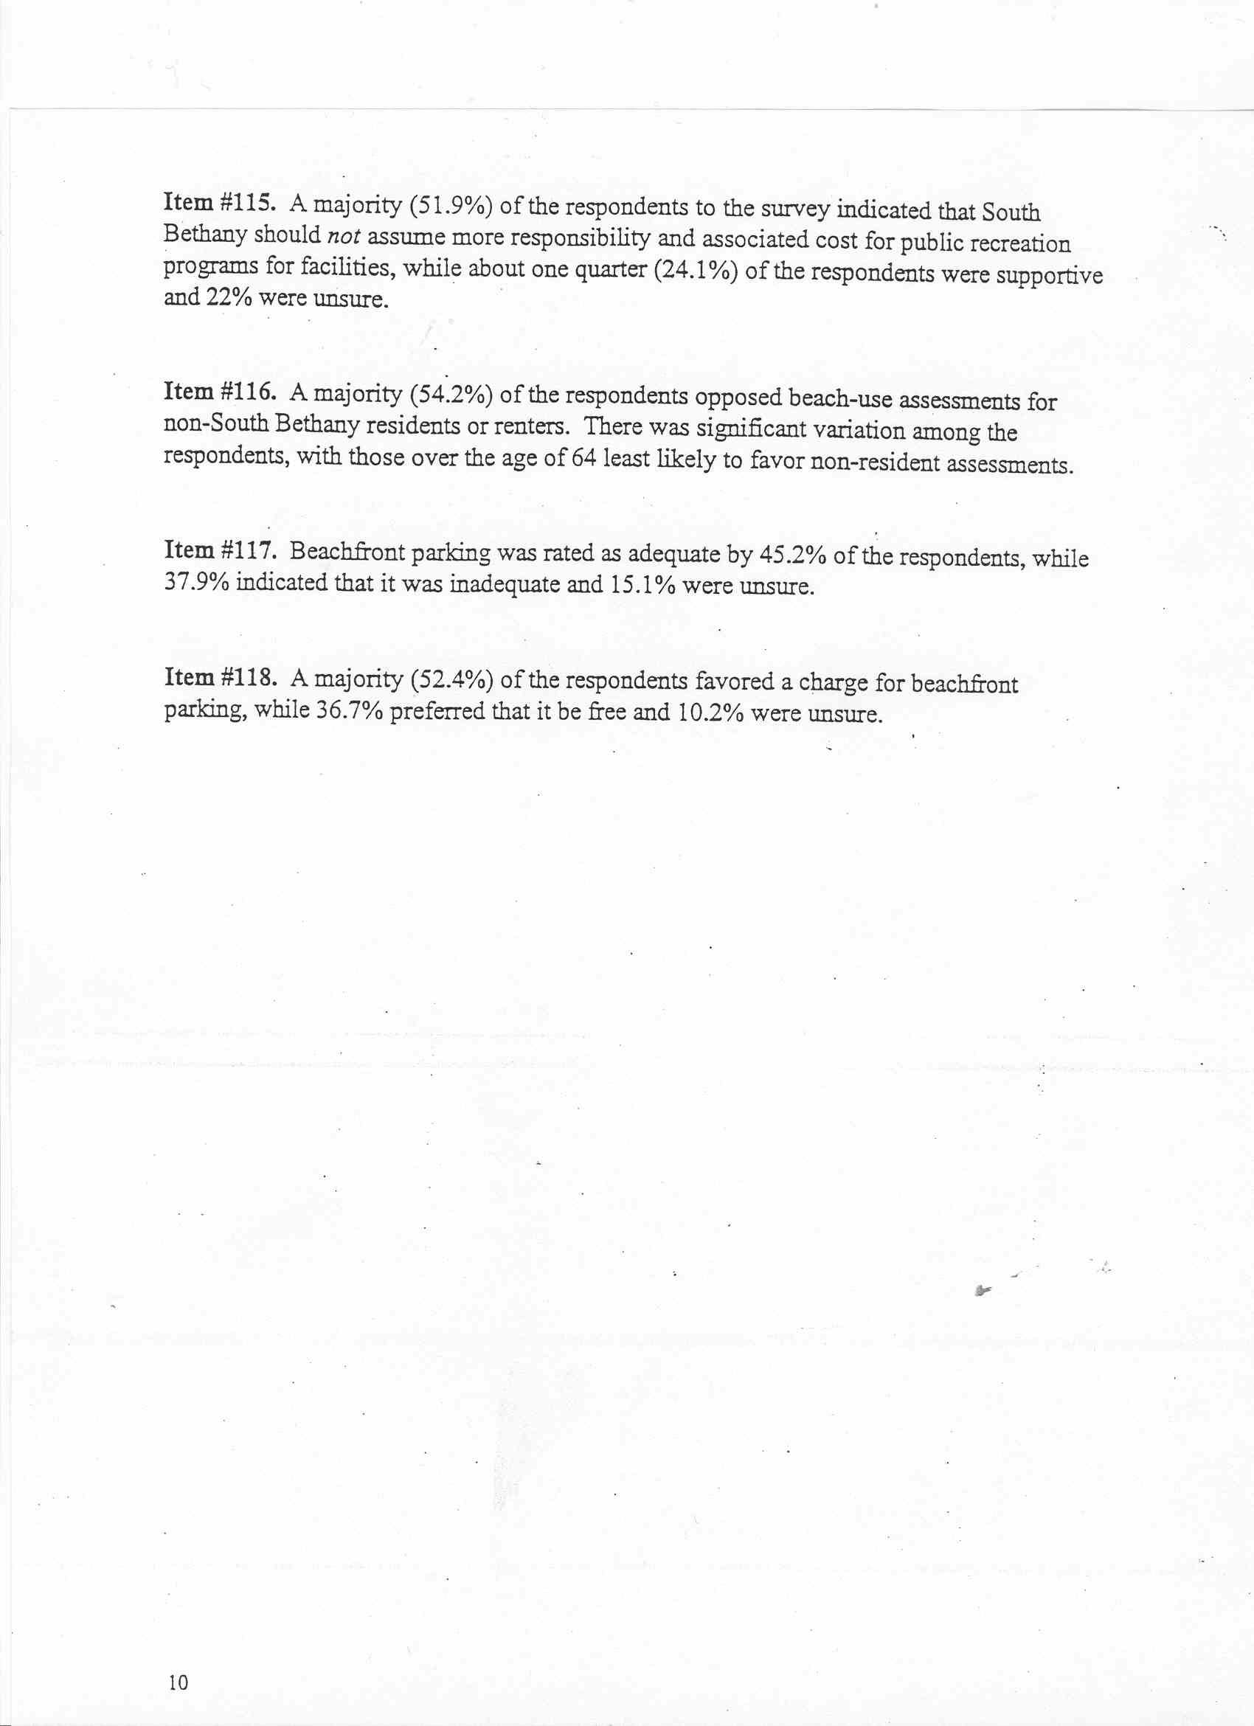

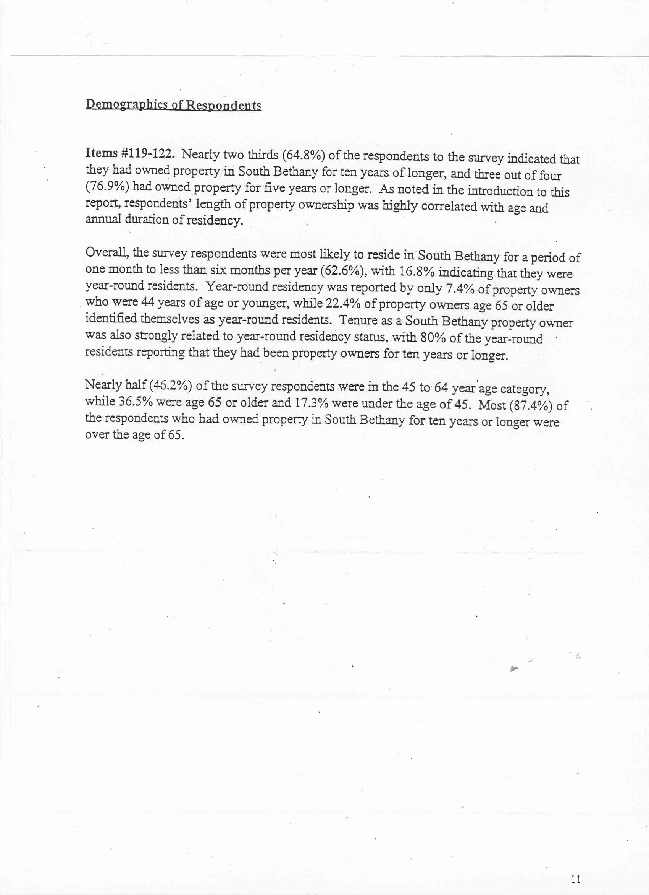

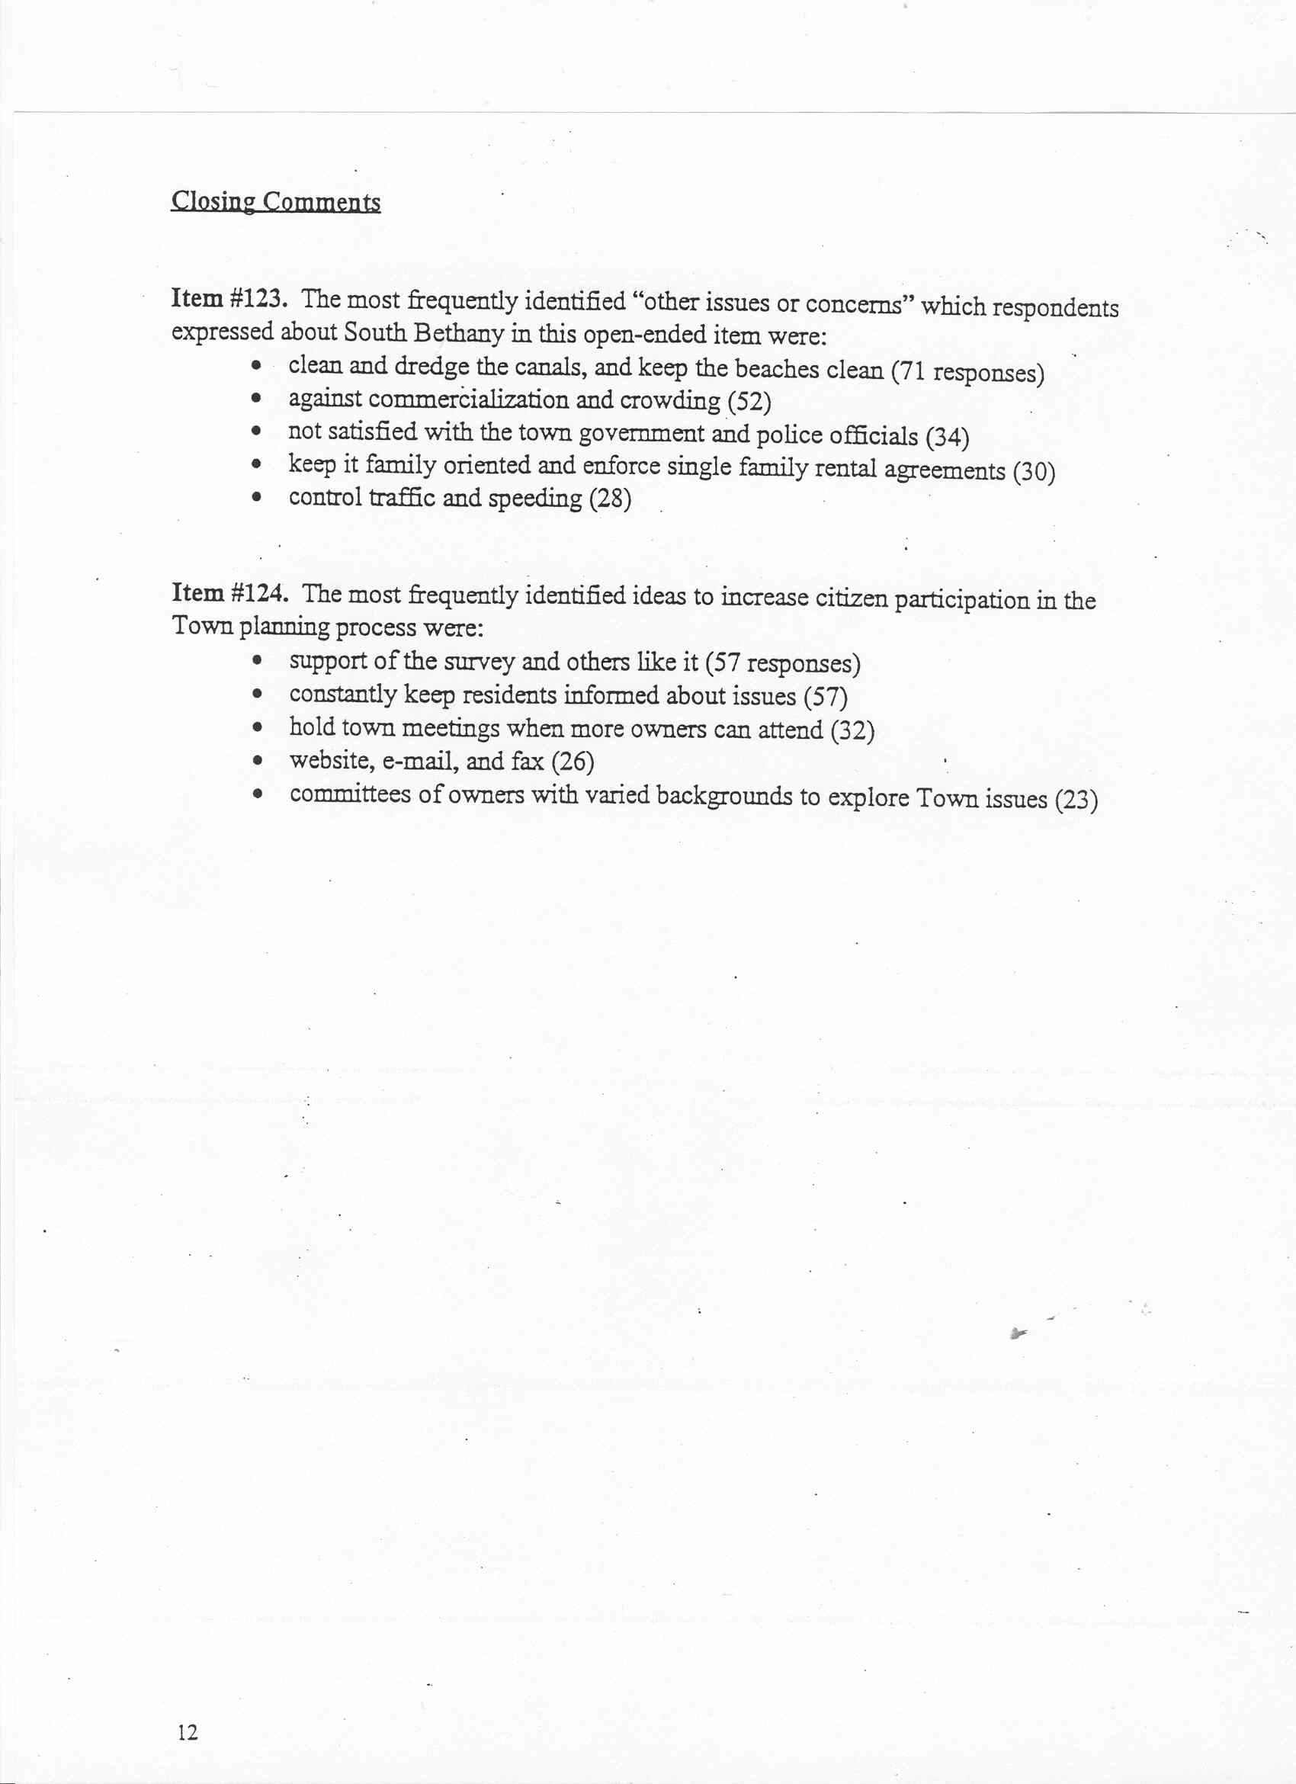

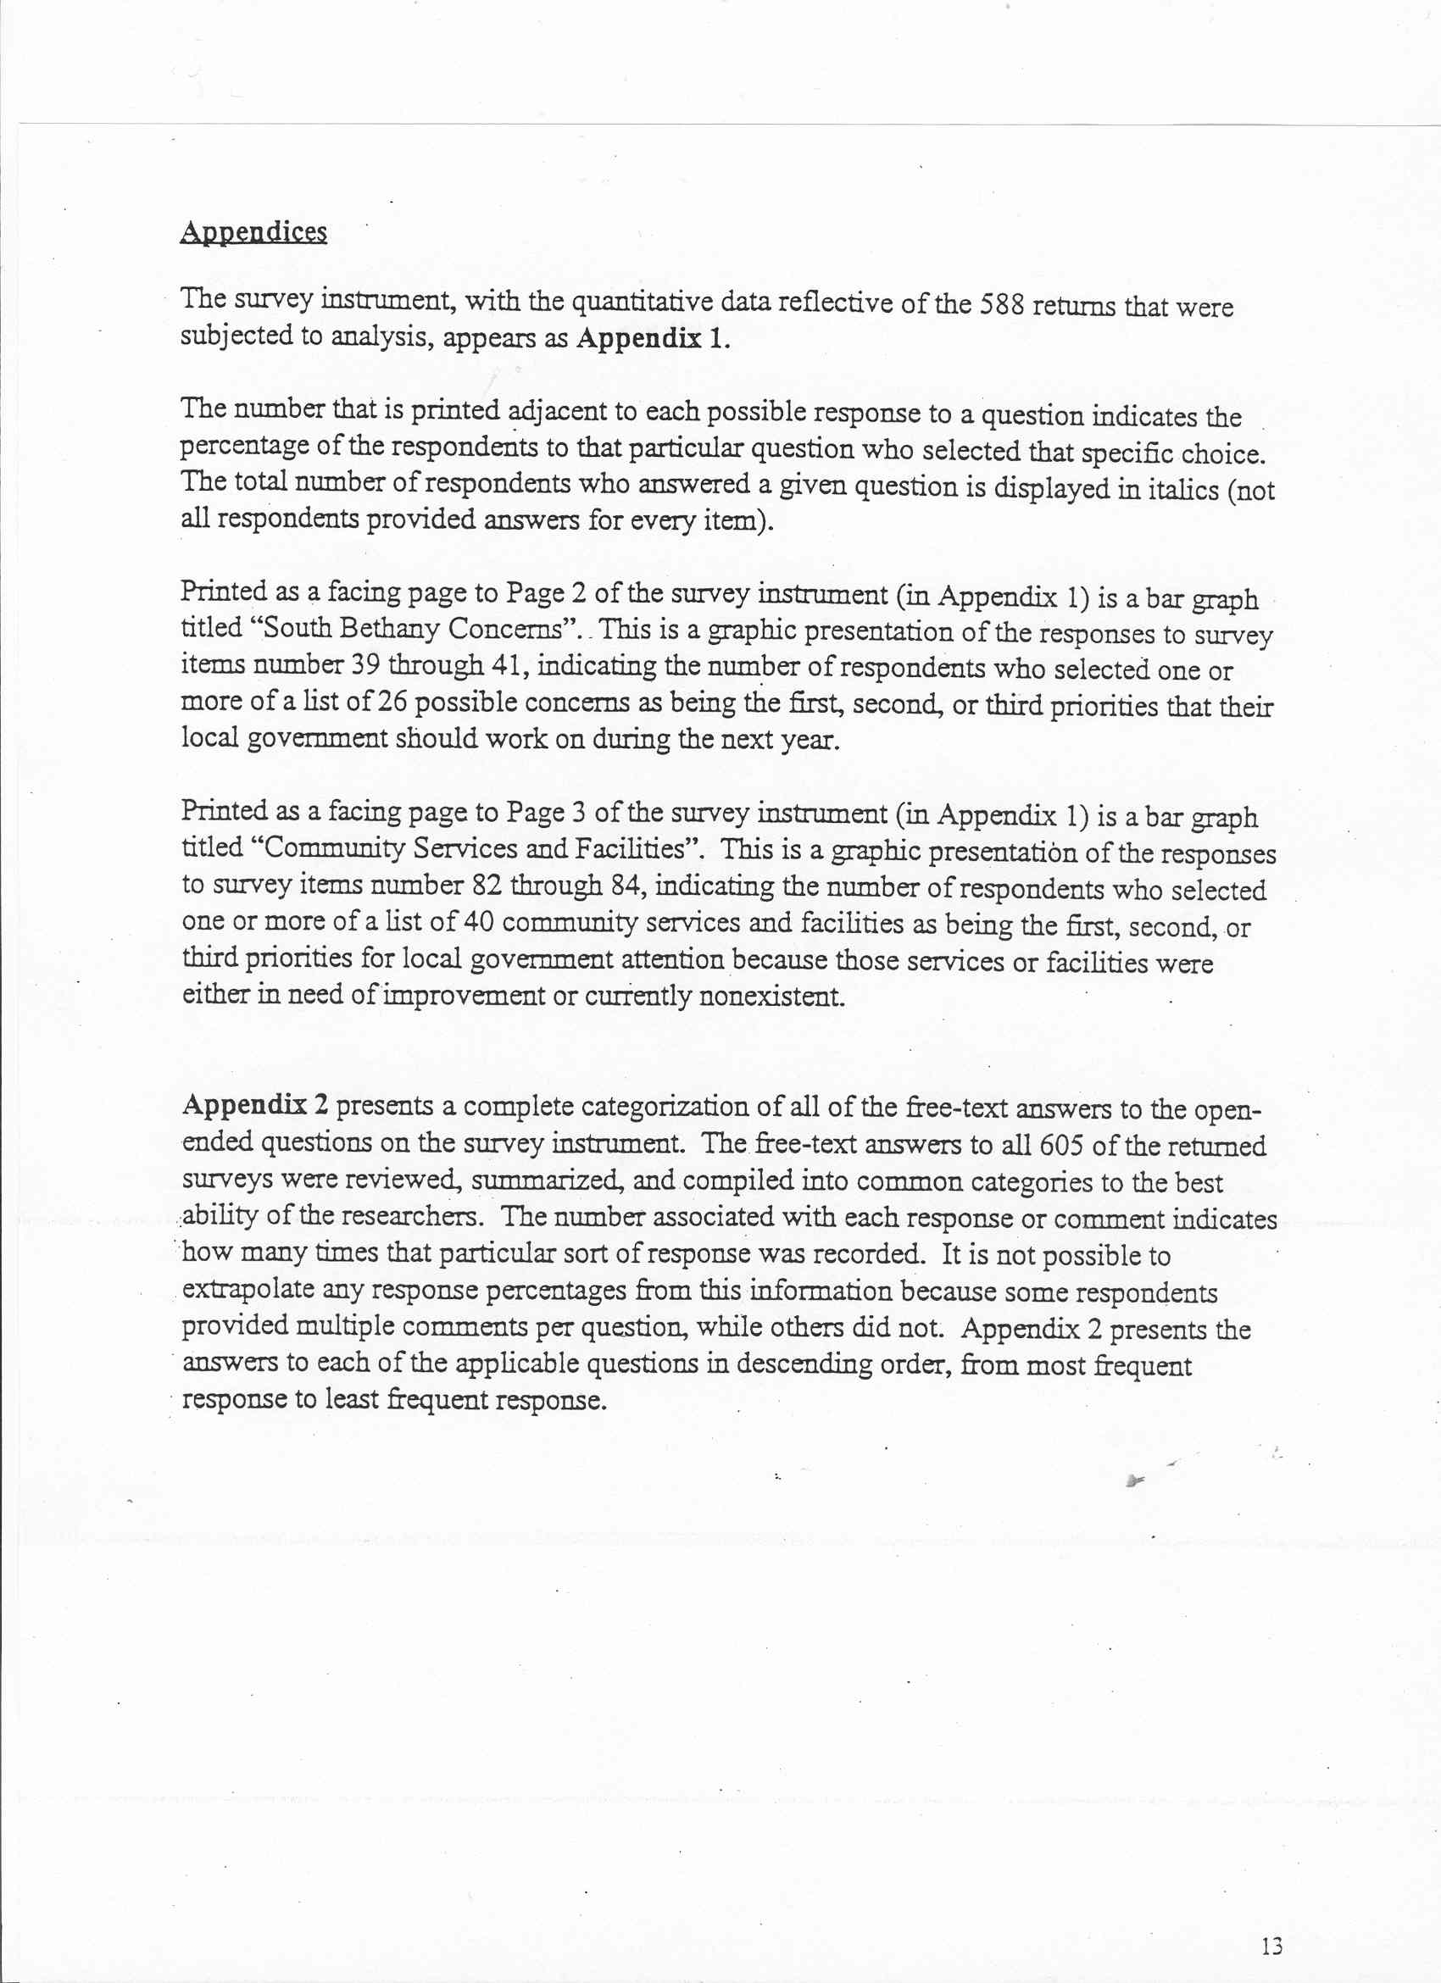

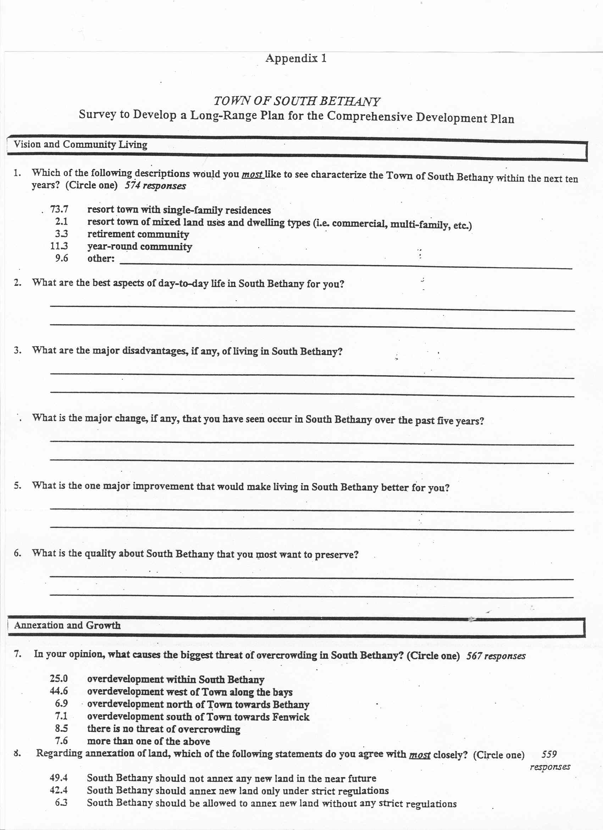

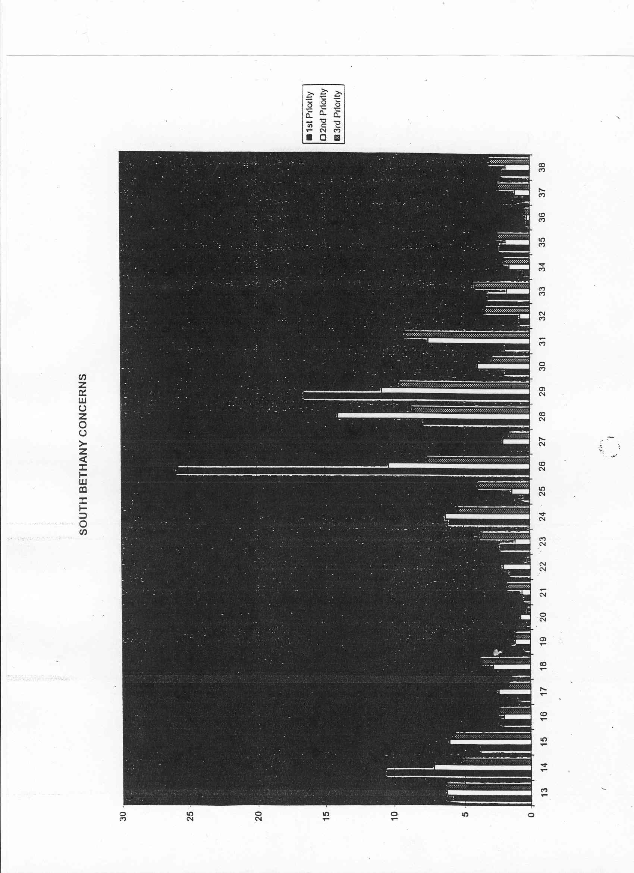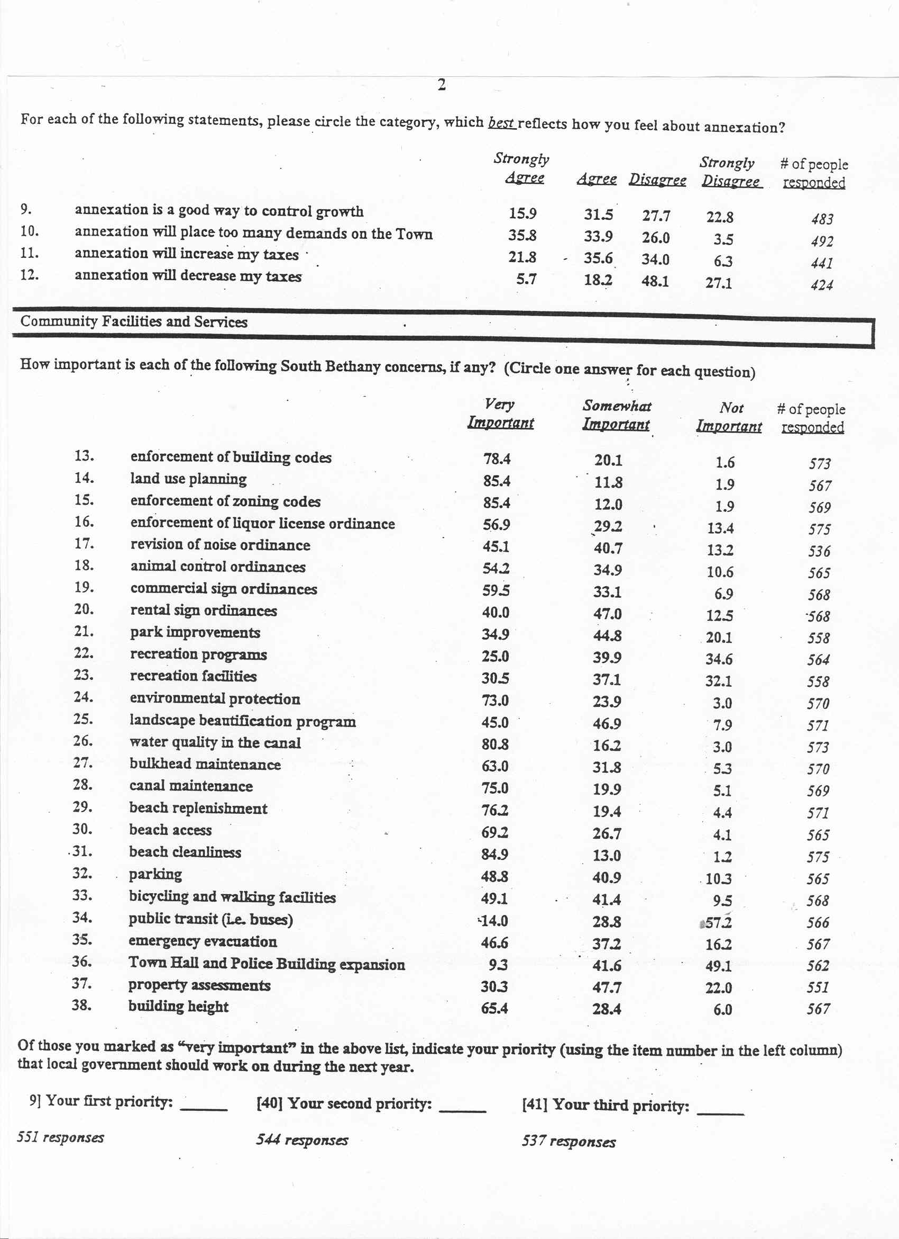

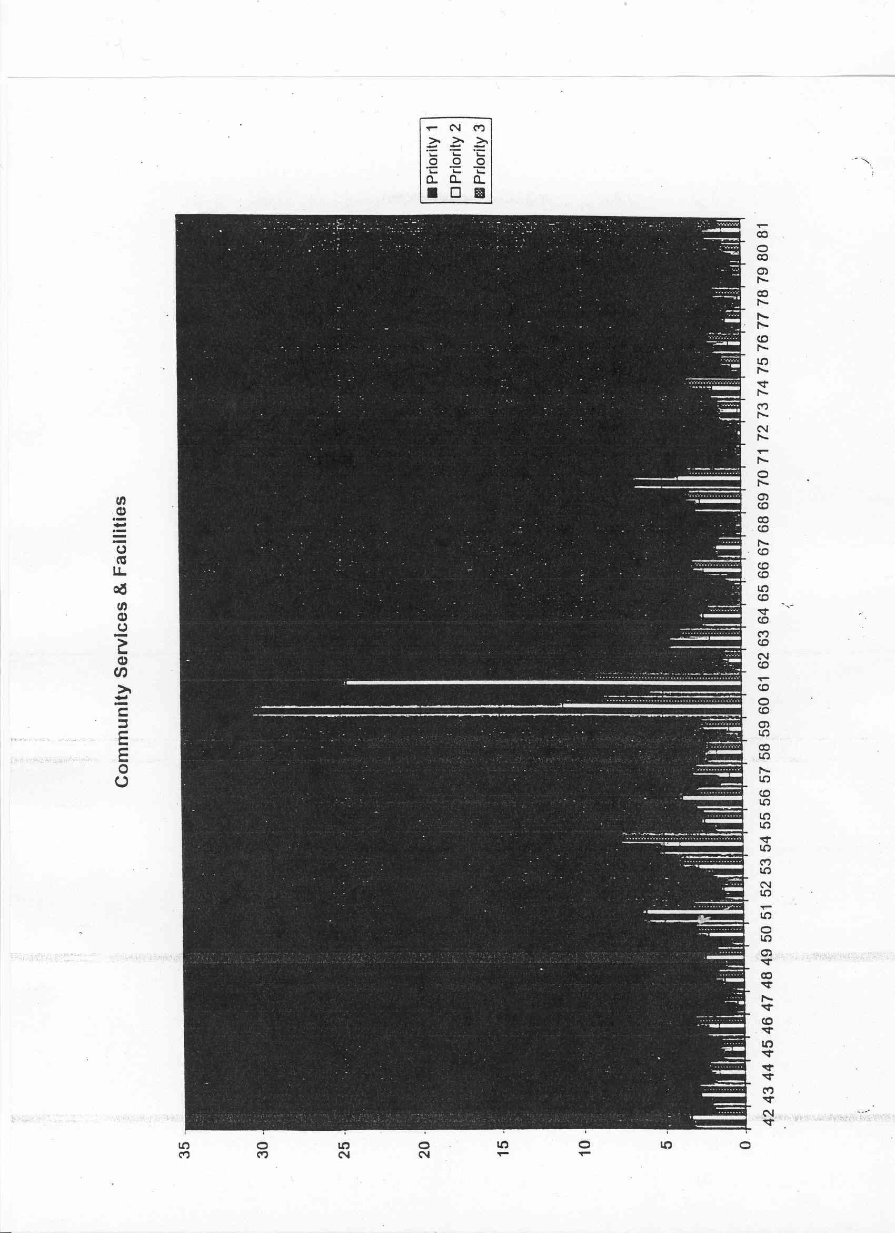

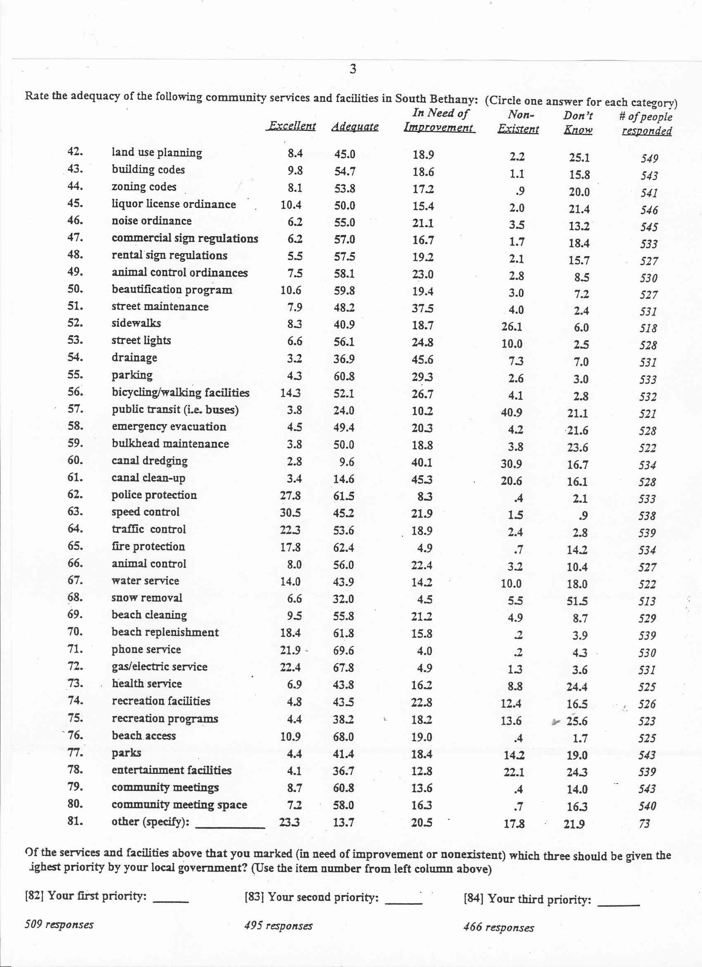

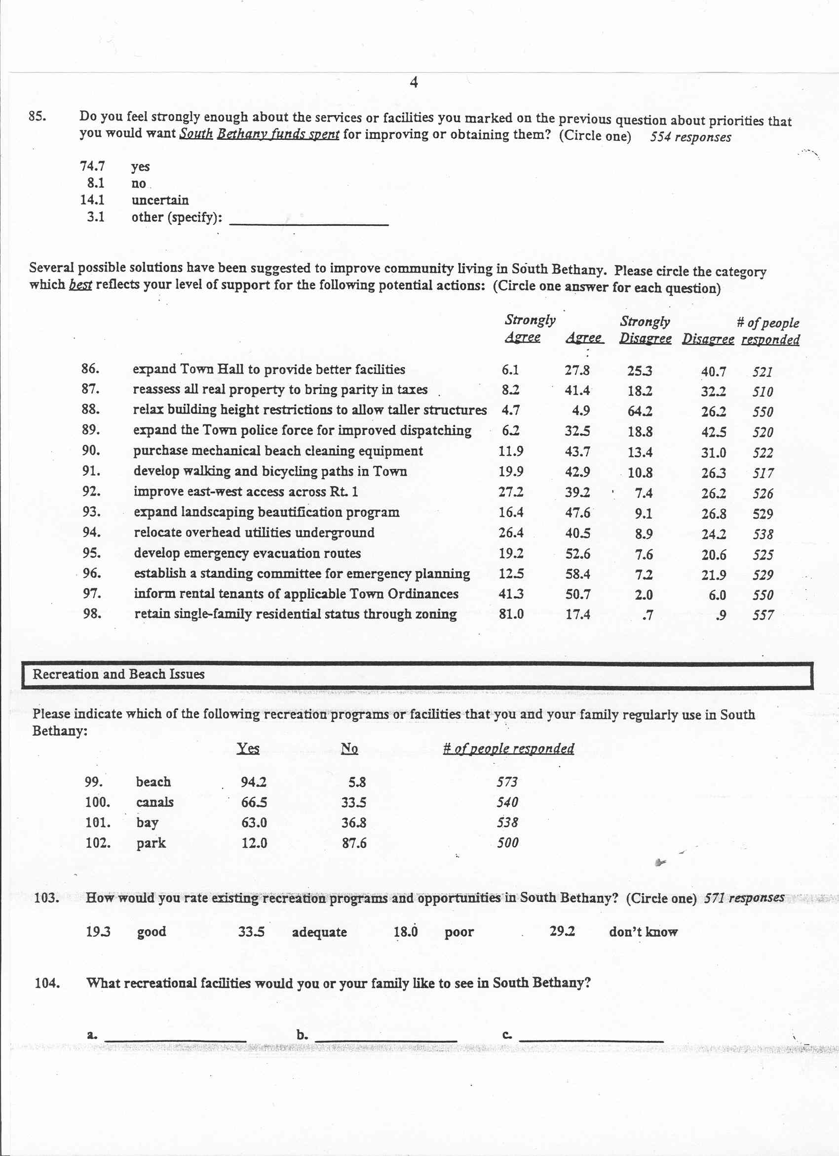

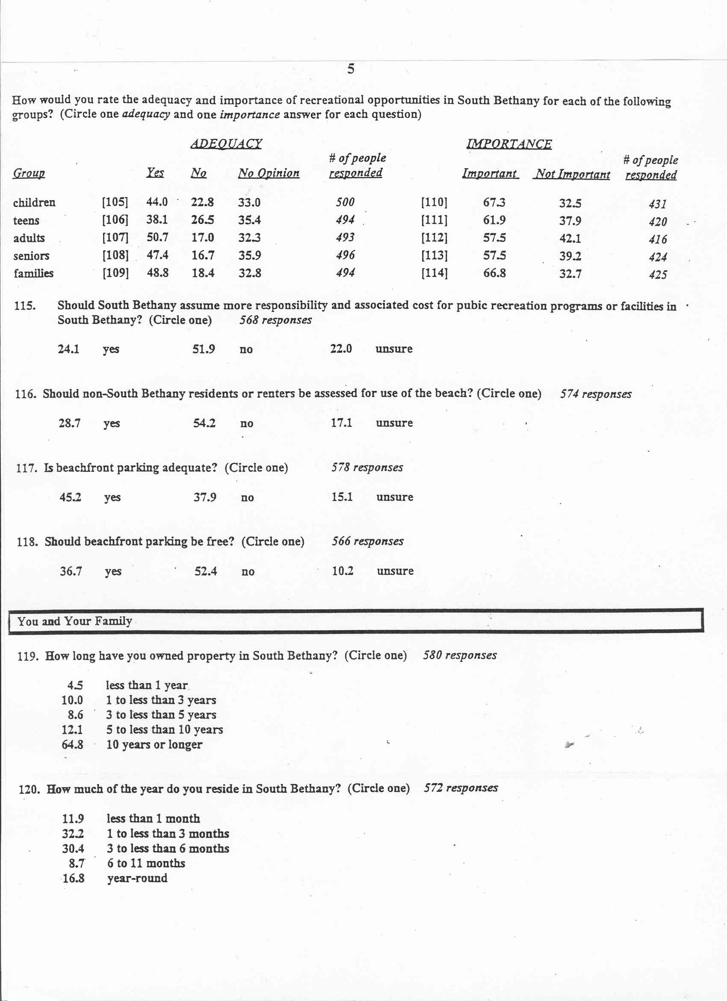

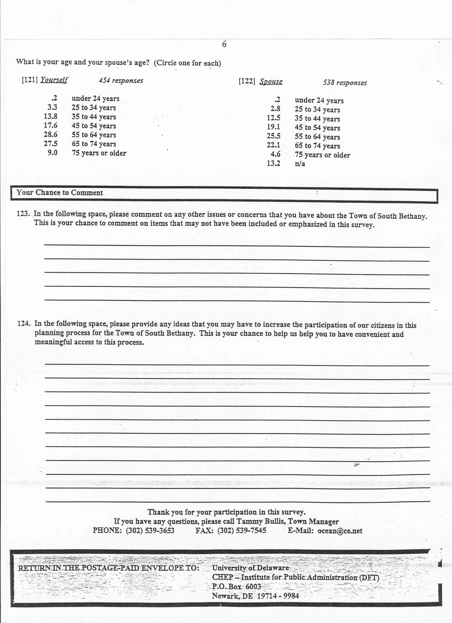

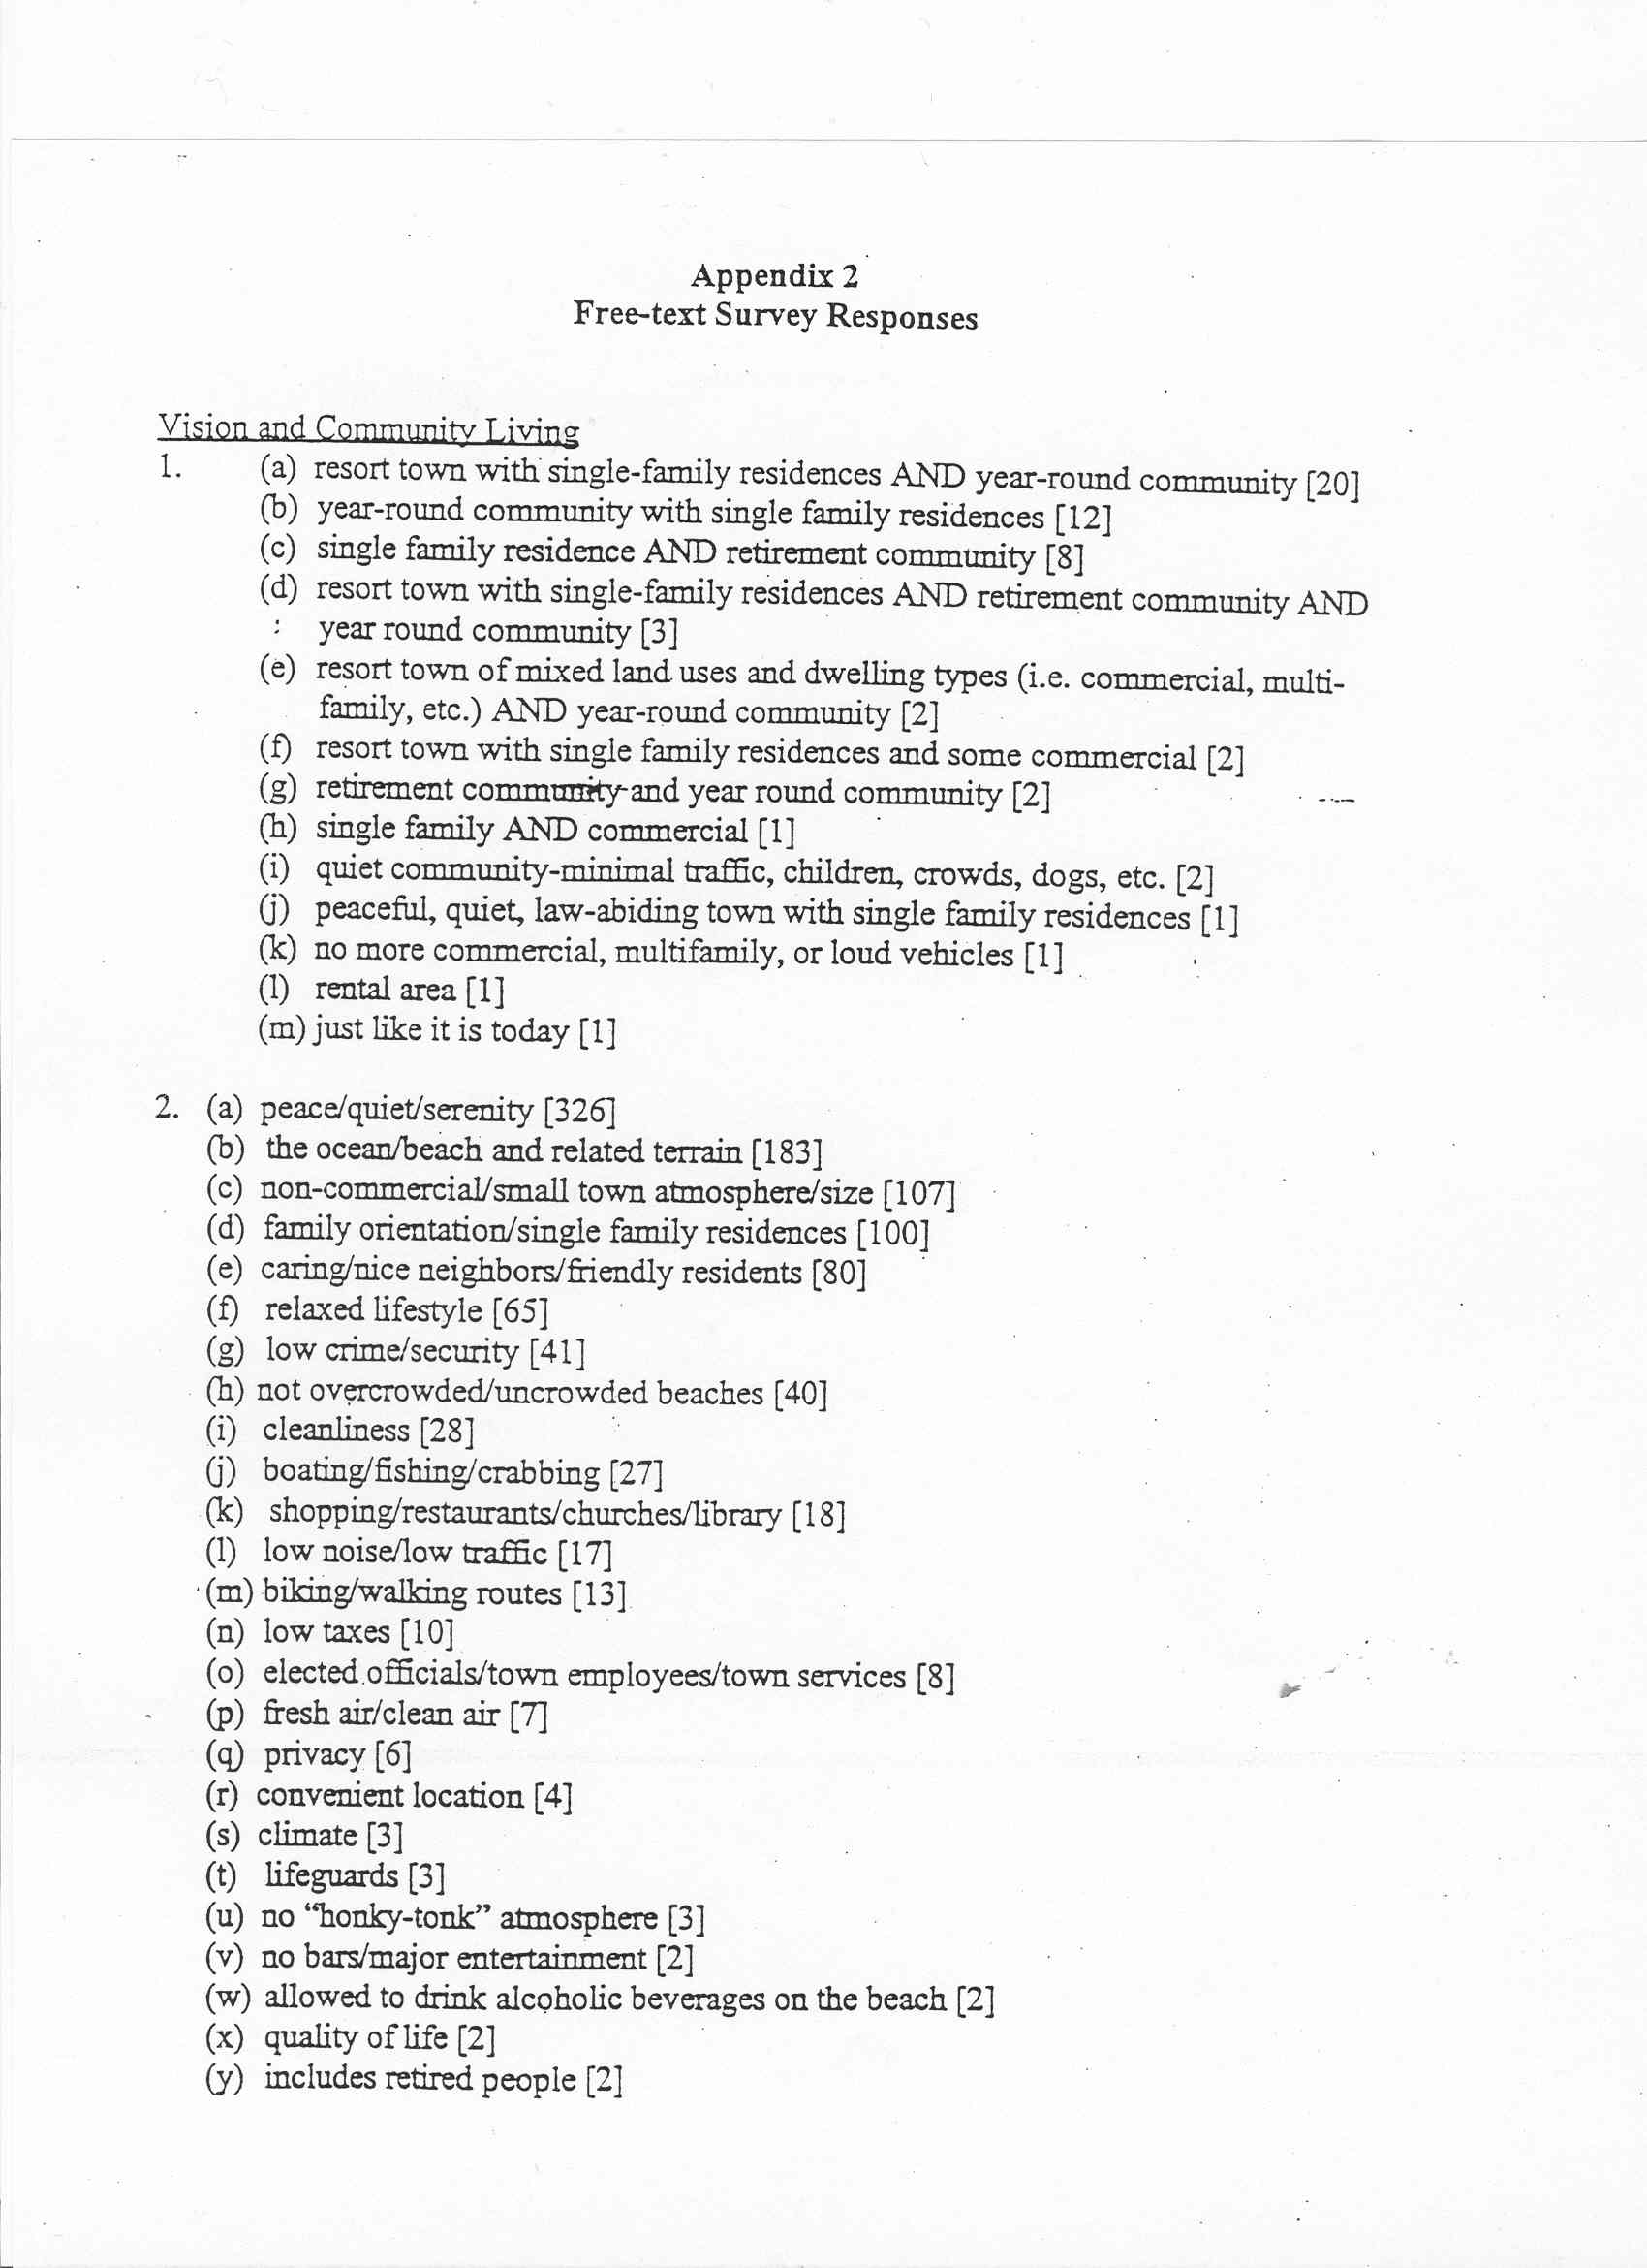

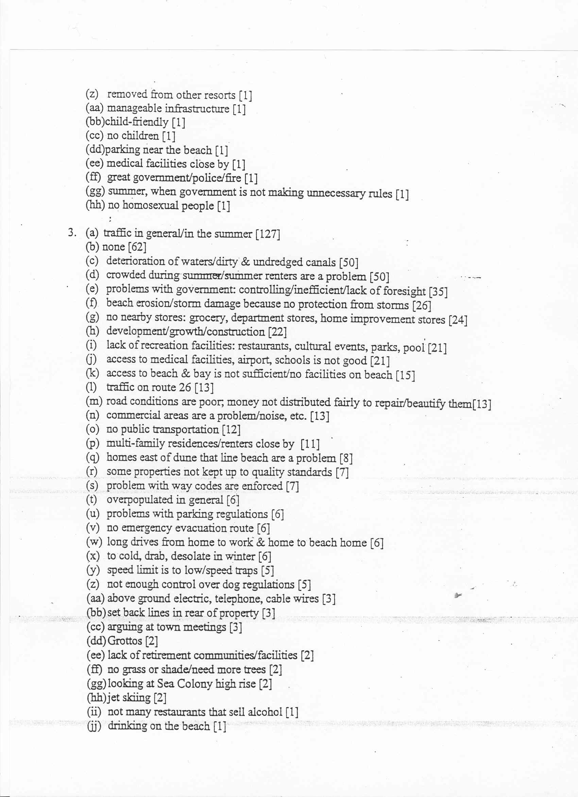

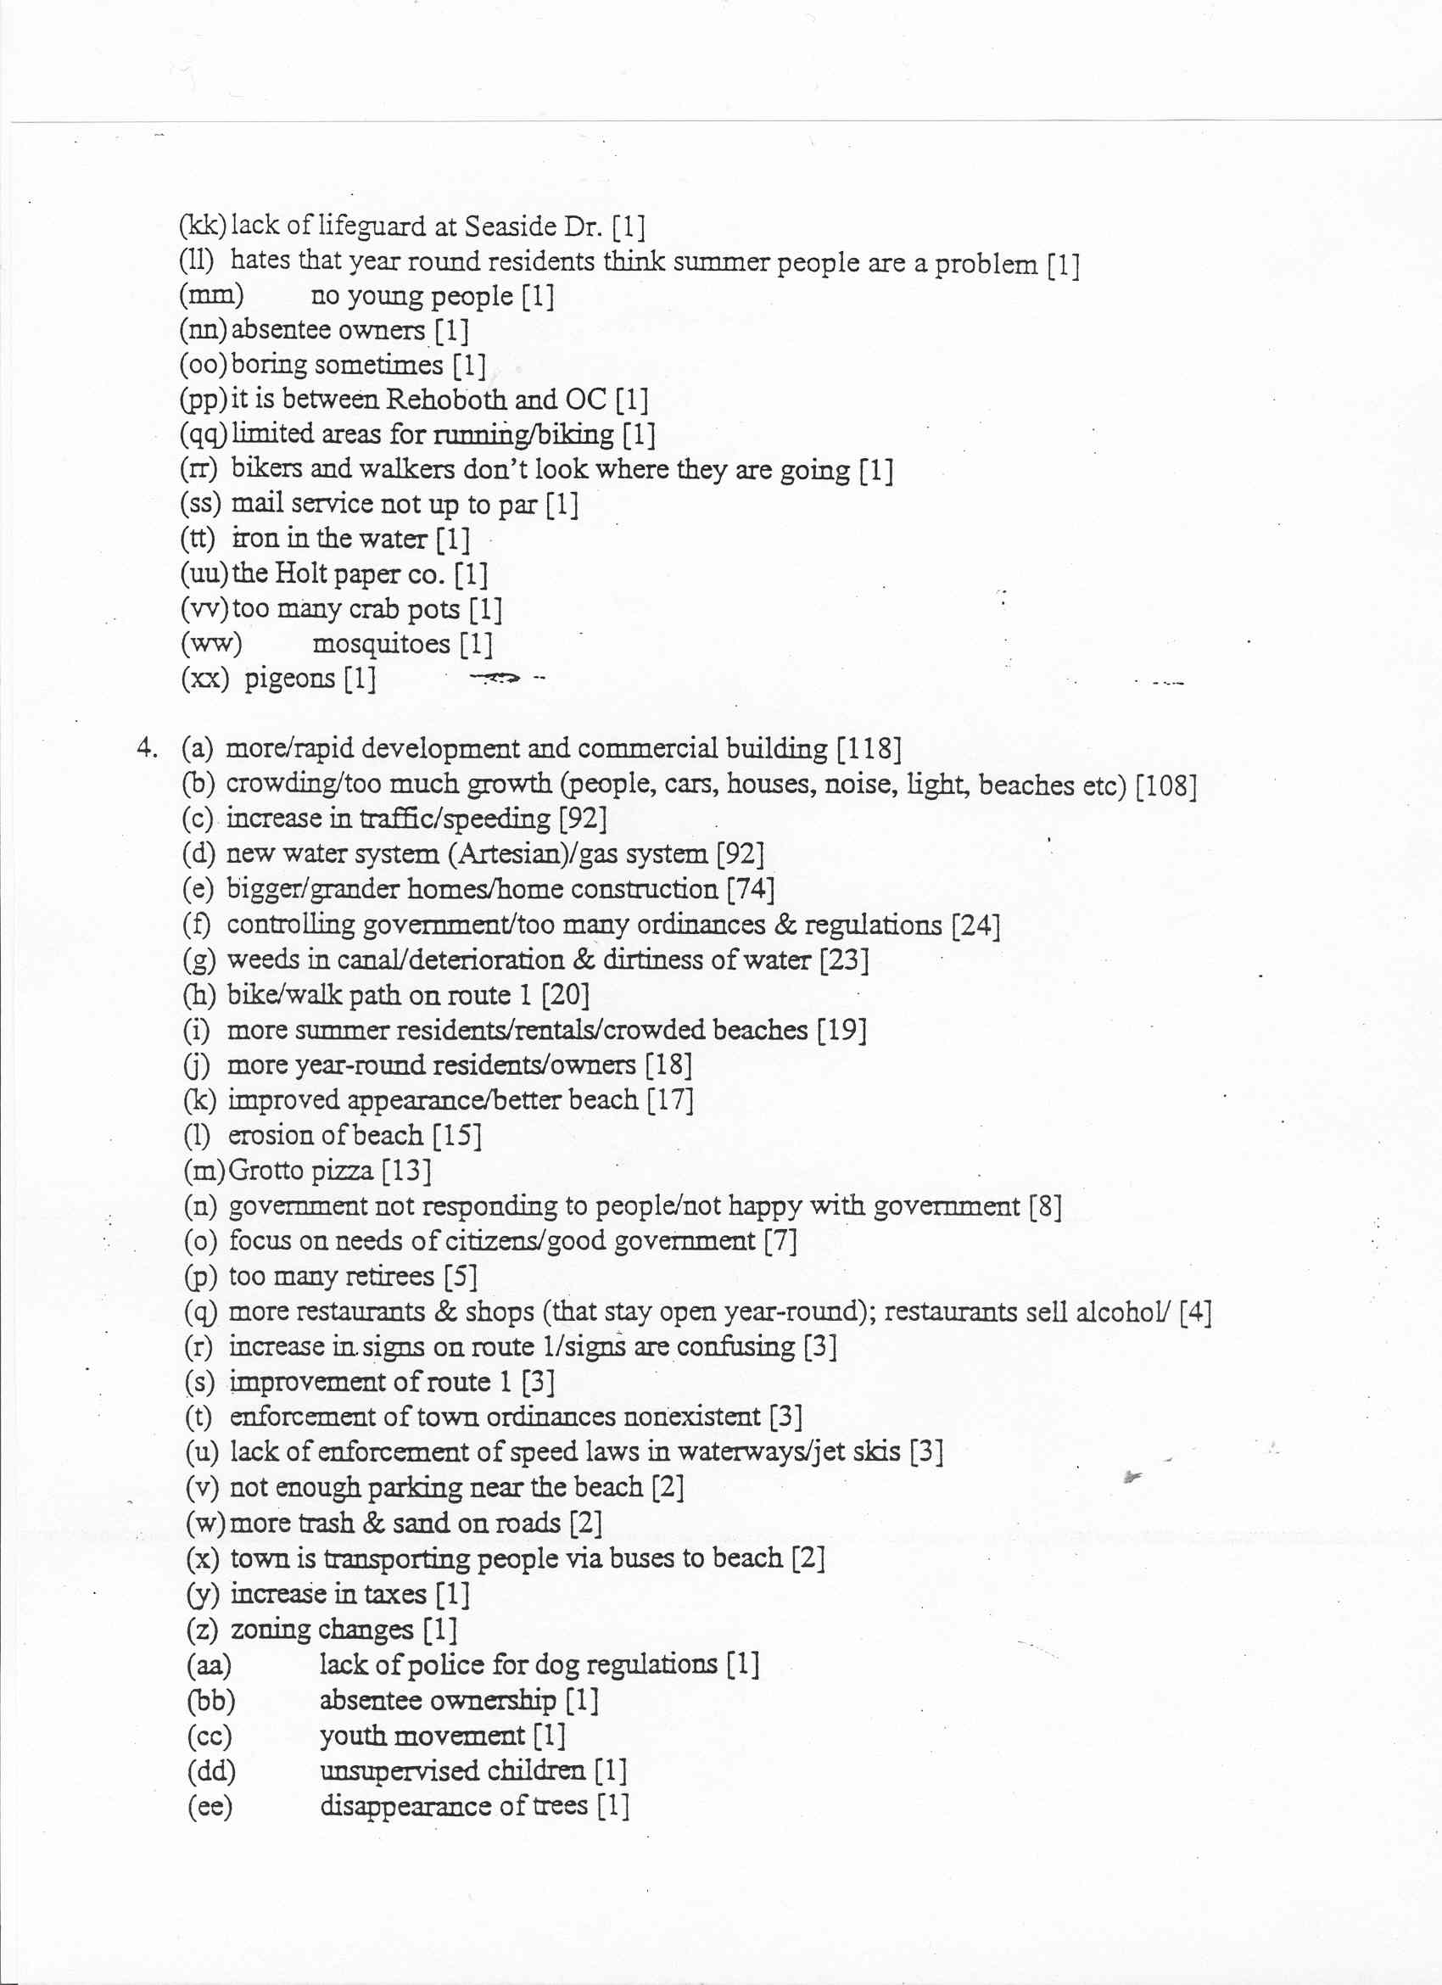

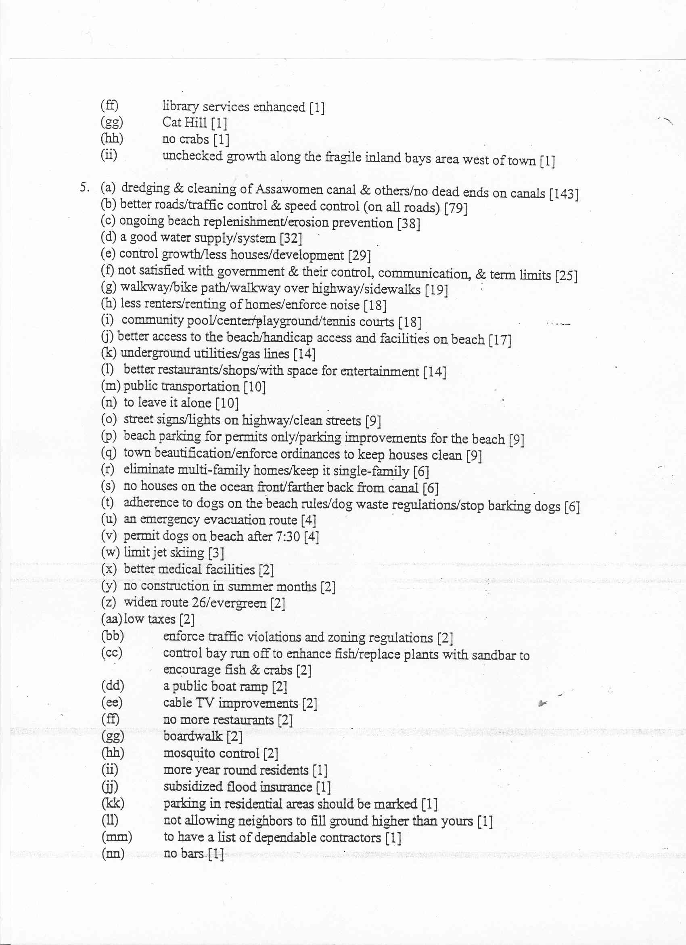

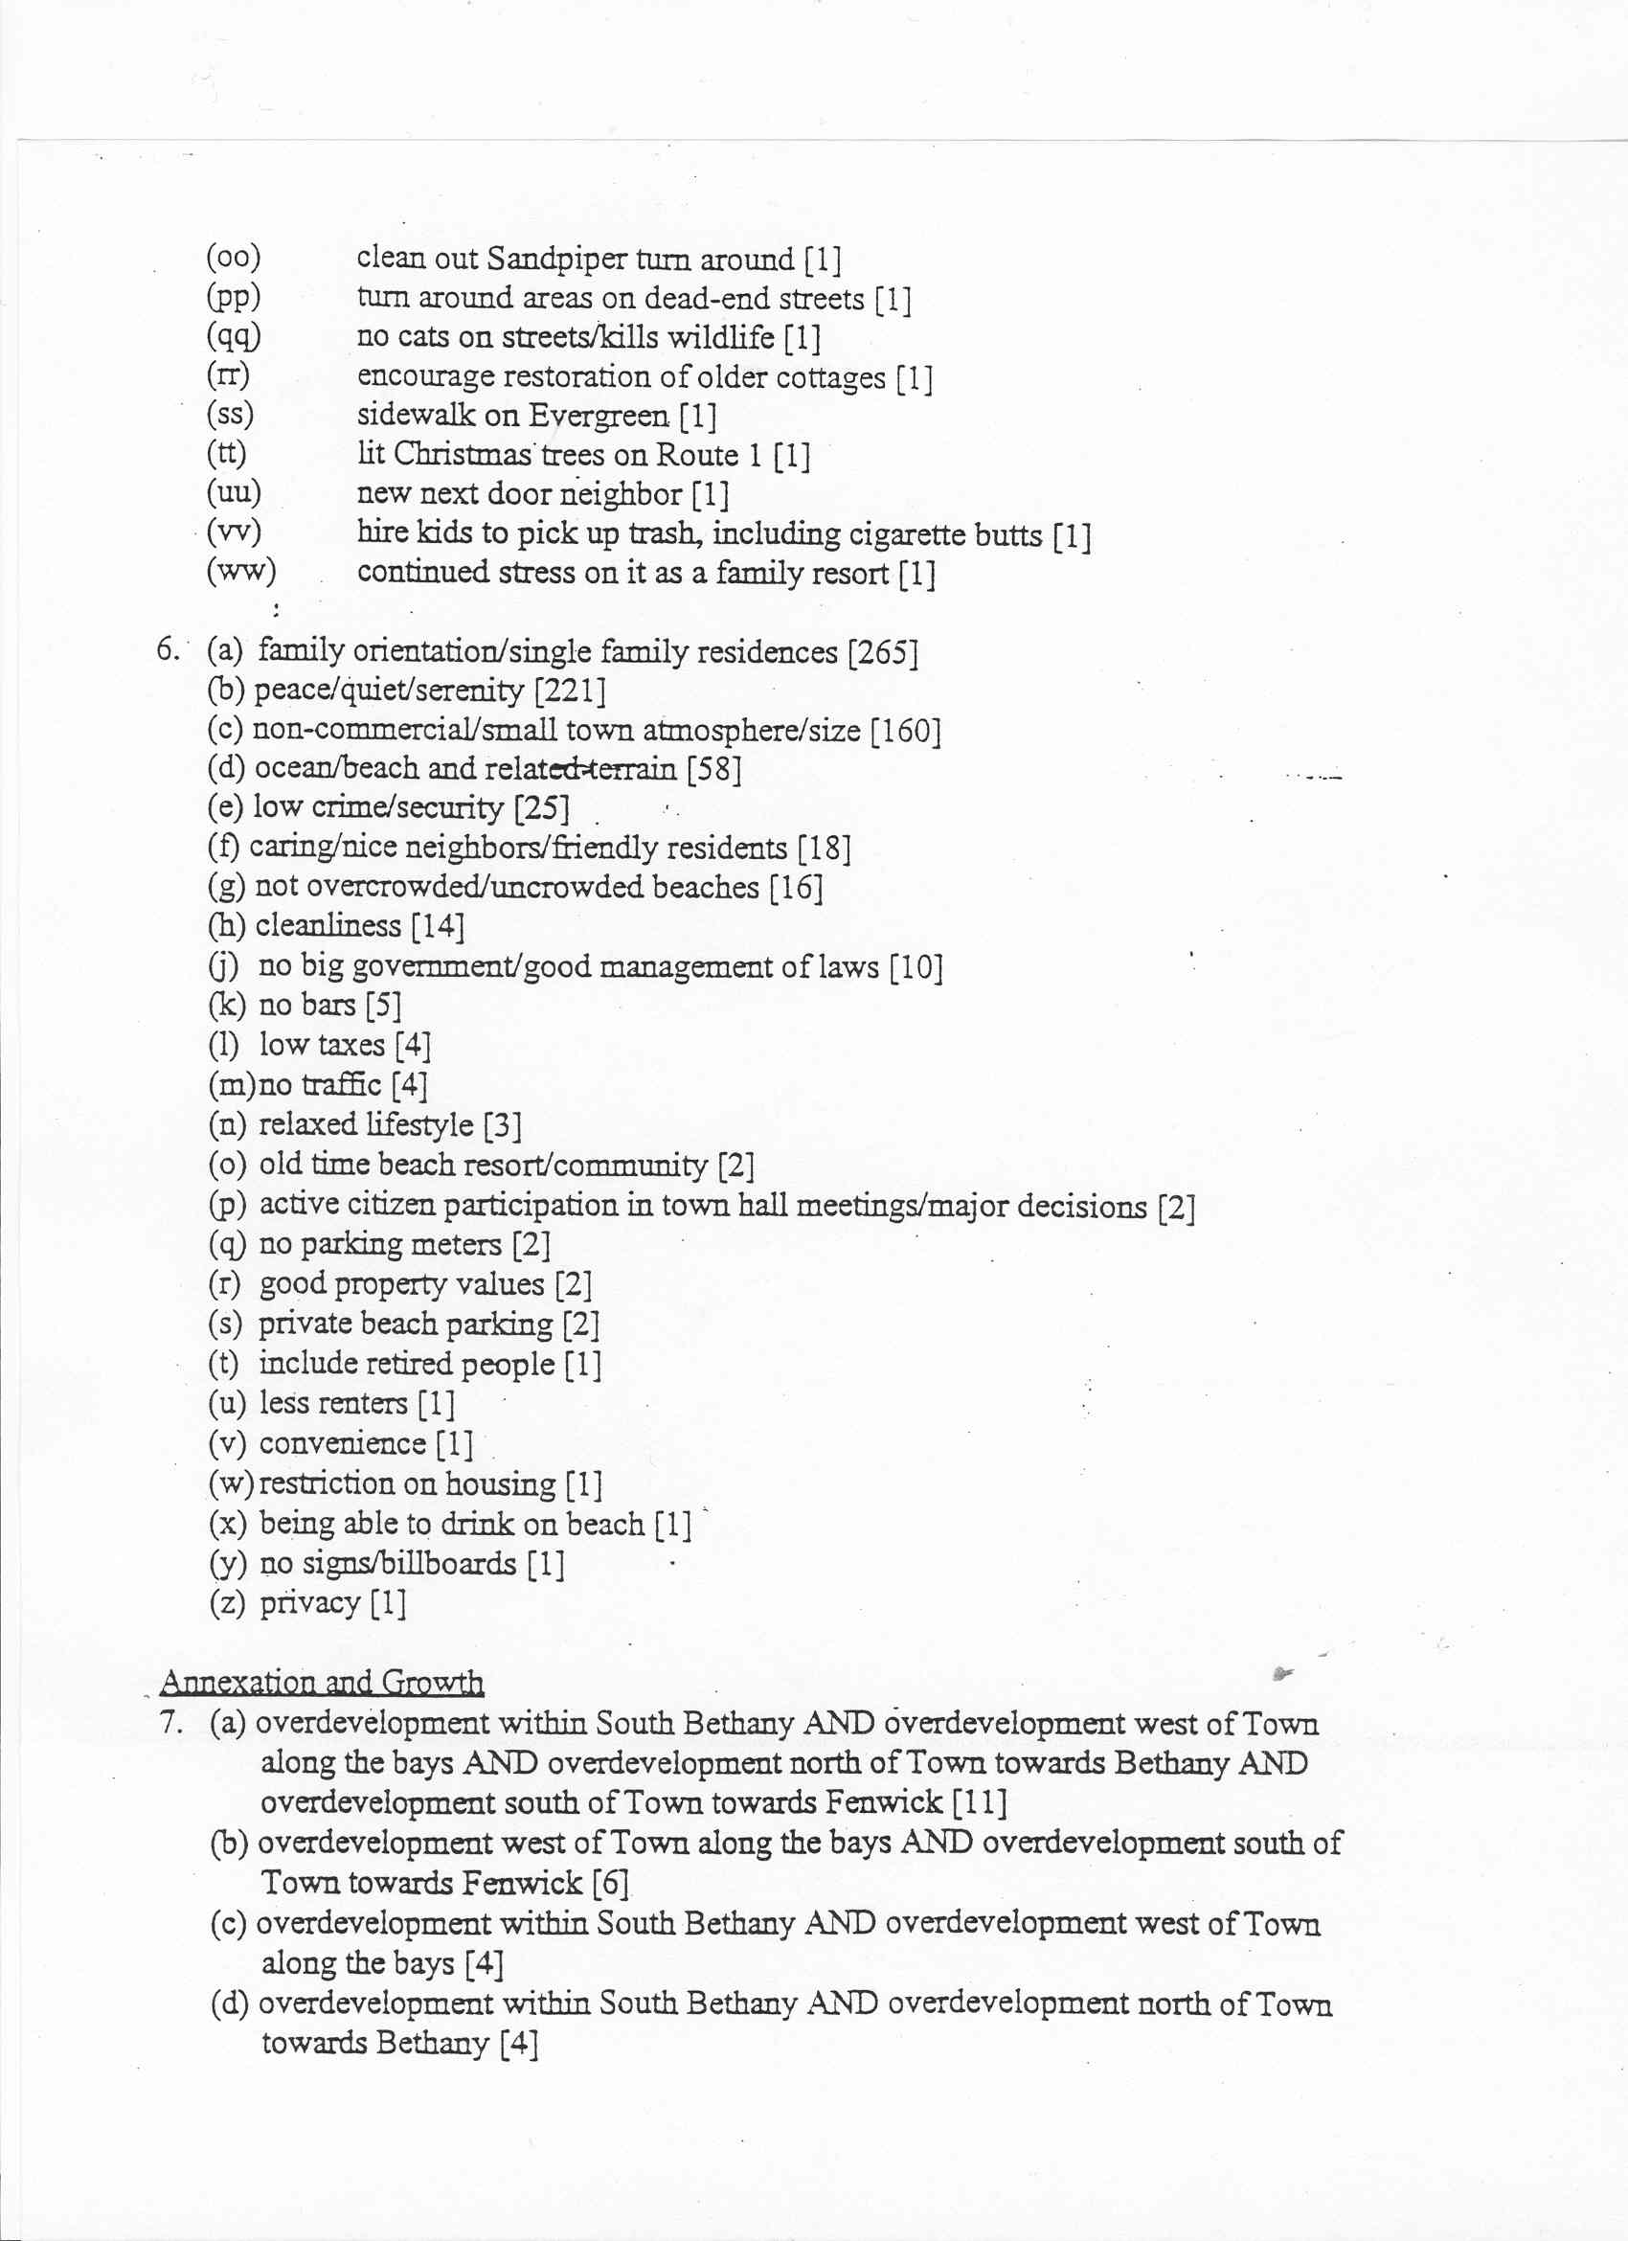

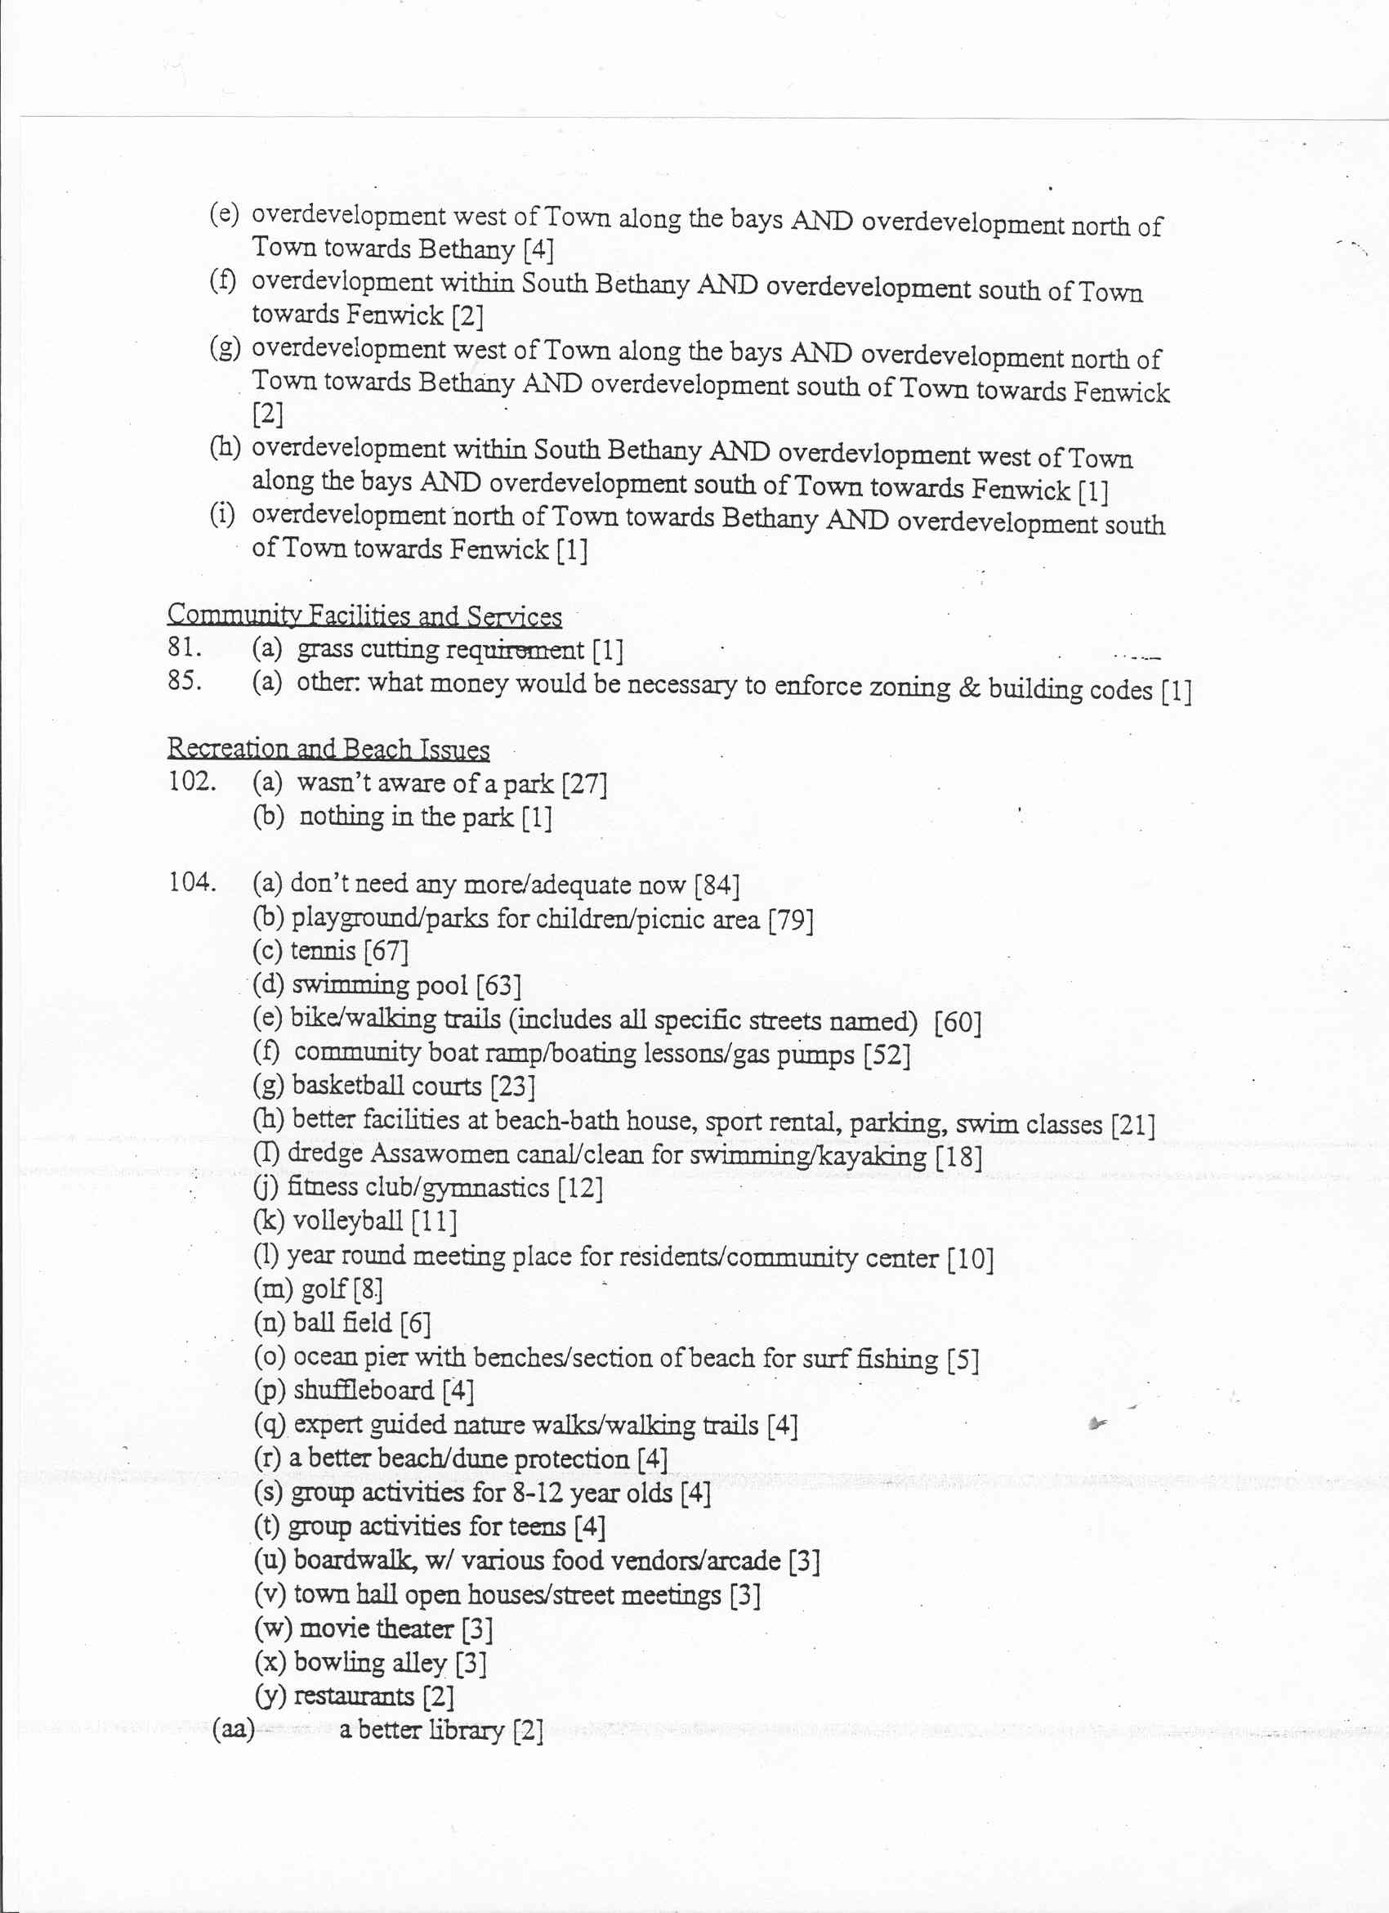

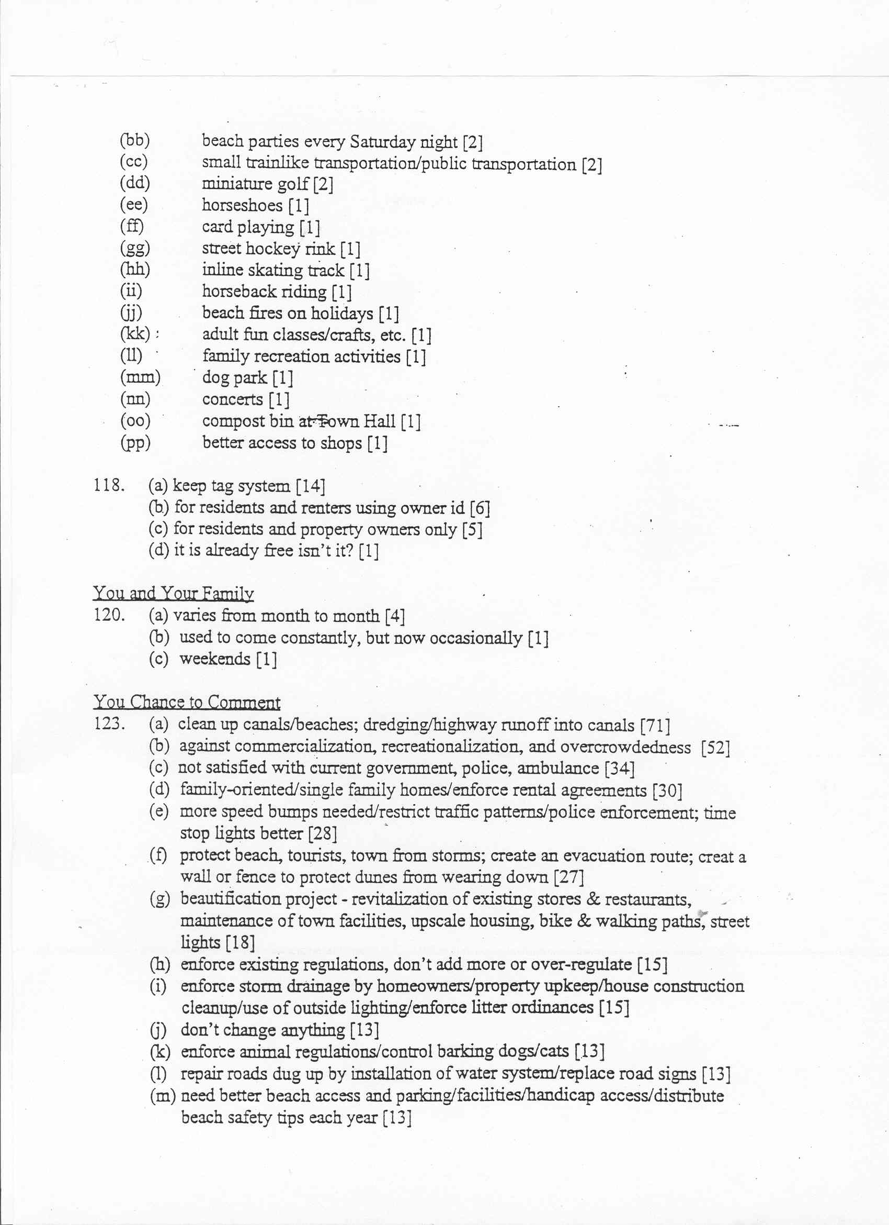

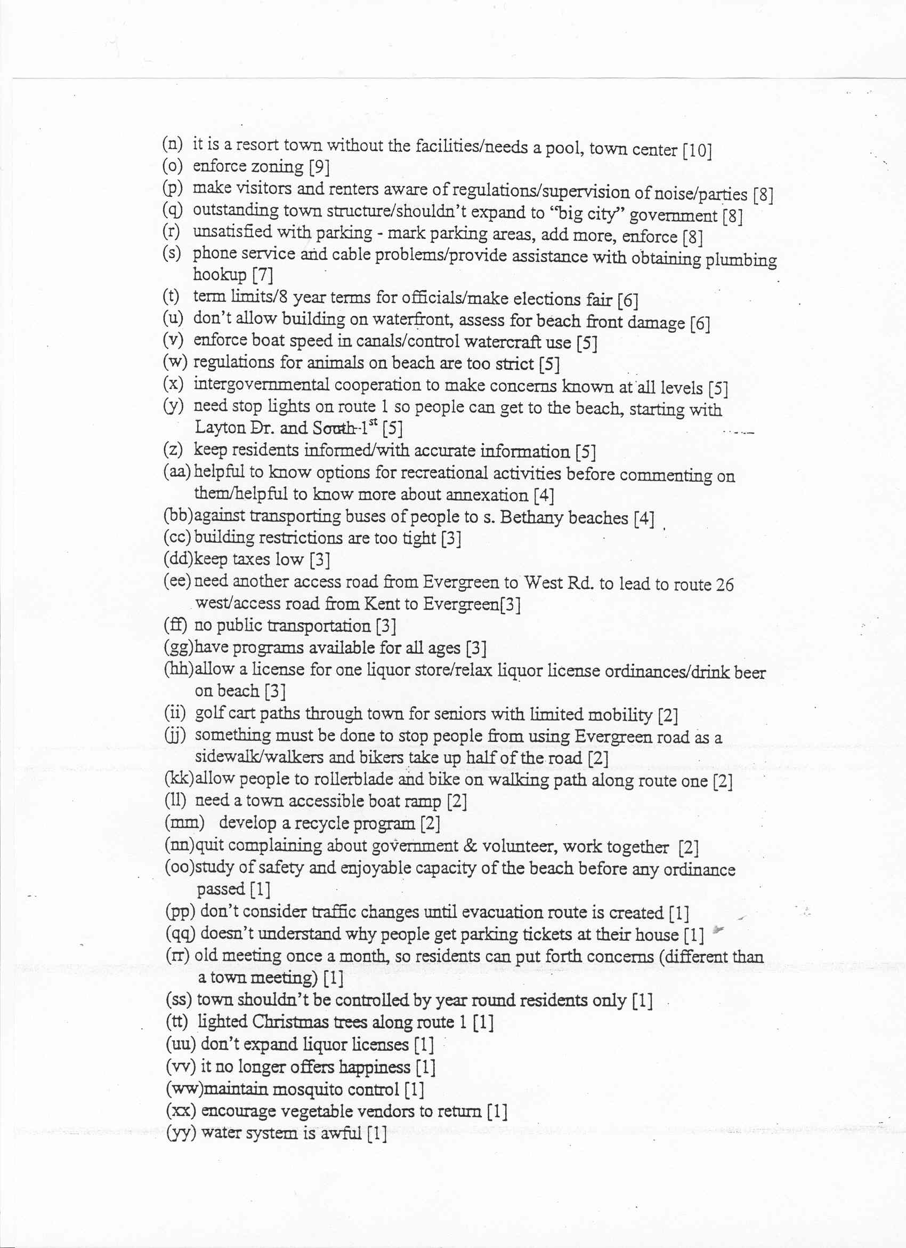

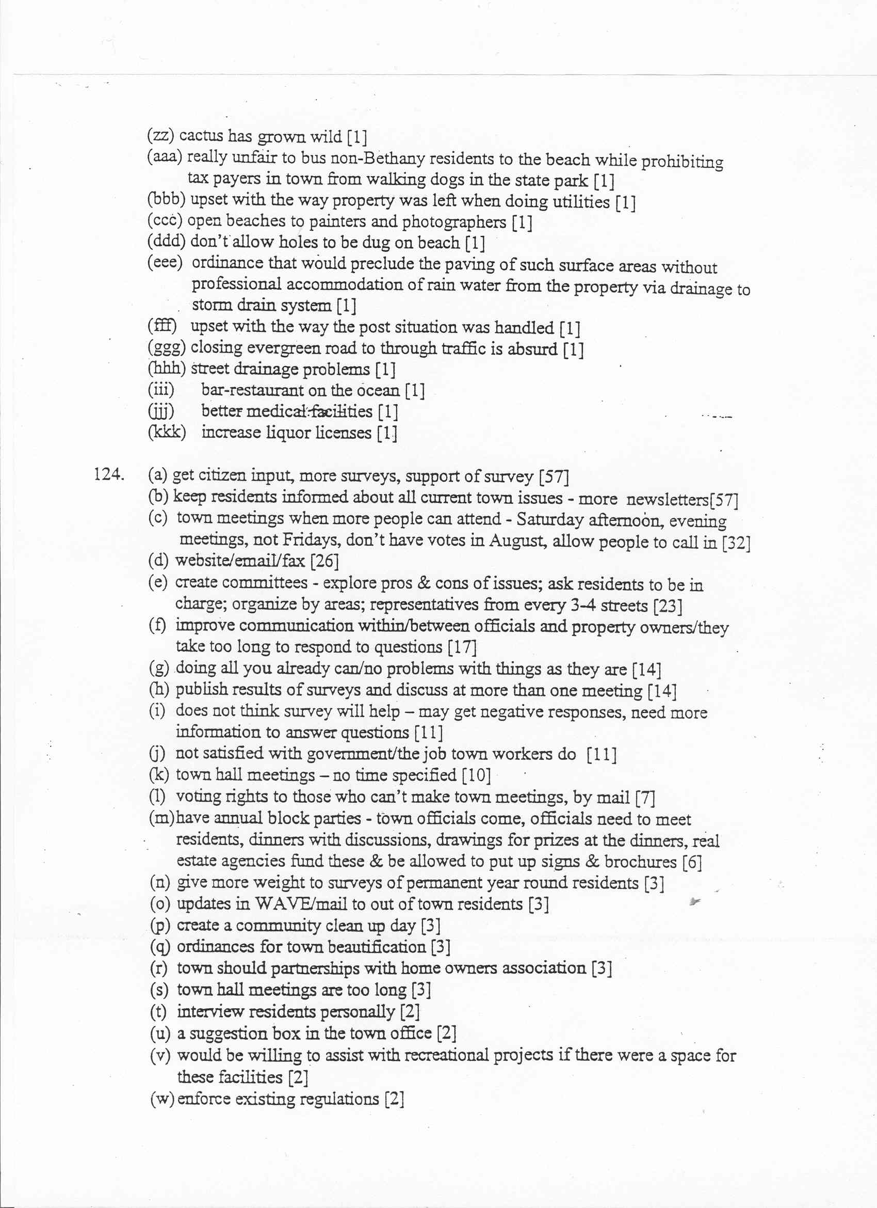

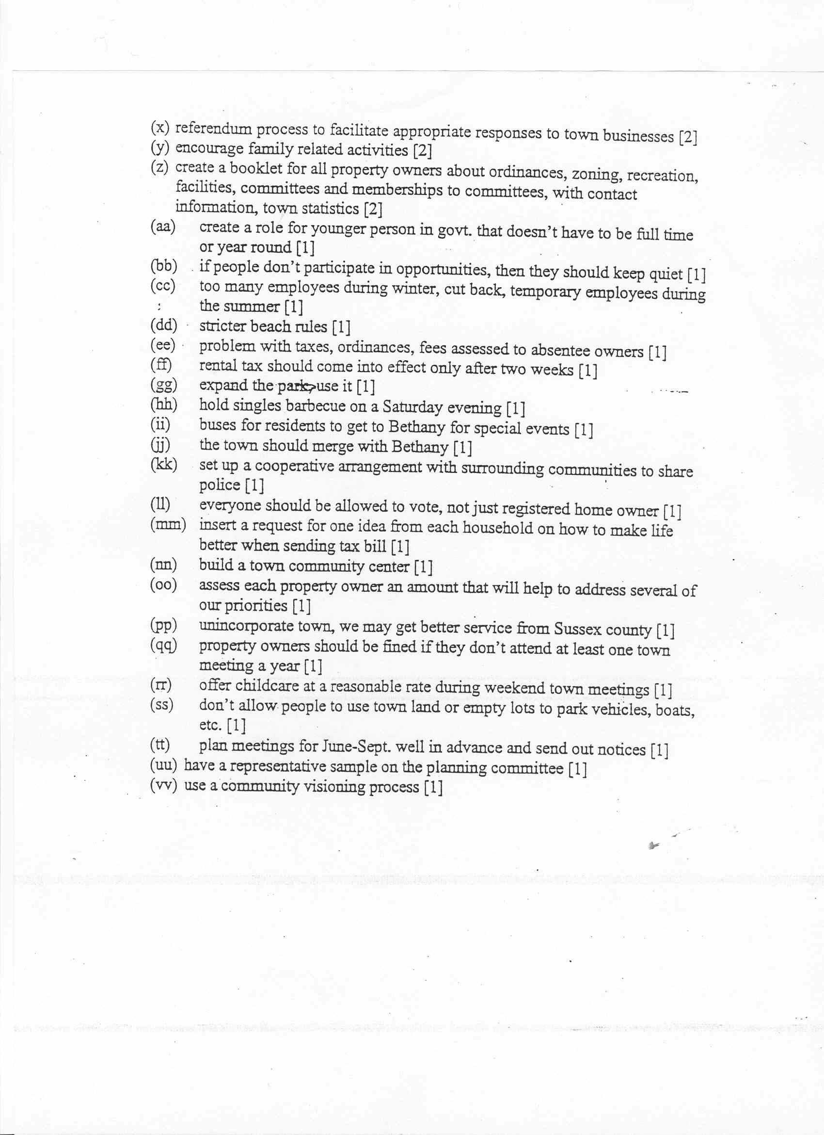

APPENDIX B

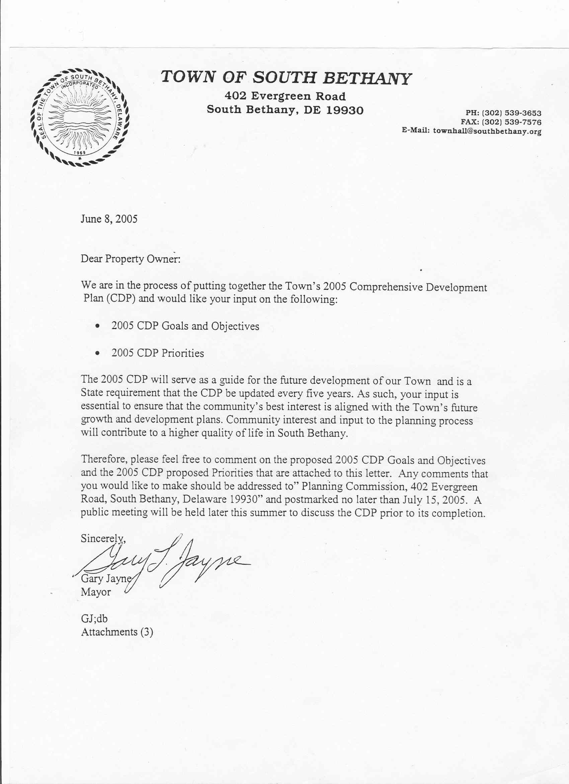

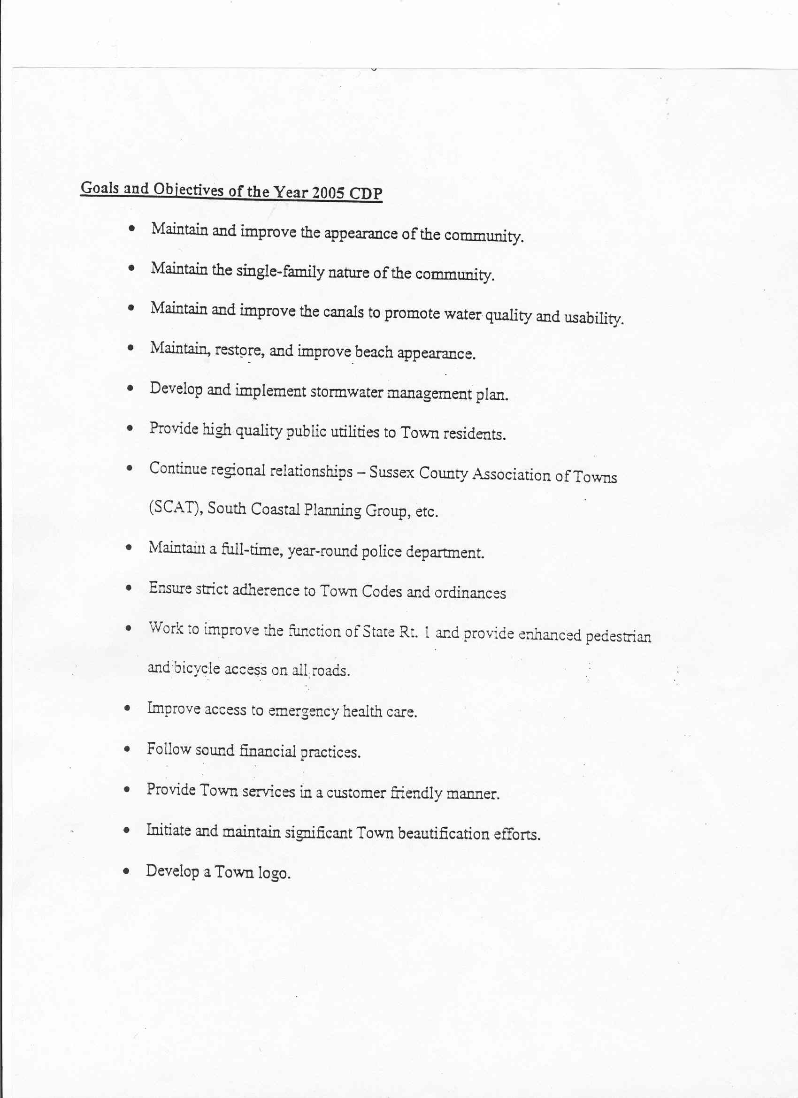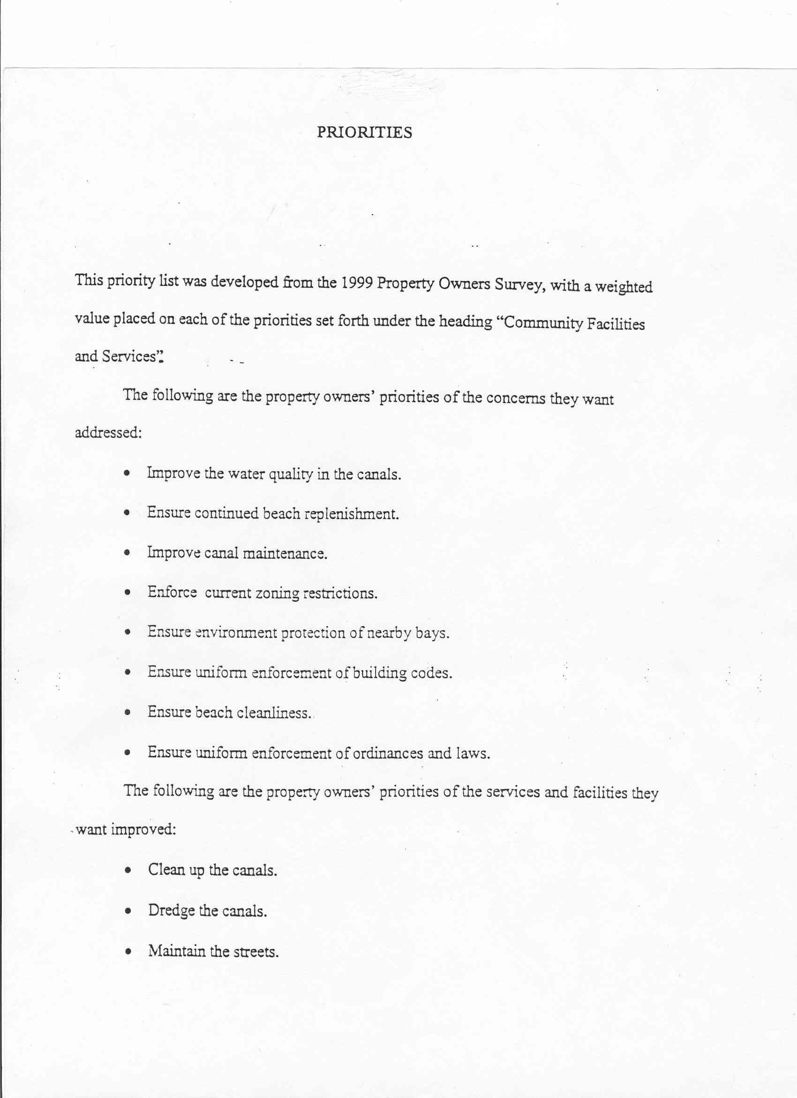

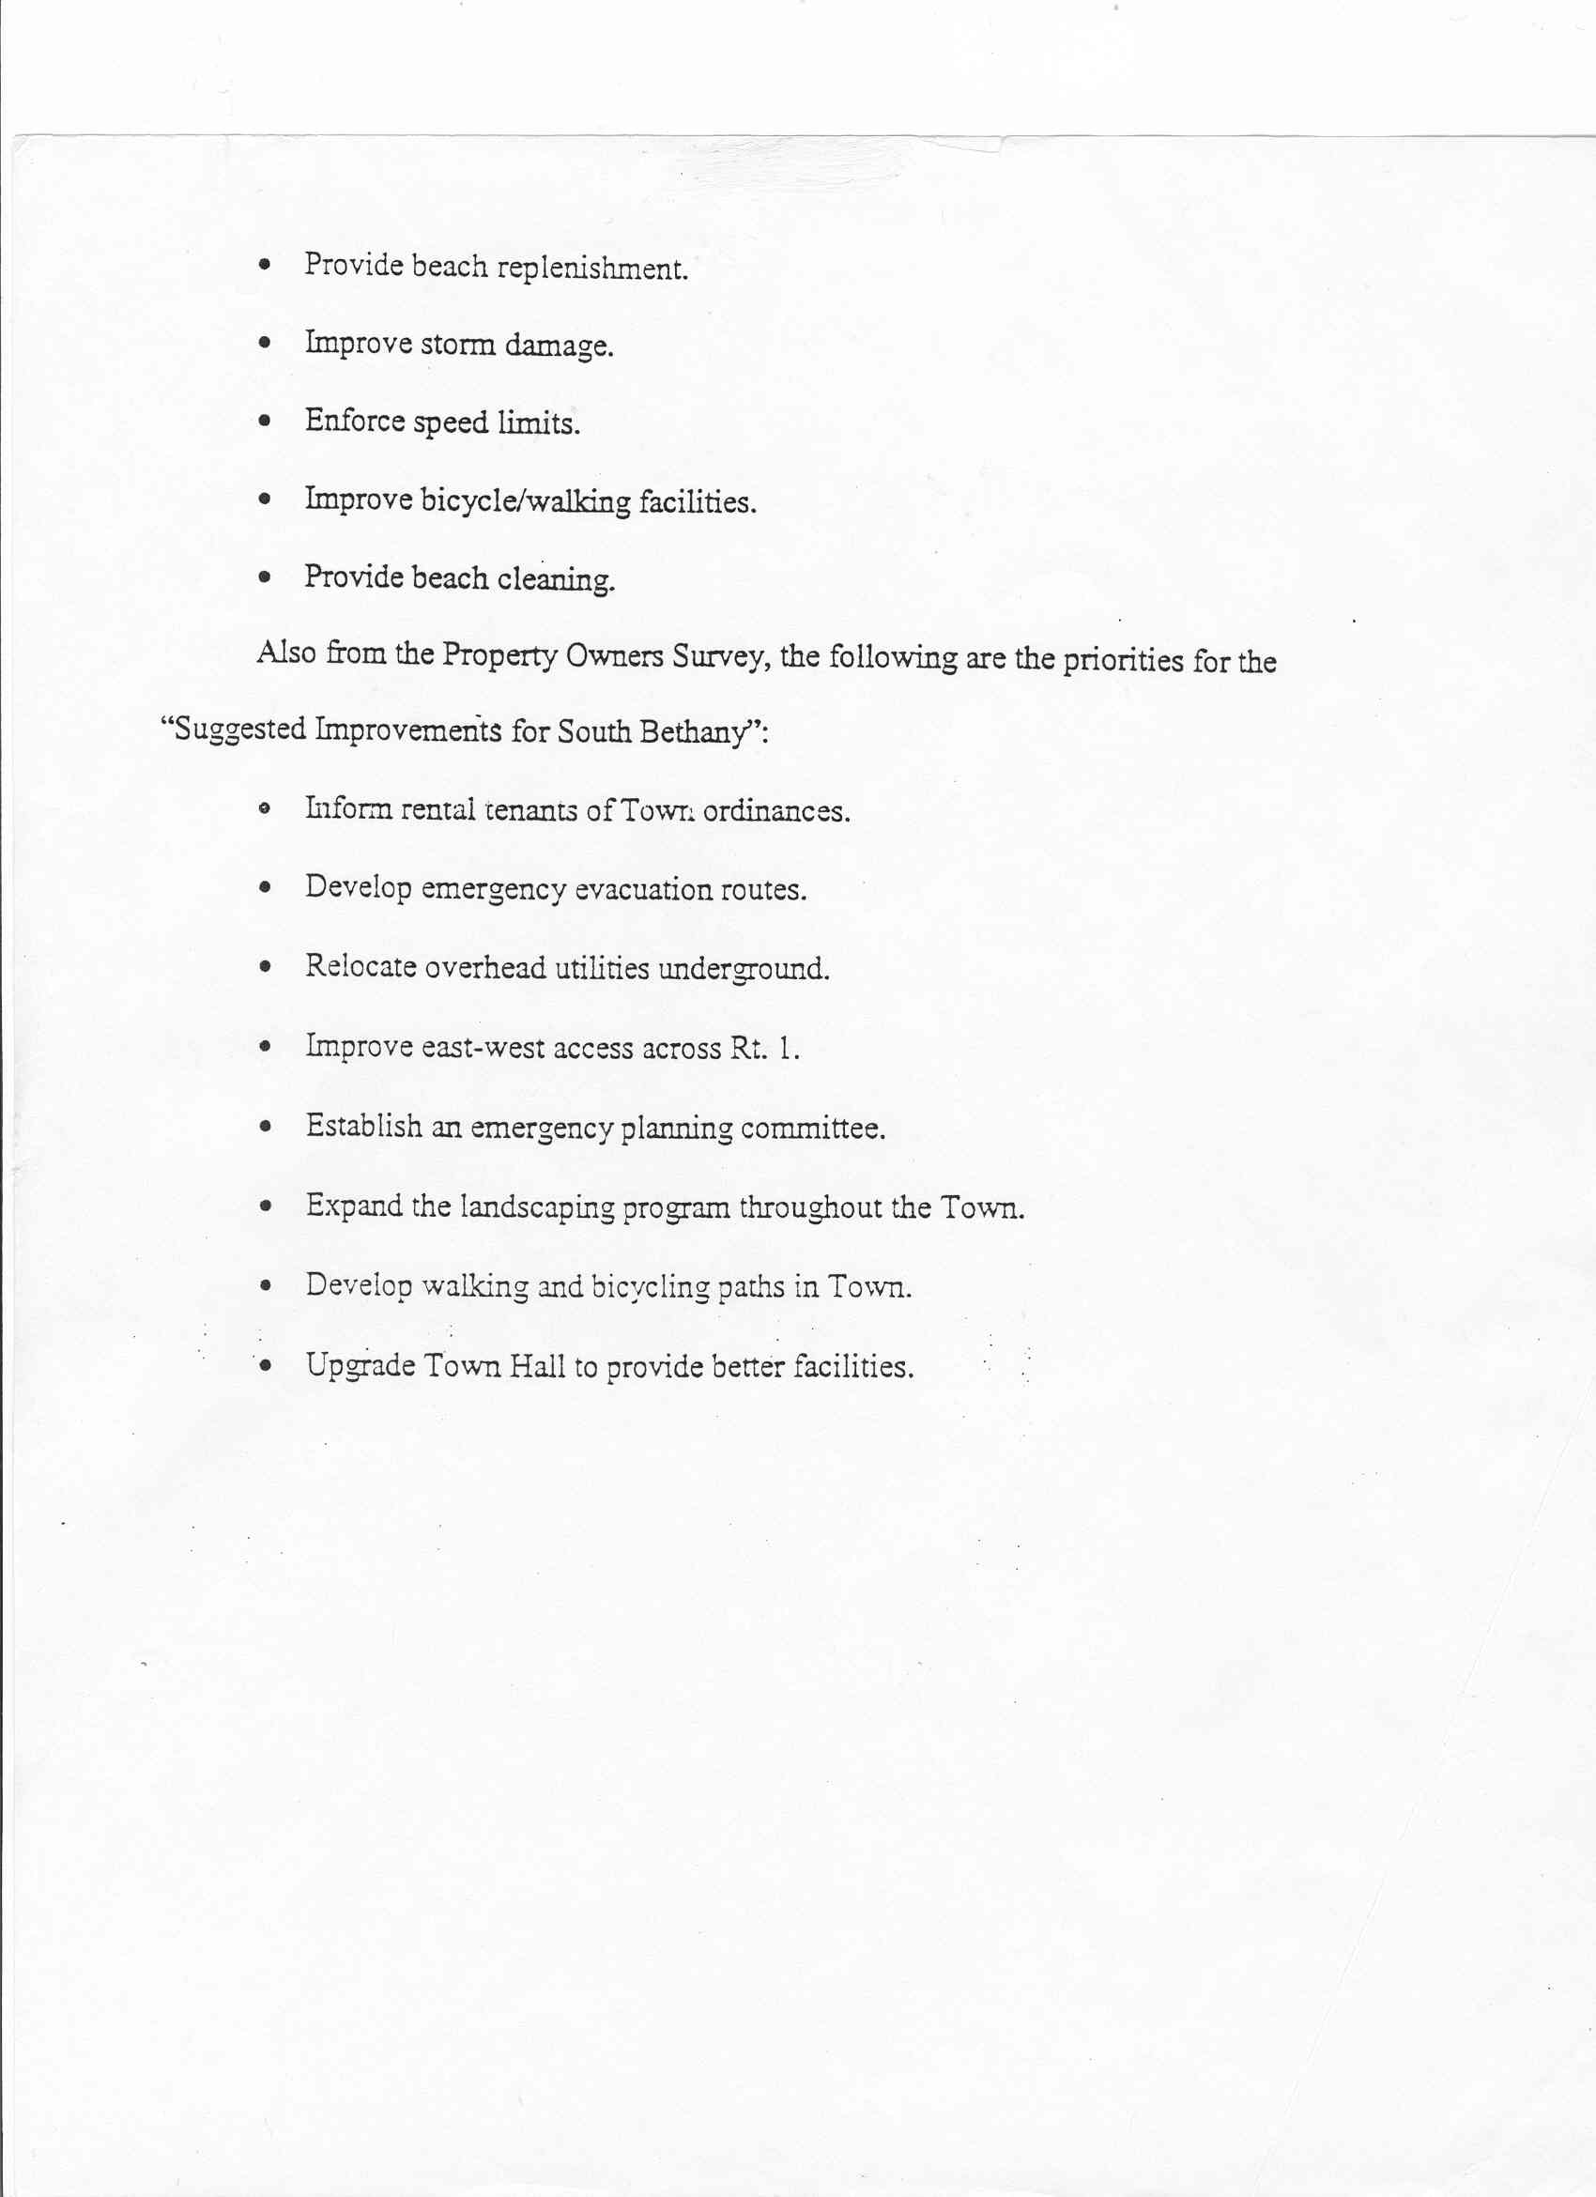

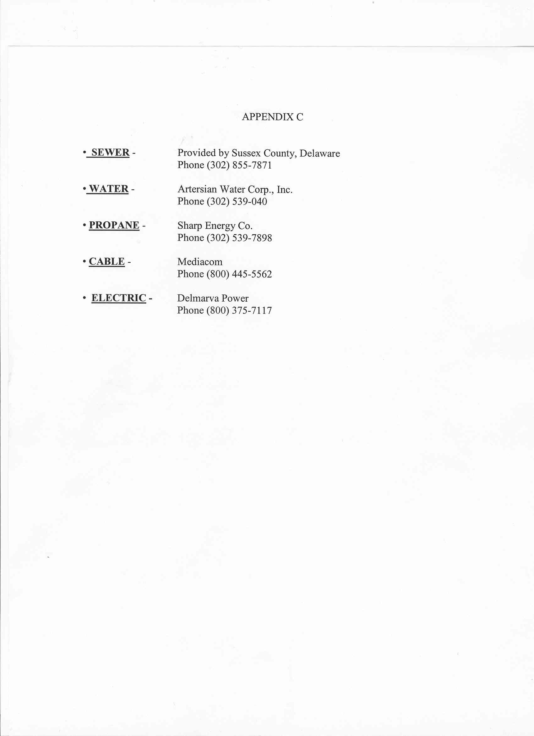

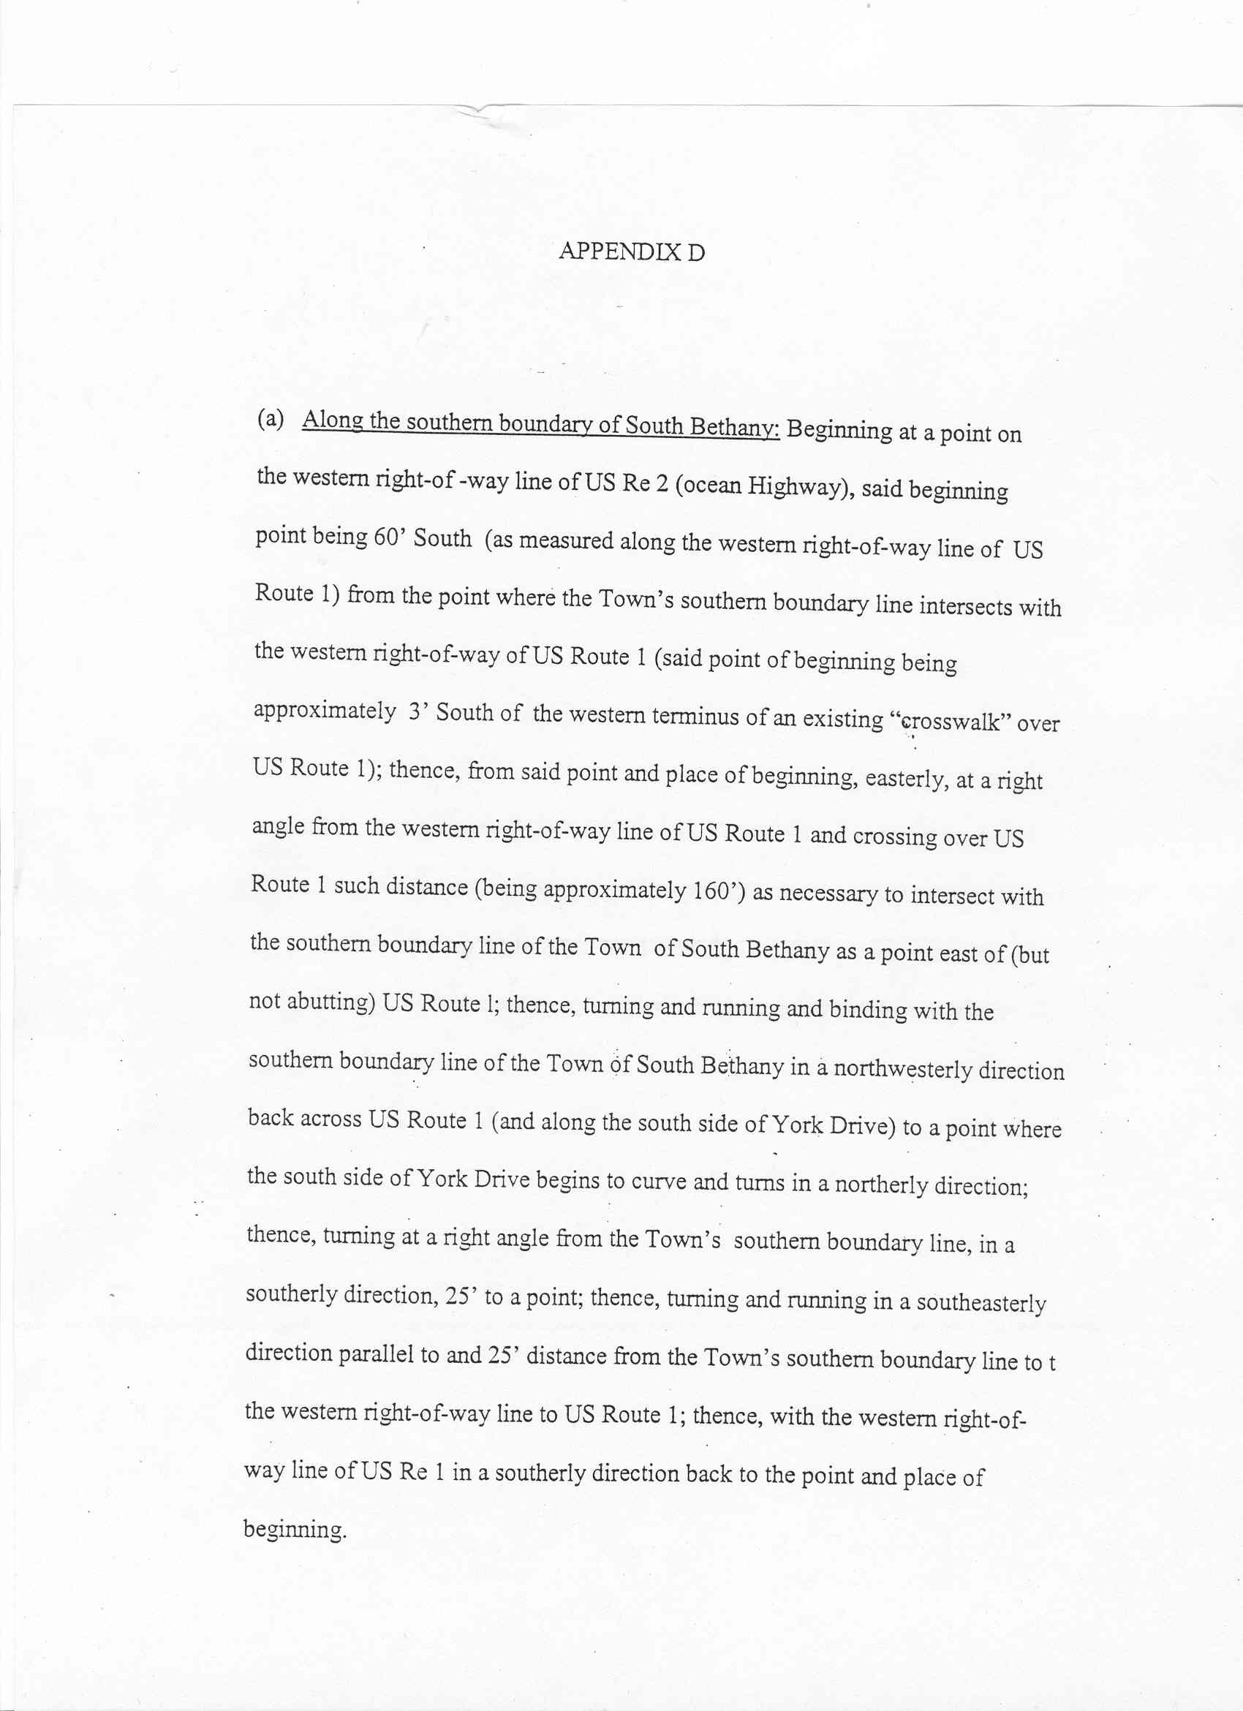

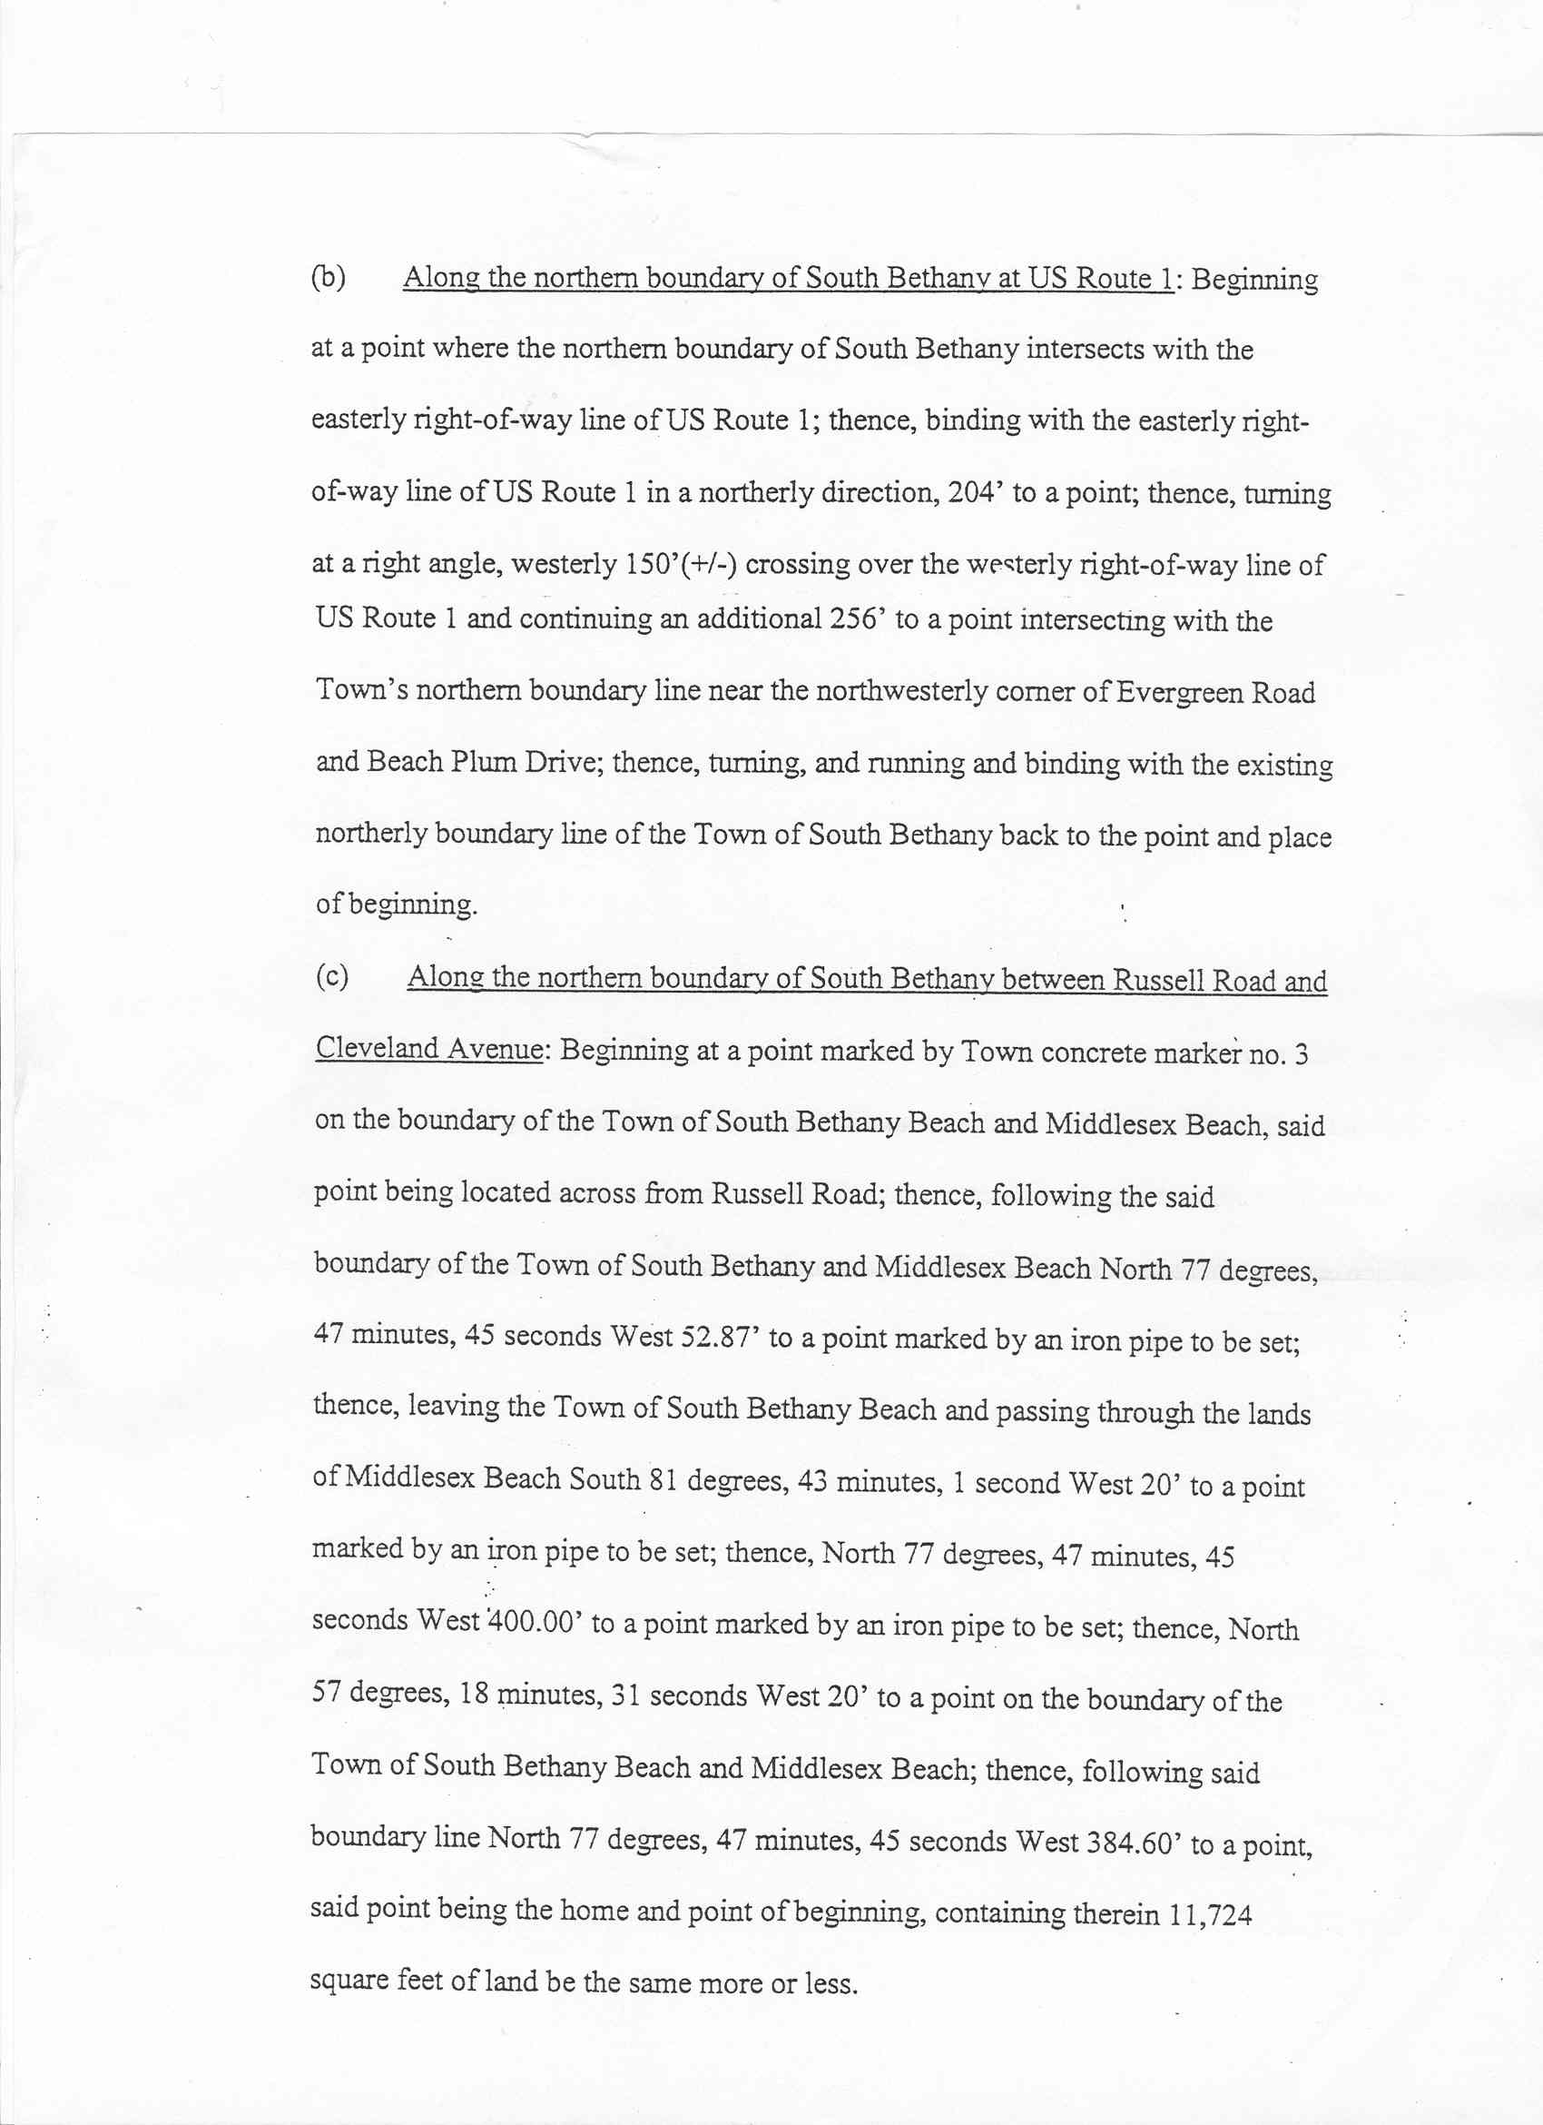

APPENDIX E


