The City of Ennis Parks and Recreation Department Is Organizing Their First Adult Softball Leagues at Bluebonnet Park! Don’t Miss the Fun This Summer, Register Soon!
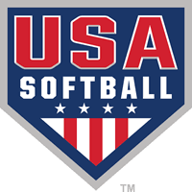
Registration begins July 5th and ends July 25th. Registration will be held at the Public Works Building, 500 Lake Bardwell Drive, in Ennis. Leagues have a limit of nine teams per league, so certain leagues may fill before the deadline. The team entry fee is $355.00 per team. Teams will play an eight game season and a league championship tournament will be held for the four teams with the best records in the regular season.* League play begins the week of August 6th. A coaches’ meeting will be held at 6:45 p.m. at the Community Center, 301 W. Crockett Street in Ennis, on Thursday, July 26th. The leagues and nights of play are as follows:
Monday – Men’s Softball League
Tuesday – Coed Recreational Softball League
Wednesday – Coed Intermediate Softball League
Thursday – Men’s Church Softball League
* - Four team leagues will only have a three team league championship tournament.
Call (972) 875-1234, Extension 2248 for more information!

