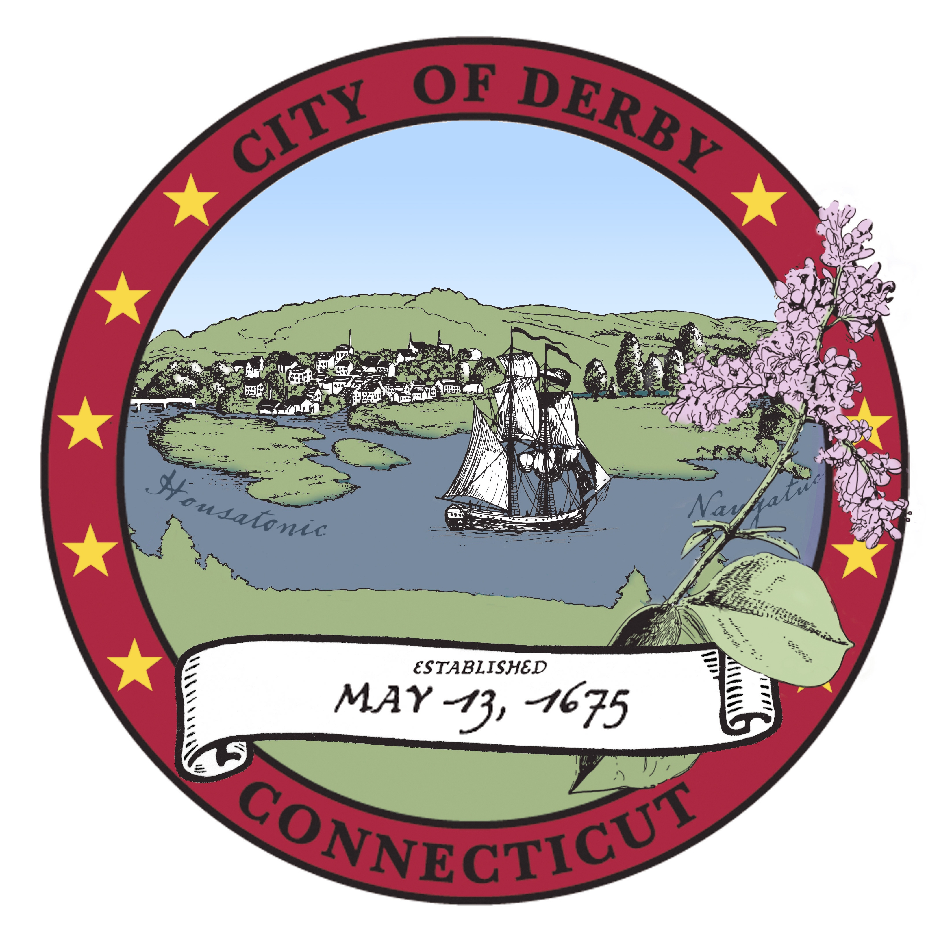

City of Derby

Board of Apportionment & Taxation meeting
Agenda
November, 20, 2017
7:00 PM
joan williamson aldermanic chambers

- Pledge of Allegiance
- Roll Call
- Additions, Deletions and Corrections to Agenda
- Public Portion.
- Motion to Approve Minutes of Meeting of October 16, 2017
- Treasurer’s Report
- Budget Procedure, Status and Advisory - Discussion and possible motion to set the Motor Vehicle Tax Rate at 39 mills.

- Permission to Move Picnic Grove Rental Fees
- From: Account 6000-660-6651, Picnic Grove Rental Fees
- To: Account 4100-480-0484, Picnic Grove Refunds
- To Account 4100-120-0122, Overtime Picnic Grove
Motion to give Finance Director the authority to recognize the picnic grove rental income and match it to the associated picnic grove expenses.
Discussion and action

- Transfer, Fire Marshall, $250.00
- From: Account 001-3400-280-0280, Education, $250.00
- To: Account 001-3400-280-0284, Fire Marshall’s Vehicle, $250.00
To pay for the cost of a new battery for the vehicle
Discussion and action

- Transfer, Fire Department $6,844.50
From: Account 001-3200-230-0231, Yankee Gas, $6,844.50
To: Account 001-3200-460-0460, New Equipment, $6,844.50
To pay for new radio equipment compatible with NW Public Safety.
Discussion and Action

- Transfer From Special Working Balance, $13,080.00
From: Account 001-8400-390-0391, Special Working Balance, $13,080.00
To: Account 001-3200-470-0470, Turnout Gear, $13,080.00
To replace 6 turnout gear outfits that were identified as obsolete by OSHA inspection.
This is mandatory equipment that has aged out of the 10 year OSHA life.
Discussion and action

Adjournment

