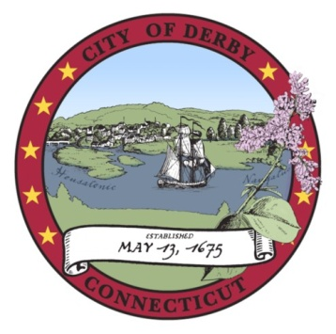

Derby Board of Education

Special Meeting

January 10, 2011
Derby Middle School

Minutes

- Call to Order

The meeting was called to order by Chairman Kenneth Marcucio at 6:37 p.m.

The following Board members were present: Kenneth Marcucio, Andrew Mancini, Laura Harris, Stephanie D’Onofrio, George Kurtyka and Christine Robinson. (A quorum was present.)

Rebecca O’Hara entered the meeting at 6:43.

- Public Participation

No one from the public wished to be heard

- Board Development

Nicholas Caruso of the Connecticut Association of Boards of Education led a workshop on effective board practices.

- Adjournment

Motion by Rebecca O’Hara, seconded by Stephanie D’Onofrio: That the meeting be adjourned.

Motion Adopted.

The meeting was adjourned at 9:18 p.m.

Respectfully submitted:

______________________________
Stephen Tracy
Superintendent of Schools

