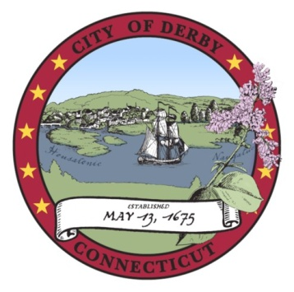

Derby Board of Education

Special Meeting
February 3, 2011
Minutes

- CALL TO ORDER

The meeting was called to order by Chairman Marcucio at 6:40 p.m.

Present: Christine Robinson
George Kurtyka
Kenneth Marcucio
Casey Picheco
Andy Mancini
Laura Harris

Kim Kreiger (arrived 6:41 p.m.)
Stephanie D’Onofrio (arrived 6:53 p.m.)

- PUBLIC PARTICIPATION

Ms. Chantel Gerkins addressed the Board on the importance of retaining the district’s full day kindergarten program.

- SCHOOL CALENDAR 2010-11

Motion (by Casey Picheco, seconded by Kim Kreiger): That the Board of Education modify the school calendar for 2010-11 to account for the inordinate number of weather related closings that the district has experienced thus far in the 2010-11 academic year.

-2-

Motion (by Kim Kreiger, seconded by Laura Harris): That the present motion be laid upon the table.

Motion to table adopted.

- DMS TURBINE MAINTENANCE CONTRACT

Motion (by Kim Kreiger, seconded by George Kurtyka): That the Board of Education approve the awarding of a contract for the maintenance of the turbines at the Derby Middle School to Earthwise Energy Technologies, pending approval of a bid waiver by the Board of Apportionment & Taxation and the Board of Aldermen, as recommended by the Superintendent

Motion adopted.

- OUT OF STATE FIELD TRIP

Motion (by Kim Kreiger, seconded by Stephanie D’Onofrio): That the Board of Education approve a Spanish Club trip to California and Arizona for April 13th through 18th for students in grades 10, 11 and 12, as recommended by the Superintendent.

Motion adopted.

- SPRING SPORTS

Motion (by Kim Kreiger, seconded by Andy Mancini): That the Board of Education approve the reinstatement of the Derby Middle School softball and baseball teams for the Spring, 2011 season pending sufficient enrollment at the discretion of the Director of Athletics, with the understanding that the cost of these teams will be reimbursed to the General Fund from the Athletic Enterprise Fund as necessary.

Motion adopted.

- SUPERINTENDENT’S RECOMMENDED BUDGET FOR FY2012

Dr. Tracy presented his Recommended Budget for Fiscal Year 2012. The proposed budget requests a total of $18,990,000 in funding from the City of
-3-

Derby, representing an increase of $1,255,000 or 7% over the budget for Fiscal Year 2011. The Superintendent’s Recommended Budget will be the subject of hearings by the Board of Education, to be conducted on February 8, 10 and 15, 2011. Final adoption of the FY2012 budget by the Board is anticipated on March 1, 2011.

- ADJOURN

Motion (by Stephanie D’Onofrio, seconded by Kim Kreiger): That the meeting be adjourned.

Respectfully submitted

______________________________
Stephen Tracy
Superintendent of Schools

