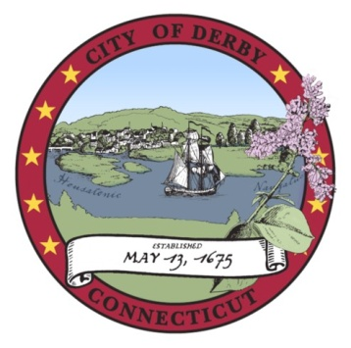

DERBY BOARD OF EDUCATION
Special Meeting

Minutes

Derby Middle School Cafetorium
10 Nutmeg Avenue, Derby, CT 06418
6:30 p.m.
February 10, 2011

 | ITEM
I. | CALL TO ORDER  The meeting was called to order by Chairperson Kenneth Marcucio at 6:39 p.m. The following members of the Board were present:  - Ms. D’Onofrio  - Ms. Harris  - Ms. Kreiger  - Mr. Mancini  - Mr. Marcucio  - Ms. Robinson
II. | PUBLIC PARTICIPATION  No one from the public wished to address the Board.
III. | NEW BUSINESS  Dr. Tracy informed the Board that, in the interest of safety and in cooperation with the Derby Police Department, the prohibition against parking in fire lanes on school property would be enforced with tickets, effective Monday, February 14, 2011.
IV. | OLD BUSINESS  There was no Old Business.
V. | FY 2012 BUDGET PRESENTATION  Dr. Tracy noted that Governor Malloy has indicated that his FY2012 state budget proposal would include a freeze on Educational Cost Sharing (ECS) funding to towns and cities for the upcoming year.  Dr. Tracy noted that the City has reported a small increase in the current grand list.  Dr. Tracy reported that he had recently completed discussions with Senator Crisco, Representative Gentile and Representative Klarides regarding the fiscal challenges facing the Derby Public School in the year ahead.  The Board reviewed those portions of the Superintendent’s Recommended Budget for FY2012 having to do with the operation of Derby Middle School and Derby High School.
VI. | ADJOURN  Motion by Ms. D’Onofrio, Seconded by Ms. Harris: That the meeting be adjourned.  Motion Adopted.  Meeting adjourned at 7:55 p.m.

Respectfully submitted,

___________________________________
Stephen Tracy
Superintendent of Schools

