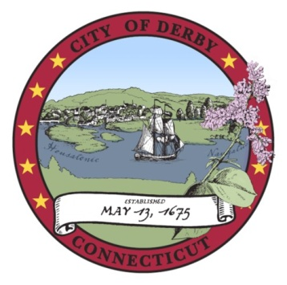

Derby Board of Education

Special Meeting
November 26, 2012

Minutes

CALL TO ORDER

The meeting was called to order by Chairman Marcucio at 6:13 p.m.

Present: Denise Bottone
Laura Harris
Kim Kreiger
George Kurtyka
Andy Mancini
Ken Marcucio
Rebecca O’Hara
Christine Robinson

Stephanie D’Onofrio (arrived 6:24 p.m.)

PUBLIC PARTICIPATION

No one from the public wished to address the Board.

EXECUTIVE SESSION

Motion (by Ms. Kreiger, second by Mr. Mancini): That the Board of Education enter into executive session for Superintendent interviews and that Dr. Jacoby be invited into Executive Session.

Motion (by Ms. Kreiger, second by Mr. Kurtyka): That the Board of Education return to public session.

ADJOURN

Motion (by Stephanie D’Onofrio, seconded by Christine Robinson): That the meeting be adjourned.

Motion adopted.

The meeting adjourned at 8:59 p.m.

Respectfully submitted

______________________________
Kenneth Marcucio, Chair
Board of Education

