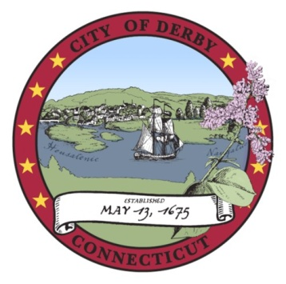
pap

DERBY BOARD OF EDUCATION
Policy Committee Meeting Minutes

Superintendent’s Office
35 Fifth Street, Derby, CT 06418
January 27, 2014

I. CALL TO ORDER
The meeting was called to order at 5:07 PM

A. Opening Ceremonies

B. Roll Call
Present were Mr. Mancini, Ms. Harris and Dr. Conway. Mr. Marcucio arrived late.

II. POLICY REVIEW
The board discussed policies 5117 through 5121.3.

#1 Change principals to stabilize instead of racial integration.

5118 - regarding certified teachers being able to request that their children attend Derby schools needs to be added to Google Drive.

5118.1 - add legal reference update.

5118.3 – discussed adding non-certified teachers and moving forward teachers should pay half of the tuition. Also, language should be added regarding availability and not to exceed class size. They asked Dr. Conway to reach out to other schools to evaluate their policy.

5121 – Three through eight and eleven should say Smarter Balance not Mastery.

5121.2 and 3- need to research. Dr. Conway will get back to board.

V. ADJOURN
Ms. Harris motioned to adjourn at 6:00 PM. Mr. Marcucio seconded and the motion carried.

Respectfully submitted,

Terri Kuskowski
Recording Secretary

These minutes are subject to the Board’s approval at their next scheduled meeting.

