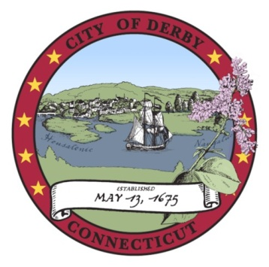
pap

DERBY BOARD OF EDUCATION
Policy Committee Meeting Minutes

Derby Middle School
10 Nutmeg Avenue, Derby, CT 06418
April 28, 2014

I. CALL TO ORDER
The meeting was called to order at 6:04 PM

A. Opening Ceremonies

B. Roll Call
Present were Mr. Stadt, Mr. Mancini, Ms. Harris and Dr. Conway. Mr. Marcucio arrived at 6:05 PM.

II. PUBLIC PARTICIPATION
Denise Bottone – wanted it on record regarding her concerns about Policy # 5118 Tuition. She stated that back in the fall there was a discussion regarding tuition for non-resident students. Teachers who do not live in town have the opportunity to have their child to go to school in Derby at no cost. Any incoming students from out of town should have to pay tuition. Dr. Conway stated that the committee had decided to charge half the tuition for teacher’s children, however, current students were grandfathered.

Ginny Stadt – spoke regarding bullying policy. Her daughter had been bullied twice before anything was done. She wanted to know what exactly zero tolerance means. Dr. Conway stated that harassment must occur more than once before it’s considered bullying. She doesn’t feel that incidents are handled timely enough.

Gabby Stadt – spoke regarding her bullying incident. Students shouldn’t be afraid to tell the teachers or feel that the school doesn’t care.

III. POLICY REVIEW
The board discussed the bullying and laptop program policies as well as policies 5131.6- 5132.1.

5131.6 –Dr. Conway stated that e-cigarettes are handled the same as regular cigarettes.

5131.6 a-f - Proceed as recommend and add “any product containing nicotine” to section f.

5131.7 – appropriate as written

5131.8 1 – add legal reference.

5131.9 – discussed. A, B, and C approved.

5131.9.2. – missing

5132 – appropriate with exception of legal reference. Change 7th to 6th grade.
5132.1 – (existing policy 5133.) School colors. Accepted as written.

V. ADJOURN
Ms. Harris motioned to adjourn at 7:10 PM. Mr. Stadt seconded and the motion carried.

Respectfully submitted,

Terri Kuskowski
Recording Secretary

These minutes are subject to the Board’s approval at their next scheduled meeting.

