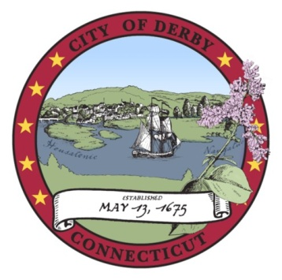
pap

DERBY BOARD OF EDUCATION

SPECIAL MEETING
POLICY COMMITTEE AGENDA

Derby Middle School Cafetorium
73 Chatfield Street, Derby, CT 06418
6:00 p.m.
March 20, 2017

 | ITEM | LEADER | TIME
I. | CALL TO ORDER  - Opening Ceremonies  - Roll Call | Mr. Mancini | 2 min.
II. | PUBLIC PARTICIPATION  * Prior to the commencement of any public meeting of any board of the city, the agenda for said meeting shall be posted in the meeting room and the first order of business of said meeting shall be the entertainment of public discussion on any item on said agenda and the conduct, length, and method of terminating said public discussion shall be determined by majority vote of the members of said board of commission. | Mr. Mancini | 3 min.
III. | REVIEW POLICY ON LICE | Mr. Mancini | 40 min.
IV. | ADJOURN  Motion: That the policy committee adjourn its meeting. | Mr. Mancini | 1 min.
TOTAL ESTIMATED MEETING TIME: 46 mins.

___________________________________
Dr. Matthew J. Conway, Jr.
Superintendent of Schools

