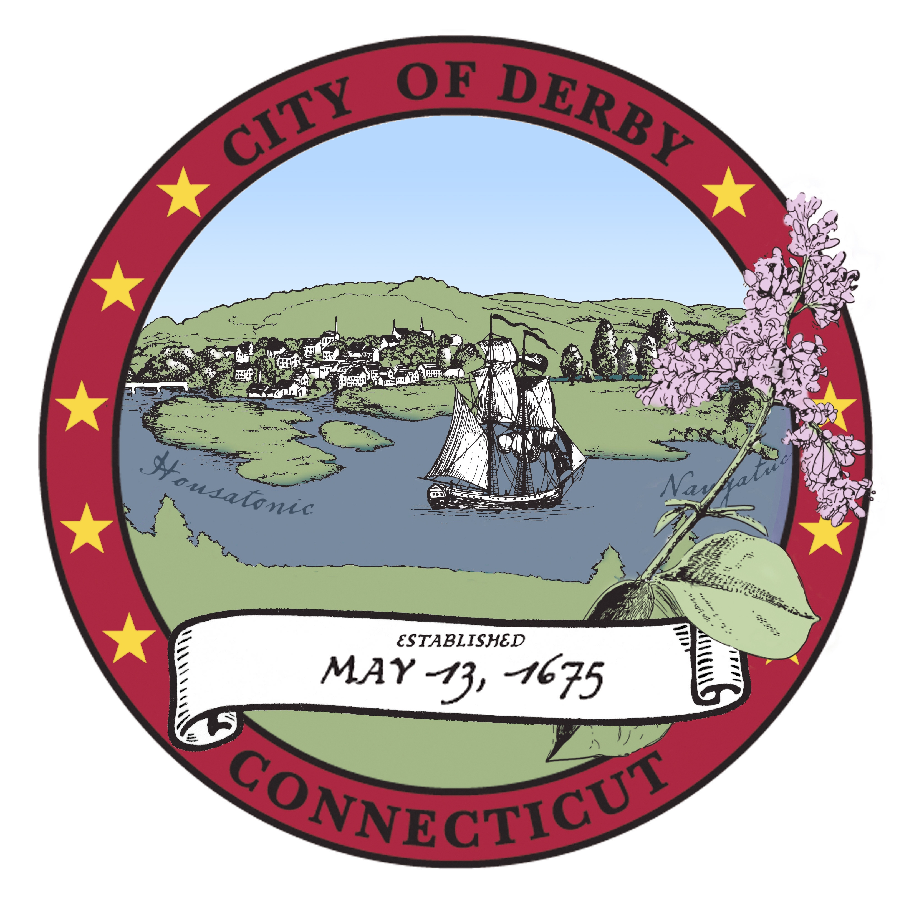

City of Derby

Board of Apportionment & Taxation
Special Meeting Agenda
April 18, 2017
6:30 PM
Joan Williamson aldermanic Chambers

- Pledge of Allegiance
- Roll Call
- Public Portion
- Budget requests from the following departments:\

- Board of Education
- Mayor’s Office
- Senior Center
- Legal

Adjournment

