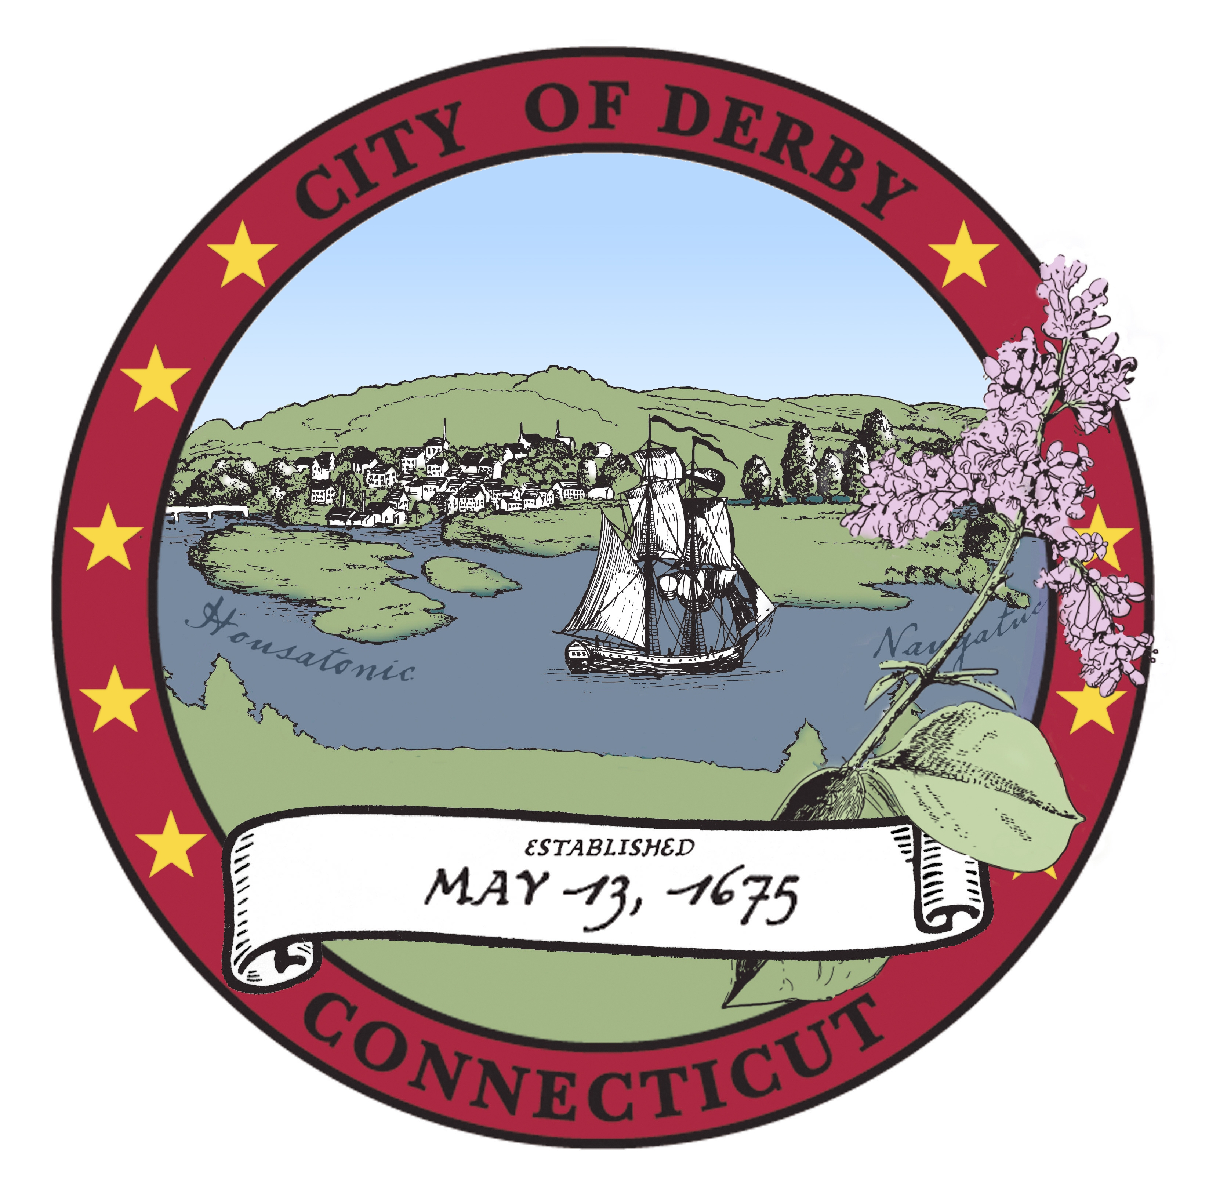

City of Derby

Board of Apportionment & Taxation meeting
Agenda
January, 16, 2018
7:00 PM
joan williamson aldermanic chambers

- Pledge of Allegiance
- Roll Call
- Additions, Deletions and Corrections to Agenda
- Public Portion.
- Motion to Approve Minutes of Meeting of December 2, 2017
- Motion to Approve Minutes of Meeting of December 18, 2017
- Treasurer’s Report
- Budget Procedure, Status and Advisory -

- Transfer, Legal Expenses, $500.00
- From: Account 001-1600-270-0271, Extra Legal Expenses, $500.00
- To: Account 001-1600-280-0280, Appraisals, $500.00
Transfer needed to pay attached appraisal invoice
Discussion and Action

- Transfer, Police Department, $32,585.60.00
- From: Account 001-3100-110-0007, Patrolmen’s Wages, $32,585.60.
- To: Account 001-3100-120-0120, Overtime Wages, $32,585.60
Transfer requested to pay for Police Department overtime from regular wages line item.
Discussion and Action

- Transfer, Fire Department $2,078.89
- From: Account 001-3200-330-0335, Radio Maintenance, $1,387.58.
- From: Account 001-3200-280-0280, Education, 691.31
- To: Account 001-3200-330-0334, Equipment Maintenance, $1,387.58
- To: Account 001-3200-460-0464 Turn Out Gear Repair, $691.31
Transfer requested to pay for turn out gear repair.
Discussion and Action

Adjournment

