President O’Neal cancelled the 1045th meeting due to the COVID-19 pandemic.

Respectfully submitted,

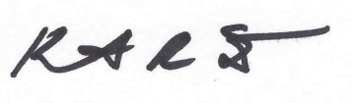
Kenneth R Steele, Secretary

