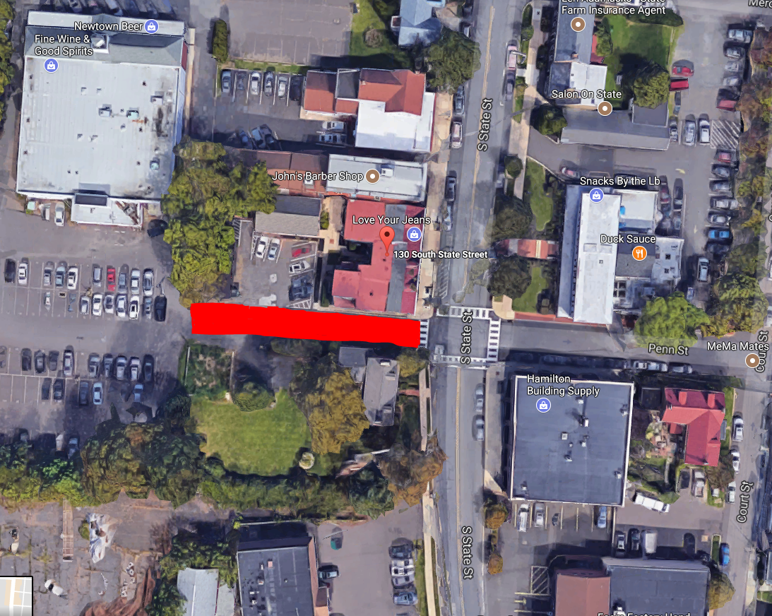

Section of West Penn Street to be changed to one-way traffic highlighted in red.

